Name Date Period
Lesson 2-5 · Session 1 · Practice · Form B
Range and IQR
Learning target — I can find the range and the interquartile range of a data set. · 6.SP.B.5c

REMEMBER  • Range = greatest − least. It uses only the two extreme values.  • IQR = Q3 − Q1. It is the spread of the middle half of the data.  • Changing only the greatest value changes the range, not the IQR. Missing max = min + range. | WORKED EXAMPLE  Hikes (km): 5, 12, 8, 20, 15, 10, 18.  Step 1 Order: 5, 8, 10, 12, 15, 18, 20.  Step 2 Range = 20 − 5 = 15 km.  Step 3 Q1 = 8, Q3 = 18, so IQR = 18 − 8 = 10 km.  Answer Range 15 km; IQR 10 km
WORDS range (rango) · interquartile range (IQR) (rango intercuartil) · variability (variabilidad)
PRACTICE show your work · label units

1. Bike Rides. Seven rides covered 6, 14, 9, 22, 17, 11, 19 miles.
Hint Order first. Range uses the ends; IQR uses Q1 and Q3.
a. Range: | b. Q1: | c. Q3: | d. IQR:

2. Car Wash. Seven sales earned 52, 66, 58, 74, 55, 69, 62 dollars. | 3. Band Rehearsals. Seven lasted 50, 68, 58, 84, 62, 75, 66 minutes.  Hint Leave the median out of both halves.
  a. Range:
  b. IQR:
  a. Range:
  b. IQR:

4. Swapped Value. A data set is 10, 15, 17, 21, 26, 28, 34. Someone replaces 34 with 90. Darnell says both the range and the IQR grow.
Hint Only the greatest value changed.
a. Range before; after:
b. IQR before; after:
c. Is he right? Explain.

5. Missing Maximum. Seven values have min 9, range 41, Q1 = 18 and Q3 = 37.
Hint Add the range to the minimum.
a. Maximum: | b. IQR:

6. Same Range? Set C: 10, 15, 20, 25, 30, 35, 40. Set D: 10, 11, 13, 25, 37, 39, 40.
a. Range of C: | b. IQR of C: | c. Range of D: | d. IQR of D:

7. Which Spread? Hourly wages: min $12, Q1 $15, median $18, Q3 $21, max $70.
a. Range: | b. IQR: | c. Better for typical spread:

8. Two Snack Bars. The box plots show daily sales.  a. Range and IQR of each bar:  b. Which bar has the steadier middle half?  c. Why could the ranges mislead if one day had unusual weather? | 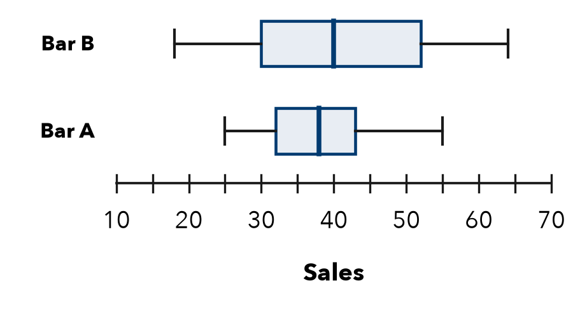

FIND THE ERROR explain the mistake, then fix it

9. Marisol’s Work. For 5, 9, 14, 18, 25, 31, 40, Marisol wrote: “The IQR is 35, the greatest value minus the least.” Explain the mistake and find the IQR.

TEST PRACTICE choose the best answer

10. The IQR describes the spread of the —
A whole data set | B middle half | C lowest values | D highest values

11. What is the range of 12, 19, 8, 25, 16?
A 17 | B 13 | C 8 | D 25

SELF-CHECK CODE find your answer · copy its letter into that problem’s box · spell a math word
26  Q | 16  M | 32  Z | 50  U | 14  A | 19  R | 17  S | 8  X | 10  E | 58  E

#1a | #1d | #2b | #3b | #5a | #5b | #7a

CHECK YOURSELF | □ I can do this on my own | □ I need a little help | □ I have a question about #

