Name Date Period
Lesson 2-5 · Session 2 · Practice · Form A
Comparing Variability
Learning target — I can compare the variability of two data sets using range and IQR. · 6.SP.B.5c

REMEMBER  • More consistent = less spread out = smaller range or smaller IQR.  • Compare the same measure for both groups. Equal ranges can hide different IQRs.  • With one far-out value, trust the IQR more than the range. | WORKED EXAMPLE  Class R: range 18, IQR 12. Class S: range 35, IQR 25.  Step 1 Ranges: 18 < 35.  Step 2 IQRs: 12 < 25.  Step 3 Both measures are smaller for R.  Answer Class R is more consistent
WORDS consistent (constante) · range (rango) · IQR (rango intercuartil)
PRACTICE show your work · label units

1. Two Classes. Class R scores: 70, 82, 76, 88, 73, 85, 79. Class S scores: 60, 90, 75, 95, 65, 80, 72. Complete the table.
Hint Order each list on its own first.
 | Range | Q1 | Q3 | IQR
Class R
Class S
More consistent

2. Vending Machines. Machine 1 daily sales: 30, 42, 35, 50, 38, 46, 33. Machine 2: 34, 39, 41, 37, 43, 40, 45.
a. Range 1: | b. IQR 1: | c. Range 2: | d. IQR 2:

3. Devi’s Claim. Sets V and W both have a range of 40. V has Q1 = 15 and Q3 = 35; W has Q1 = 25 and Q3 = 30. Devi says they vary the same amount.  Hint Equal ranges only match the extremes.  IQRs | 4. Hugo’s Claim. Sets T and U both have an IQR of 12. T runs from 30 to 54; U runs from 8 to 96. Hugo says they are equally spread out.  Hint Equal IQRs only match the middle halves.  Ranges
  □ Right | □ Not right
  □ Right | □ Not right

5. Choosing a Measure. A list of home prices has one house priced far above all the others. Which measure of spread fits better, the range or the IQR? Explain.

6. Different Stories. Set M has range 40 and IQR 6. Set N has range 24 and IQR 18.
Hint A range much bigger than the IQR points to an extreme value.
a. Wider middle half: | b. Likely has one unusual value:

7. Phone Batteries. Phone 1 hours: 16, 20, 18, 24, 22, 26, 14. Phone 2 hours: 19, 21, 20, 23, 18, 24, 17.
a. Range 1: | b. IQR 1: | c. Range 2: | d. IQR 2:

8. Choosing a Bus. The box plots show how many minutes late each bus was.  a. IQR of Bus 1:  b. IQR of Bus 2:  c. More predictable:  d. Bus 2 is sometimes almost on time. Why might you still choose Bus 1? | 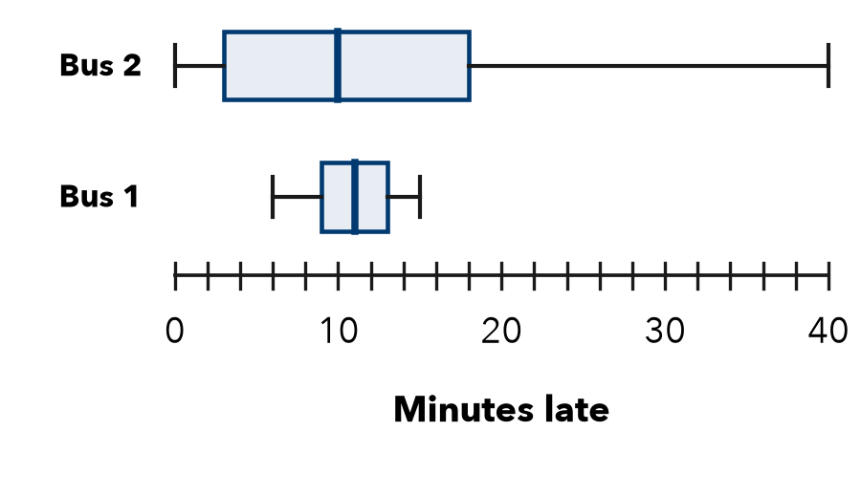

FIND THE ERROR explain the mistake, then fix it

9. Harlan’s Work. Harlan wrote: “Set A has the greater IQR, so Set A must have the greater range too.” Explain the mistake.

TEST PRACTICE choose the best answer

10. A smaller IQR means the middle half of the data is —
A more spread out | B closer together | C greater | D missing values

11. A range much larger than the IQR suggests —
A an extreme value | B no variability | C equal quartiles | D a small data set

SELF-CHECK CODE find your answer · copy its letter into that problem’s box · spell a math word
5  I | 8  Y | 15  G | Class S  Q | 13  A | 4  N | 17  Z | Class R  V | 9  X | 6  R

#1 | #2b | #2d | #7b | #7d | #8a | #8b

CHECK YOURSELF | □ I can do this on my own | □ I need a little help | □ I have a question about #

