Name Date Period
Lesson 2-5 · Session 2 · Practice · Form B
Comparing Variability
Learning target — I can compare the variability of two data sets using range and IQR. · 6.SP.B.5c

REMEMBER  • More consistent = less spread out = smaller range or smaller IQR.  • Compare the same measure for both groups. Equal ranges can hide different IQRs.  • With one far-out value, trust the IQR more than the range. | WORKED EXAMPLE  Class R: range 18, IQR 12. Class S: range 35, IQR 25.  Step 1 Ranges: 18 < 35.  Step 2 IQRs: 12 < 25.  Step 3 Both measures are smaller for R.  Answer Class R is more consistent
WORDS consistent (constante) · range (rango) · IQR (rango intercuartil)
PRACTICE show your work · label units

1. Two Teams. Team J scores: 64, 78, 71, 83, 67, 80, 74. Team K scores: 55, 92, 70, 88, 60, 81, 66. Complete the table.
Hint Order each list on its own first.
 | Range | Q1 | Q3 | IQR
Team J
Team K
More consistent

2. Vending Machines. Machine 1 daily sales: 28, 45, 33, 52, 36, 48, 31. Machine 2: 38, 42, 44, 40, 47, 43, 49.
a. Range 1: | b. IQR 1: | c. Range 2: | d. IQR 2:

3. Aaliyah’s Claim. Sets V and W both have a range of 50. V has Q1 = 20 and Q3 = 45; W has Q1 = 30 and Q3 = 36. Aaliyah says they vary the same amount.  Hint Equal ranges only match the extremes.  IQRs | 4. Mateo’s Claim. Sets T and U both have an IQR of 10. T runs from 40 to 62; U runs from 12 to 95. Mateo says they are equally spread out.  Hint Equal IQRs only match the middle halves.  Ranges
  □ Right | □ Not right
  □ Right | □ Not right

5. Choosing a Measure. A list of monthly phone bills has one bill far above all the others. Which measure of spread fits better, the range or the IQR? Explain.

6. Different Stories. Set M has range 36 and IQR 20. Set N has range 50 and IQR 5.
Hint A range much bigger than the IQR points to an extreme value.
a. Wider middle half: | b. Likely has one unusual value:

7. Tablet Batteries. Tablet 1 hours: 10, 15, 12, 19, 17, 21, 8. Tablet 2 hours: 13, 15, 14, 17, 12, 18, 16.
a. Range 1: | b. IQR 1: | c. Range 2: | d. IQR 2:

8. Choosing a Bus. The box plots show how many minutes late each bus was.  a. IQR of Bus 1:  b. IQR of Bus 2:  c. More predictable:  d. Bus 1 is sometimes almost on time. Why might you still choose Bus 2? | 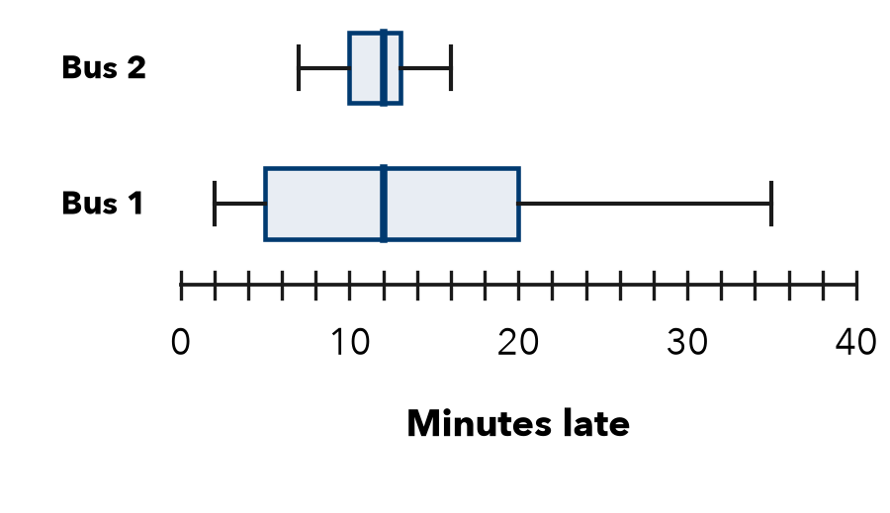

FIND THE ERROR explain the mistake, then fix it

9. Nadia’s Work. Nadia wrote: “Set A has the greater IQR, so Set A must have the greater range too.” Explain the mistake.

TEST PRACTICE choose the best answer

10. Set X has range 12; Set Y has range 30. Which is more spread out overall?
A Set X | B Set Y | C They are equal | D Cannot tell

11. Two sets have the same median but different IQRs. They differ in —
A center | B spread of the middle half
C number of values | D median

SELF-CHECK CODE find your answer · copy its letter into that problem’s box · spell a math word
21  Z | 15  R | 4  A | 3  E | 17  O | Team K  Q | 9  P | Team J  C | 7  M | 33  X

#1 | #2b | #2d | #7b | #7d | #8a | #8b

CHECK YOURSELF | □ I can do this on my own | □ I need a little help | □ I have a question about #

