Name Date Period
Lesson 2-8 · Session 1 · Practice · Form A
Finding the Mean
Learning target — I can find the mean of a data set by sharing the total equally among the values. · 6.SP.B.5c

REMEMBER  • The mean is a fair share: add all the values, then divide by how many values there are.  • Count every value, even a 0.  • The mean is always between the least and greatest values. | WORKED EXAMPLE  Four friends have 3, 5, 6 and 10 stickers. Find the mean.  Step 1 Add: 3 + 5 + 6 + 10 = 24.  Step 2 Count: there are 4 values.  Step 3 Divide: 24 ÷ 4 = 6. Check: 6 is between 3 and 10.  Answer 6 stickers each
WORDS mean (media) · average (promedio) · measure of center (medida de centro) · data set (conjunto de datos)
PRACTICE show your work · label units

1. Find the mean of each data set.
a. 8, 12, 9, 11, 15 | b. 7, 4, 9, 6, 9
c. 20, 16, 22, 18, 25, 25 | d. 25, 30, 20, 35, 40, 30

2. Bird Feeder. The dot plot shows the number of birds that visited a feeder on six mornings.
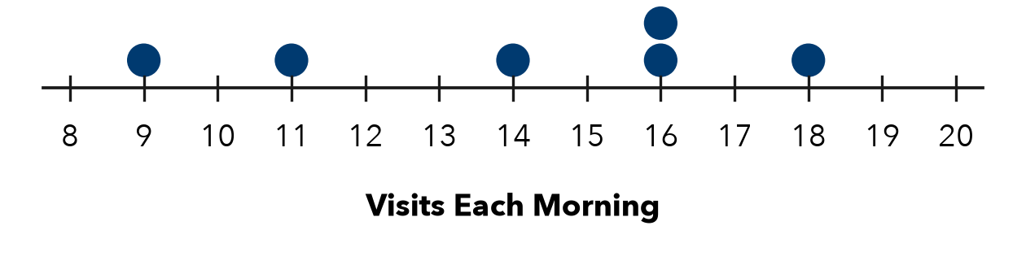
a. Total visits:
b. Mean visits per morning:

3. Seedling Growth. Five seedlings grew 12, 9, 15, 11 and 13 cm. Find the mean growth.  Hint Total the growths first, then share the total among 5.  Answer cm | 4. Repeated Values. For 10, 10, 10, 40, Bryce says the mean is 10 because most values are 10. Is he right? Find the mean.  Hint The mean uses every value. Total them all first.  Mean
  Show your work.
  Show your work.

5. Sticker Swap. Four friends have 3, 8, 5 and 12 stickers. They share them evenly. How many does each get?  Hint Sharing equally means dividing the total by 4.  Answer stickers | 6. Dog Walking. Five afternoons of dog walking earned $14, $21, $17, $19 and $24. Find the mean earnings.  Answer dollars
  Show your work.
  Show your work.

7. The Zero Day. A student earned $12, $0, $15, $9 and $14 recycling cans on five days. Nyla says to leave out the $0 day. Is she right? Find the mean.
Hint Count every day, including the day with $0.

Show your work.
Answer dollars

8. Class Fundraiser. Six students raised $30, $45, $25, $50, $40 and $50.
a. Find the mean amount raised. dollars
b. A seventh student raises $96. Will the mean rise or fall? Find the new mean. dollars

Show your work.

FIND THE ERROR explain the mistake, then fix it

9. Simone’s Work. For 6, 10, 8, 12, Simone added the values and wrote that the mean is 36. Explain her mistake and find the mean.

TEST PRACTICE choose the best answer

10. Find the mean of 6, 8, 10, 12.
A 9 | B 36 | C 10 | D 4

11. Five values total 85. What is the mean?
A 80 | B 17 | C 425 | D 90

SELF-CHECK CODE find your answer · copy its letter into that problem’s box · spell a math word
40  E | 19  A | 7  R | 70  X | 12.50  Q | 12  V | 16.8  Z | 17.5  E | 10  G | 14  A

#2b | #3 | #4 | #5 | #6 | #7 | #8a

CHECK YOURSELF | □ I can do this on my own | □ I need a little help | □ I have a question about #

