Name Date Period
Lesson 3-1 · Session 1 · Practice · Form B
Understanding Ratios
Learning target — I can describe a relationship between two quantities using ratio language. · 6.RP.A.1

REMEMBER  • A ratio compares two amounts: 3 to 5, 3 : 5, or 3/5. Order matters.  • Part-to-part compares two groups. Part-to-whole adds the groups to find the total.  • Simplest form: divide both terms by the same number. | WORKED EXAMPLE  A shelf has 6 math books and 9 reading books. Write reading to math, then math to all books.  Step 1 Reading first: 9 : 6.  Step 2 All books: 6 + 9 = 15, so math to all is 6 : 15.  Step 3 Divide both terms by 3: 6 : 15 = 2 : 5.  Answer 9 : 6 and 2 : 5
WORDS ratio (razón) · term (término) · part-to-part (parte a parte) · part-to-whole (parte al todo)
PRACTICE show your work · label units

1. Fruit Basket. A basket holds 6 green apples, 10 oranges and 4 bananas. Write each ratio in simplest form.
a. apples to oranges: | b. bananas to all fruit:
c. oranges to apples: | d. apples to all fruit:

2. Art Brushes. An art bin has 6 wide brushes and 15 detail brushes.
Hint For the whole, add both kinds of brushes first.
a. Detail to wide, three ways. Then simplify:
b. Wide to all brushes, simplest form:

3. Track Team. The team has 14 sprinters and 6 distance runners. Write sprinters to distance runners in simplest form.  Ratio | 4. Garden Harvest. A garden has 21 tomatoes and 28 peppers. A helper says tomatoes to peppers is 4 to 3. Is the helper correct?  Hint Write 21 : 28, then simplify.  Yes or no
  Show your work.
  Show your work.

5. Library Books. In a stack of 35 books, 15 are comic books and the rest are mystery books. Write mystery to all books as a fraction in simplest form.
Hint Subtract to find the mystery books first.

Show your work.
Fraction

6. Band Sections. A band has 10 flutes, 6 trumpets and 4 drums.
Hint For drums to all, add all three sections.
a. Trumpets to flutes:
b. Drums to all band members:

7. Marble Bag. A bag holds 6 red marbles. The ratio of red to blue is 1 : 4.
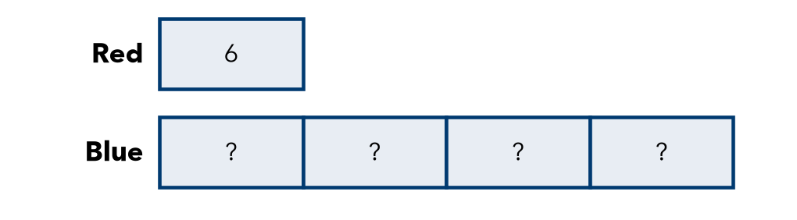
a. How many blue marbles?
b. Red to all marbles, simplest form:

8. Class Election. In a class of 30 students, 12 voted for Ana and the rest for Ben.
a. Ana to Ben, simplest form:
b. Ben to all votes, simplest form:
c. Four new students vote for Ana. Is Ana to Ben now 1 : 1? Explain.

Show your work.

FIND THE ERROR explain the mistake, then fix it

9. Maya’s Work. A pet store has 4 rabbits and 7 guinea pigs. Maya wrote: “The ratio of guinea pigs to rabbits is 4 to 7.” Explain her mistake and write the correct ratio.

TEST PRACTICE choose the best answer

10. A box has 8 pens and 12 pencils. The ratio of pens to pencils in simplest form is —
A 3 : 2 | B 8 : 20 | C 4 : 5 | D 2 : 3

11. A team has 9 girls and 4 boys. The ratio of boys to all the players is —
A 4 : 9 | B 9 : 4 | C 4 : 13 | D 13 : 4

SELF-CHECK CODE find your answer · copy its letter into that problem’s box · spell a math word
4/7  P | 2 : 7  I | 3 : 5  S | 7 : 3  M | 7 : 2  Z | 1 : 5  L | 24  E | 30  X | 3 : 7  Q

#1a | #2b | #3 | #5 | #6b | #7a

CHECK YOURSELF | □ I can do this on my own | □ I need a little help | □ I have a question about #

