Name Date Period
Lesson 3-1 · Session 2 · Practice · Form A
Ratios and Tape Diagrams
Learning target — I can use a tape diagram to share a total according to a given ratio. · 6.RP.A.1

REMEMBER  • A tape diagram uses equal boxes. The ratio tells how many boxes each group gets.  • One box = total ÷ total parts. Multiply one box by each term.  • If you know one group, divide it by its boxes to find one box. | WORKED EXAMPLE  Ana and Ben share 28 stickers in the ratio 3 : 4. Find each share.  Step 1 Total parts: 3 + 4 = 7.  Step 2 One box: 28 ÷ 7 = 4.  Step 3 Ana 3 × 4 = 12; Ben 4 × 4 = 16. Check: 12 + 16 = 28.  Answer Ana 12, Ben 16
WORDS tape diagram (diagrama de cinta) · unit (unidad) · total parts (partes totales)
PRACTICE show your work · label units

1. Trail Mix. A recipe uses 2 cups of granola for every 3 cups of cranberries. A chef makes a 25-cup batch.
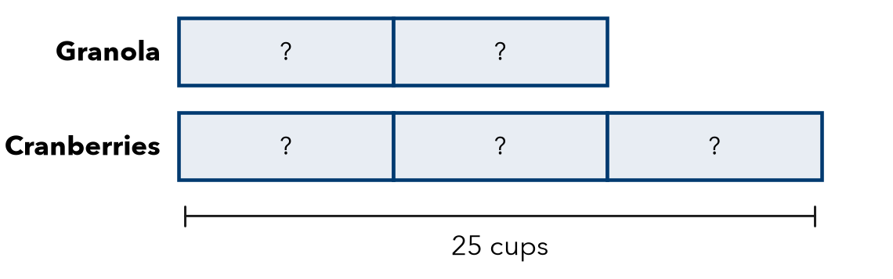
a. Total parts:
b. Value of one box: cups
c. Granola and cranberries:

2. Smoothie. A smoothie uses 3 strawberries for every 2 bananas. A pitcher uses 20 fruits. How many bananas?  Hint Total parts: 3 + 2. Divide 20 by it.  Answer bananas | 3. Mural Paint. Art club mixes 4 cups blue with 1 cup white. They need 35 cups in all. How much blue?  Answer cups
  Show your work.
  Show your work.

4. Fish Tank. A tank has goldfish and guppies in the ratio 5 to 3. There are 32 fish in all. How many goldfish?  Hint One box = 32 ÷ 8, not 32 ÷ 5.  Answer goldfish | 5. Camp Counselors. A camp has 1 counselor for every 6 campers. There are 42 campers. How many counselors are needed?  Hint Each counselor goes with a group of 6.  Answer counselors
  Show your work.
  Show your work.

6. Splitting Money. Two cousins share $45 in the ratio 4 : 5.
Hint Add the terms. Divide $45 by that total.
a. Cousin 1: $ | b. Cousin 2: $

7. Find the Total. A trail mix uses 2 parts raisins to 5 parts nuts. The recipe uses 15 ounces of nuts.
Hint Nuts are 5 boxes. Find one box first.
a. How many ounces is one part? oz
b. How many ounces does the recipe make in all? oz

Show your work.

8. Garden Beds. A gardener plants beans and corn in the ratio 5 : 3 with 96 seeds in all.
a. Bean seeds and corn seeds:
b. How many more bean seeds than corn seeds?
c. Next year she wants equal amounts. What ratio?

Show your work.

FIND THE ERROR explain the mistake, then fix it

9. Sofia’s Work. A mix uses 2 cups sugar and 5 cups flour, 28 cups in all. Sofia divided 28 by 2 and got 14 cups of sugar. Explain her mistake and find the sugar.

TEST PRACTICE choose the best answer

10. A ratio of 2 : 3 shares a total of 30. One box is worth —
A 5 | B 6 | C 10 | D 15

11. A ratio of 1 : 4 shares 25 cookies. The larger share is —
A 4 | B 5 | C 20 | D 24

SELF-CHECK CODE find your answer · copy its letter into that problem’s box · spell a math word
24  M | 12  Q | 8  I | 4  Z | 21  A | 7  R | 28  A | 5  D | 20  G | 252  X

#1b | #2 | #3 | #4 | #5 | #7b | #8b

CHECK YOURSELF | □ I can do this on my own | □ I need a little help | □ I have a question about #

