Name Date Period
Lesson 3-1 · Session 2 · Practice · Form B
Ratios and Tape Diagrams
Learning target — I can use a tape diagram to share a total according to a given ratio. · 6.RP.A.1

REMEMBER  • A tape diagram uses equal boxes. The ratio tells how many boxes each group gets.  • One box = total ÷ total parts. Multiply one box by each term.  • If you know one group, divide it by its boxes to find one box. | WORKED EXAMPLE  Ana and Ben share 28 stickers in the ratio 3 : 4. Find each share.  Step 1 Total parts: 3 + 4 = 7.  Step 2 One box: 28 ÷ 7 = 4.  Step 3 Ana 3 × 4 = 12; Ben 4 × 4 = 16. Check: 12 + 16 = 28.  Answer Ana 12, Ben 16
WORDS tape diagram (diagrama de cinta) · unit (unidad) · total parts (partes totales)
PRACTICE show your work · label units

1. Trail Mix. A recipe uses 3 cups of oats for every 2 cups of raisins. A chef makes a 30-cup batch.
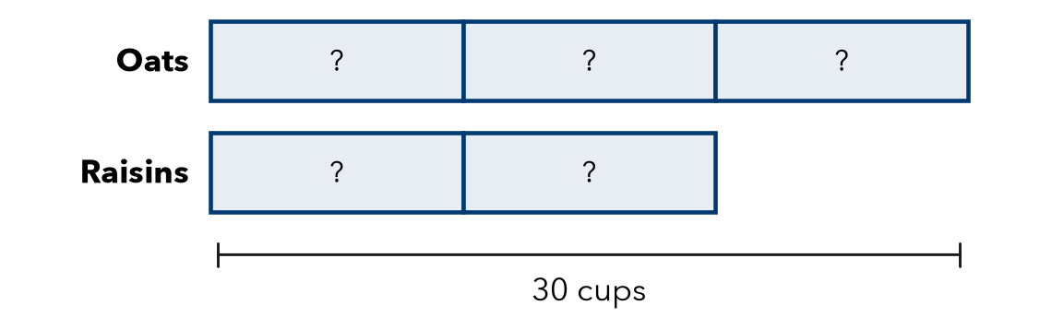
a. Total parts:
b. Value of one box: cups
c. Oats and raisins:

2. Smoothie. A smoothie uses 4 strawberries for every 3 bananas. A pitcher uses 21 fruits. How many bananas?  Hint Total parts: 4 + 3. Divide 21 by it.  Answer bananas | 3. Mural Paint. Art club mixes 4 cups blue with 1 cup white. They need 40 cups in all. How much white?  Answer cups
  Show your work.
  Show your work.

4. Fish Tank. A tank has goldfish and guppies in the ratio 3 to 5. There are 40 fish in all. How many guppies?  Hint One box = 40 ÷ 8, not 40 ÷ 5.  Answer guppies | 5. Camp Counselors. A camp has 1 counselor for every 12 campers. There are 60 campers. How many counselors are needed?  Hint Each counselor goes with a group of 12.  Answer counselors
  Show your work.
  Show your work.

6. Splitting Money. Two cousins share $56 in the ratio 3 : 4.
Hint Add the terms. Divide $56 by that total.
a. Cousin 1: $ | b. Cousin 2: $

7. Find the Total. A snack mix uses 3 parts raisins to 4 parts nuts. The recipe uses 20 ounces of nuts.
Hint Nuts are 4 boxes. Find one box first.
a. How many ounces is one part? oz
b. How many ounces does the recipe make in all? oz

Show your work.

8. Garden Beds. A gardener plants carrots and peas in the ratio 7 : 5 with 96 seeds in all.
a. Carrot seeds and pea seeds:
b. How many more carrot seeds than pea seeds?
c. Next year she wants equal amounts. What ratio?

Show your work.

FIND THE ERROR explain the mistake, then fix it

9. Diego’s Work. A pot of chili uses 3 cups rice and 4 cups beans, 42 cups in all. Diego divided 42 by 3 and got 14 cups of rice. Explain his mistake and find the rice.

TEST PRACTICE choose the best answer

10. A ratio of 3 : 4 shares a total of 28. One box is worth —
A 3 | B 4 | C 7 | D 12

11. A ratio of 1 : 5 shares 30 cookies. The smaller share is —
A 5 | B 6 | C 25 | D 29

SELF-CHECK CODE find your answer · copy its letter into that problem’s box · spell a math word
16  D | 9  I | 35  E | 5  D | 15  X | 720  Q | 8  V | 20  Z | 6  D | 25  I

#1b | #2 | #3 | #4 | #5 | #7b | #8b

CHECK YOURSELF | □ I can do this on my own | □ I need a little help | □ I have a question about #

