Name Date Period
Lesson 3-1 · Homework Packet · Sheet 1 of 2
Understanding Ratios
Maryland Standard 6.RP.A.1 · Learning target — I can describe a relationship between two quantities using ratio language.

REMEMBER  • A ratio compares two quantities: 3 to 5, 3 : 5, or 3/5. Order matters — follow the order of the words.  • Part-to-part compares two groups. Part-to-whole compares one group to the total.  • Simplest form: divide both terms by their GCF. | WORKED EXAMPLE  A shelf has 10 science books and 15 history books. Write the ratio of science books to all the books in simplest form.  Step 1 Total: 10 + 15 = 25 books  Step 2 Science first: 10 : 25  Step 3 Divide both terms by 5: 2 : 5  Answer 2 : 5 — for every 2 science books, there are 5 books in all
PRACTICE show your work · label units
1. A snack bag has 6 pretzels and 9 crackers. Write each ratio in simplest form.
a. pretzels to crackers | b. crackers to pretzels
c. pretzels to all snacks | d. crackers to all snacks

2. Write each ratio in simplest form.
a. 12 : 18 = | b. 20 : 8 = | c. 15 : 35 =

3. A volleyball team has 8 girls and 7 boys. Jada writes the ratio 8 : 15. Is her ratio part-to-part or part-to-whole? What does the 15 count?
□ Part-to-part | □ Part-to-whole
15 counts

4. Class Trip Vote. There are 24 students in a class. 14 students vote for the museum and the rest vote for the aquarium. Write the ratio of museum votes to aquarium votes in simplest form. Then finish the sentence: For every museum votes, there are aquarium votes.

Show your work.
Ratio

5. Find the Error. An animal shelter has 4 cats and 10 dogs. Marcus says the ratio of dogs to cats is 2 : 5. Explain his mistake and write the correct ratio.

CHECK YOURSELF | □ I can do this on my own | □ I need a little help | □ I have a question about #
AT HOME Count two kinds of things at home, like forks and spoons. Say the ratio both ways.
Name Date Period
Lesson 3-1 · Homework Packet · Sheet 2 of 2
Ratios and Tape Diagrams
Maryland Standard 6.RP.A.1 · Learning target — I can use a tape diagram to share a total according to a given ratio.

REMEMBER  • A tape diagram uses equal boxes; the boxes match the ratio.  • One box = total ÷ total parts. Multiply one box by each term. Check that the amounts add to the total. | WORKED EXAMPLE  Leah and Omar share 35 stickers in the ratio 2 : 5. Find each share.  Step 1 Total parts: 2 + 5 = 7  Step 2 One box: 35 ÷ 7 = 5 stickers  Answer Leah: 2 × 5 = 10. Omar: 5 × 5 = 25.
PRACTICE show your work · label units

1. The tape diagram shows the ratio of red beads to blue beads on a bracelet. There are 48 beads in all.  a. What is the value of one box? beads  b. Find the red beads and the blue beads. | 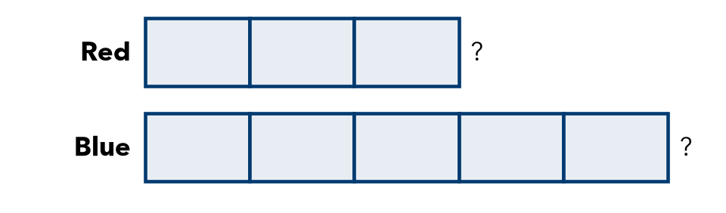

2. Find both amounts.
a. Share 42 in the ratio 3 : 4. | b. Share 66 in the ratio 2 : 9.

3. Work Backward. A fruit cup has grapes and melon pieces in the ratio 3 : 4. It has 12 grapes.
a. What is the value of one box?
b. How many melon pieces?
c. How many pieces of fruit are in the cup in all?

4. Stretch. Maya and Theo share stickers in the ratio 2 : 7. Theo gets 35 more stickers than Maya.
a. What is the value of one box? stickers
b. How many stickers do they have in all? stickers

5. Find the Error. Tyrell shared 45 marbles in the ratio 4 : 5 as 36 and 45. Explain his mistake. Find the correct shares.

TEST PRACTICE choose the best answer
6. Jamal and Rosa share $40 in the ratio 3 : 5. How much money does Rosa get?
A $5 | B $15 | C $24 | D $25

7. A tape diagram shows a ratio of 4 : 3 with a total of 56. What is the value of one box?
A 7 | B 8 | C 14 | D 32

CHECK YOURSELF | □ I can do this on my own | □ I need a little help | □ I have a question about #
AT HOME Show someone at home how to split 30 snacks in the ratio 2 : 3.

