Name Date Period
Lesson 3-4 · Session 1 · Practice · Form B
Graphing Ratios on the Coordinate Plane
Learning target — I can turn a ratio into ordered pairs and plot them on a coordinate plane. · 6.RP.A.3a

REMEMBER  • An ordered pair (x, y) names one point. Go across x first, then up y.  • Each column of a ratio table is one point. Points from equivalent ratios form a straight line through (0, 0).  • To test a point, multiply its x by the rate. Do you get its y? | WORKED EXAMPLE  Each tray holds 8 muffins (x = trays, y = muffins). Write and plot three points.  Step 1 Table: 1 tray = 8, 2 trays = 16, 3 trays = 24.  Step 2 Pairs: (1, 8), (2, 16), (3, 24).  Step 3 Plot each pair from (0, 0): across x, then up y.  Answer The points lie on one straight line through (0, 0)
WORDS coordinate plane (plano de coordenadas) · ordered pair (par ordenado) · origin (origen)
PRACTICE show your work · label units

1. Each bag holds 8 soccer balls (x = bags, y = balls). Write the ordered pair for:
a. 1 bag | b. 3 bags
c. 5 bags | d. 7 bags

2. Hiking Trail. Hikers climb 4 miles every hour (x = hours, y = miles).  a. Complete: (1, 4), (2, ), (3, ), (4, )  b. Plot the points. Draw a line through (0, 0).  c. What point shows 7 hours? | 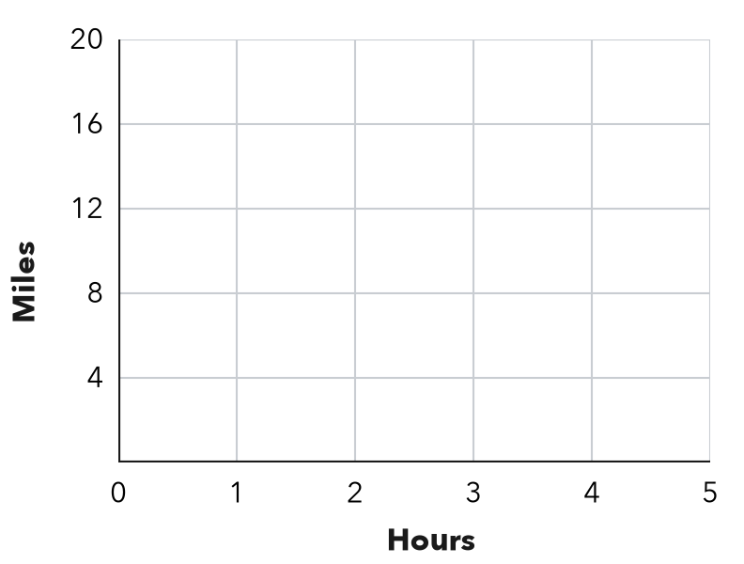

3. File Downloads. A computer downloads 3 GB every 2 minutes (x = minutes, y = GB).  Hint 10 minutes is 5 groups of 2 minutes.  a. Complete: (2, 3), (4, 6), (6, )  b. GB in 10 minutes: GB | 4. Street Trees. A crew plants 9 trees on every block (x = blocks, y = trees).  a. Complete: (1, 9), (2, ), (3, )  b. Point for 5 blocks:
  Show your work.
  Show your work.

5. Allowance Savings. Diego saves $5 each week (x = weeks, y = dollars).  Hint Multiply each number of weeks by 5.  a. Complete: (1, 5), (2, ), (4, ), (6, )  b. Find y for the point (7, y). dollars  c. Plot your points and label the point for 7 weeks. | 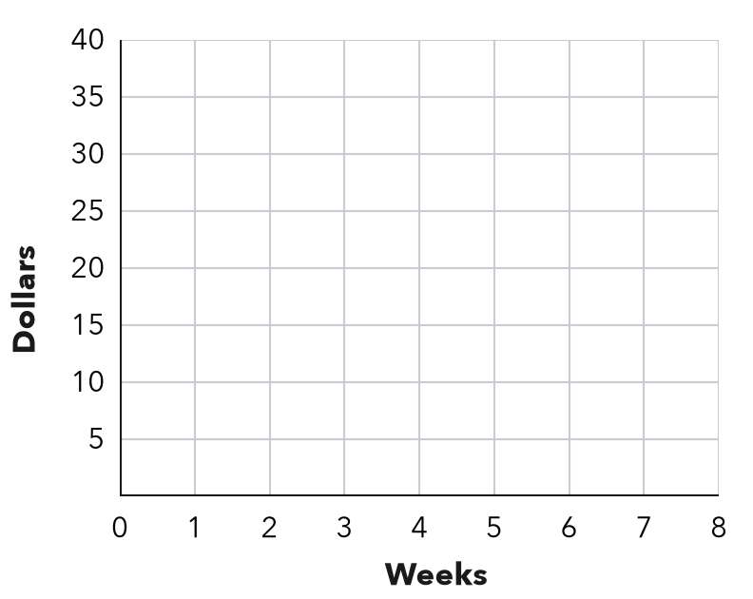

6. Poster Printing. A printer prints 6 posters each minute (x = minutes, y = posters).
Hint The equation is y = (rate) × x.
a. Write the equation: y =
b. What does (0, 0) mean here?

7. Scooter Range. A scooter goes 12 miles on each battery charge (x = charges, y = miles). Which point is on its graph: (3, 38), (4, 48) or (5, 55)?
Hint Multiply each x by 12. Does it match y?

Show your work.
Point

8. Two Stores. Store A sells notebooks at 2 for $5. Store B sells them at 5 for $15. Graph x = notebooks, y = cost.
a. Cost of 10 notebooks at each store:
b. Whose line is steeper? What does steeper mean here?

Show your work.

FIND THE ERROR explain the mistake, then fix it

9. Mateo’s Work. A train travels 60 miles each hour (x = hours, y = miles). Mateo plotted the points (60, 1) and (120, 2). Explain his mistake and write the correct points.

TEST PRACTICE choose the best answer

10. In the ordered pair (7, 21), the number 21 is the —
A x-value | B y-value | C unit rate | D origin

11. The ratio of x to y is 1 : 4. Which ordered pair has x = 5?
A (5, 9) | B (20, 5) | C (5, 20) | D (4, 5)

SELF-CHECK CODE find your answer · copy its letter into that problem’s box · spell a math word
(4, 48)  S | (7, 28)  O | 15  I | (7, 56)  P | (56, 7)  Q | (28, 7)  X | (5, 45)  N | (48, 4)  Z | 35  T

#1d | #2c | #3b | #4b | #5b | #7

CHECK YOURSELF | □ I can do this on my own | □ I need a little help | □ I have a question about #

