Name Date Period
Lesson 3-4 · Session 2 · Practice · Form A
Interpreting Points on Ratio Graphs
Learning target — I can explain what a point on a ratio graph means in the situation it describes. · 6.RP.A.3a

REMEMBER  • A point (x, y) says x of one thing goes with y of another. Read the axis labels.  • The unit rate point is (1, r). If x is not 1, divide: for (3, 15), 15 ÷ 3 = 5, so (1, 5).  • To find x from y, divide y by the unit rate: rate 5, y = 30, so x = 6. | WORKED EXAMPLE  x = pounds of apples, y = cost in dollars. The line passes through (4, 12). Find the cost of 6 pounds.  Step 1 Read it: 4 pounds cost $12.  Step 2 Divide: 12 ÷ 4 = 3, so the unit rate point is (1, 3).  Step 3 Multiply: 6 × 3 = 18, so (6, 18).  Answer $3 per pound; 6 pounds cost $18
WORDS unit rate point (punto de tasa unitaria) · interpret (interpretar) · coordinates (coordenadas)
PRACTICE show your work · label units

1. Find the unit rate point (1, r) for a line through each point.
a. (3, 15) | b. (4, 36)
c. (6, 15) | d. (5, 40)

2. Lucy’s Charms. The graph shows bracelets (x) and charms (y).  a. What does (0, 0) mean?  b. What does (1, 5) mean?  c. Charms for 9 bracelets: charms | 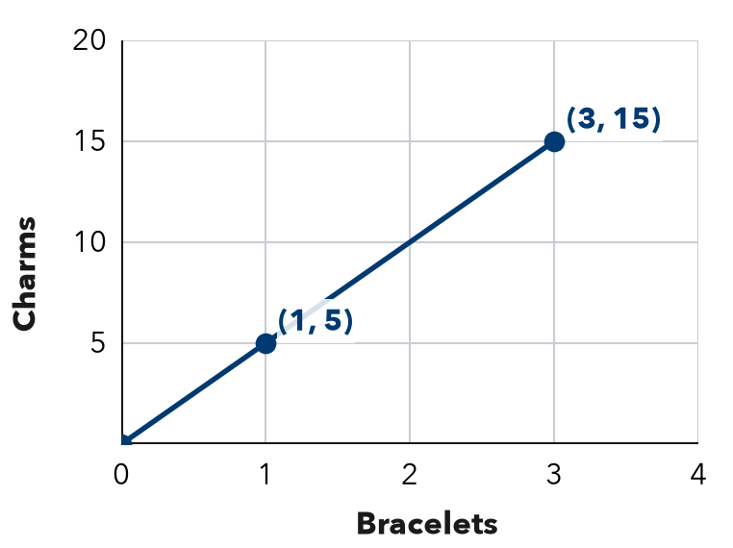

3. Water Pump. A graph of minutes (x) and gallons (y) passes through (1, 8) and (5, 40).
Hint Divide the gallons by the unit rate.
a. Unit rate: gallons per minute
b. What does (5, 40) mean?
c. Minutes to pump 72 gallons: minutes

4. Snow Shoveling. A graph of driveways (x) and dollars (y) passes through (1, 9) and (4, 36). What is the pay for 11 driveways?  Hint Use the unit rate point (1, 9).  Answer dollars | 5. Drone Flight. A graph of seconds (x) and meters (y) passes through (1, 12). What point shows 8 seconds?  Point
  Show your work.
  Show your work.

6. Robot Speed. A graph of seconds (x) and meters (y) passes through (3, 12).  Hint Divide 12 by 3 to get the unit rate.  a. Unit rate point:  b. Distance in 10 seconds: m | 7. Bike Racks. A graph of racks (x) and spaces (y) passes through (4, 28). Find the unit rate point. Is (9, 63) on the line?  Hint Check: does 9 × the unit rate equal 63?  Yes or no
  Show your work.
  Show your work.

8. Two Bike Riders. Both graphs show hours (x) and kilometers (y). Rider 1’s line passes through (3, 36). Rider 2’s passes through (4, 40).
a. Each rider’s unit rate:
b. Whose line is steeper? What does that mean?
c. How far ahead is the faster rider after 6 hours? km

Show your work.

FIND THE ERROR explain the mistake, then fix it

9. Noah’s Work. A graph of items (x) and cost in dollars (y) passes through (1, 8). Noah says, “This means 8 items cost 1 dollar.” Explain his mistake and say what the point really means.

TEST PRACTICE choose the best answer

10. On a ratio graph, the point (1, 9) shows the —
A origin | B x-value only | C unit rate | D total

11. A ratio graph passes through (5, 20). The unit rate is —
A 4 | B 15 | C 25 | D 100

SELF-CHECK CODE find your answer · copy its letter into that problem’s box · spell a math word
(1, 0.4)  Q | 45  R | 40  E | 9  A | 99  P | 12  D | 576  Z | (8, 96)  H | (96, 8)  X | (1, 2.5)  G

#1c | #2c | #3c | #4 | #5 | #6b | #8c

CHECK YOURSELF | □ I can do this on my own | □ I need a little help | □ I have a question about #

