EXIT TICKET · LESSON 3-4 · SESSION 1 Name
Graphing Ratios on the Coordinate Plane

1. Each box holds 9 crayons (x = boxes, y = crayons). Write the ordered pair for:
a. 2 boxes | b. 4 boxes

2. Plot (1, 2), (2, 4) and (3, 6). Do they lie on one line through (0, 0)?  Yes or no | 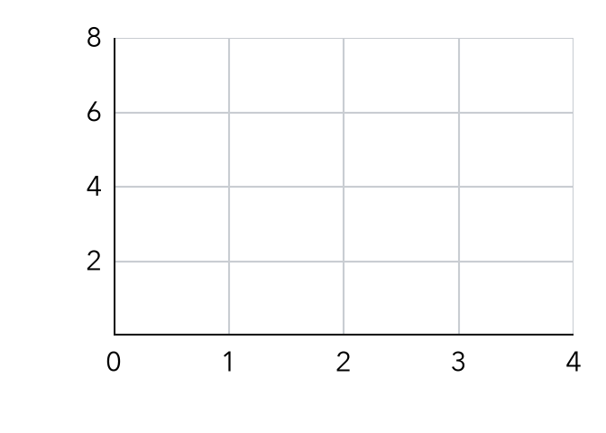

3. A ratio graph always passes through —
A (1, 1) | B (0, 0) | C (10, 10) | D (0, 1)

HOW DID IT GO? □ I got it □ Almost □ I need help
cut here
EXIT TICKET · LESSON 3-4 · SESSION 1 Name
Graphing Ratios on the Coordinate Plane

1. Each box holds 9 crayons (x = boxes, y = crayons). Write the ordered pair for:
a. 2 boxes | b. 4 boxes

2. Plot (1, 2), (2, 4) and (3, 6). Do they lie on one line through (0, 0)?
Yes or no

3. A ratio graph always passes through —
A (1, 1) | B (0, 0) | C (10, 10) | D (0, 1)

HOW DID IT GO? □ I got it □ Almost □ I need help
EXIT TICKET · LESSON 3-4 · SESSION 2 Name
Interpreting Points on Ratio Graphs

1. Find the unit rate point (1, r) for a line through:
a. (4, 28) | b. (6, 9)

2. A graph of tickets (x) and cost in dollars (y) passes through (2, 10). What does (2, 10) mean? What does one ticket cost?

3. On a ratio graph, the origin (0, 0) means —
A one of each quantity | B none of either quantity
C the unit rate | D the total amount

HOW DID IT GO? □ I got it □ Almost □ I need help
cut here
EXIT TICKET · LESSON 3-4 · SESSION 2 Name
Interpreting Points on Ratio Graphs

1. Find the unit rate point (1, r) for a line through:
a. (4, 28) | b. (6, 9)

2. A graph of tickets (x) and cost in dollars (y) passes through (2, 10). What does (2, 10) mean? What does one ticket cost?

3. On a ratio graph, the origin (0, 0) means —
A one of each quantity | B none of either quantity
C the unit rate | D the total amount

HOW DID IT GO? □ I got it □ Almost □ I need help

