Name Date Period
Lesson 3-4 · Session 1 · Guided Notes
Graphing Ratios on the Coordinate Plane
Learning target — I can turn a ratio into ordered pairs and plot them on a coordinate plane. · 6.RP.A.3a
WORDS TO KNOW fill in the missing words
WORD | WHAT IT MEANS | EXAMPLE
coordinate plane  plano de coordenadas | A where you plot points. | x across, y up
ordered pair  par ordenado | (x, y) names one point: first, then up. | (2, 14)
origin  origen | The point where the axes cross. | 0 trays, 0 muffins
KEY IDEA complete each sentence
• Each column of a ratio table becomes one : x from the top row, y from the bottom row.
• Points from equivalent ratios lie on a line through the .
WORKED EXAMPLE fill in the blanks as we solve
Each tray holds 8 muffins. Let x = trays and y = muffins. Graph the ratio.
Step 1 Table: 1 tray = 8 muffins, 2 trays = , 3 trays = .
Step 2 Pairs: (1, 8), (2, 16), (3, 24). Go across x, then up y.
Step 3 Plot each pair, starting from (0, 0).
Answer The points lie on a through (0, 0).
YOU TRY use the example as a model

1. Each pack holds 4 pens (x = packs, y = pens). Write the pairs for 1, 2 and 3 packs. Plot them.  Pairs | 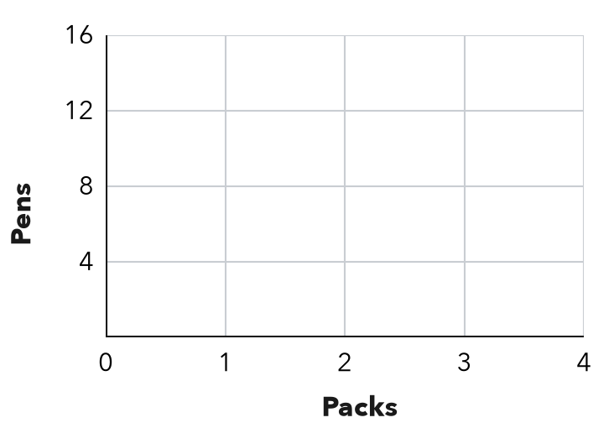

2. The ratio of x to y is 1 : 7. Write the ordered pair for:
a. x = 2 | b. x = 5

SUM IT UP in your own words
On a ratio graph, the point (x, y) means , and the line always passes through .
Name Date Period
Lesson 3-4 · Session 2 · Guided Notes
Interpreting Points on Ratio Graphs
Learning target — I can explain what a point on a ratio graph means in the situation it describes. · 6.RP.A.3a
WORDS TO KNOW fill in the missing words
WORD | WHAT IT MEANS | EXAMPLE
unit rate point  punto de tasa unitaria | The point (1, r). The r is the amount for . | (1, 9): 9 for each 1
origin  origen | (0, 0): zero of one quantity goes with of the other. | 0 hours, 0 miles
interpret  interpretar | To say in what a point means. | (4, 36): 4 driveways earn $36
KEY IDEA complete each sentence
• A point (x, y) means x of the first quantity goes with of the second. Read the axis labels.
• To find the unit rate point (1, r), divide by x.
WORKED EXAMPLE fill in the blanks as we solve
Let x = pounds of apples and y = cost in dollars. The line passes through (4, 12). How much do 6 pounds cost?
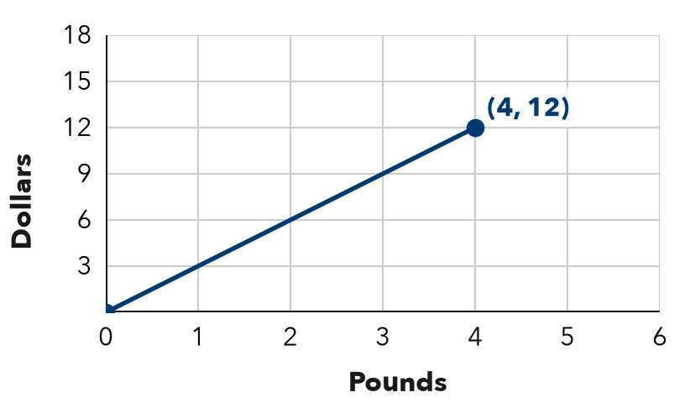
Step 1 Read the point: 4 pounds cost .
Step 2 Divide: 12 ÷ 4 = dollars per pound, so the unit rate point is (1, 3).
Step 3 Multiply: 6 × 3 = 18.
Answer 6 pounds cost ; the point is (6, 18).
YOU TRY use the example as a model

1. Find the unit rate point (1, r) for a line through:
a. (5, 35) | b. (2, 9)

2. A graph of hours (x) and dollars earned (y) passes through (3, 45). What does (3, 45) mean? What is the pay for 1 hour?

SUM IT UP in your own words
The point (1, r) on a ratio graph tells me because .

