Lesson 3-4 · Session 1

Graphing Ratios on the Coordinate Plane
Version 2 / Regular
Name ______________________________ Date ______________ Period ______
Maryland Standard 6.RP.A.3a · Learning target — I can turn a ratio into ordered pairs and plot them on a coordinate plane.
Show a model, calculation, or explanation. Answer every part and label units when needed.
Exercises 1–12 earn 1 point for a correct response and 1 for supporting work. Spiral Review and Test Practice earn 1 point each.
Learn from a model
REMEMBER  • Graph each pair of corresponding quantities as (x, y). Label both axes with quantities and units.  • Points that represent equivalent ratios lie on a straight line through the origin (0,0).  • Watch out — the x-axis label tells you which quantity goes first in every pair.  • Check it — every point you plot should simplify to the same ratio. | WORKED EXAMPLE  Turning a Ratio into Points on a Graph A sticker sheet holds 7 stickers per page. Let x = pages and y = stickers.  Step 1 Make a table. 1 page 7 2 pages 14 3 pages 21  Step 2 Write each row as an ordered pair. (1, 7) (2, 14) (3, 21)  Step 3 Plot the points and add (0, 0) — zero pages hold zero stickers.  Step 4 Draw one straight line through the origin and all the points.  Answer The points (0, 0), (1, 7), (2, 14), (3, 21) lie on one straight line.

Practice
1. A ratio of 2:3 gives the pairs (2,3), (4,6), (6,9). Plot these three points on a coordinate grid.
Answer ______________________________
PLOT AND LABEL YOUR POINTS
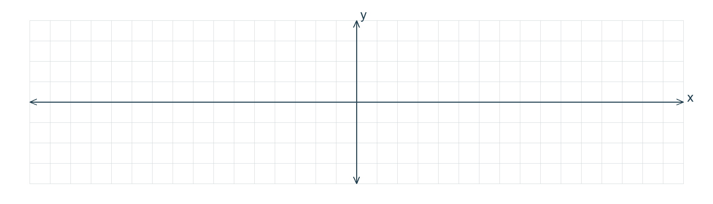

2. Do the points in problem 1 form a straight line through the origin? ______
Answer ______________________________
SHOW YOUR THINKING


3. Using the pattern, what point would represent the ratio pair with x = 8? ______
Answer ______________________________
SHOW YOUR THINKING

4. A city bus seats 6 riders in every row. Let x = rows and y = riders. Complete each ordered pair.
a. 1 row ( 1 , ______ )
b. 3 rows ( 3 , ______ )
c. 5 rows ( 5 , ______ )
d. 9 rows ( 9 , ______ )
e. 0 rows ( 0 , ______ )
Answer ______________________________
SHOW YOUR THINKING


5. Juice Cartons. A crate holds 9 juice cartons. Let x = crates and y = cartons. Make a table for 1, 2, 3, and 4 crates, then write the four ordered pairs.
Answer ______________________________
SHOW YOUR THINKING

6. Sidewalk Chalk. One box of sidewalk chalk holds 12 sticks. Write the ordered pair for 7 boxes, then explain how you would find that point on the graph.
Sentence Frame: "I know this because..."
Answer ______________________________
EXPLAIN WITH MATHEMATICAL EVIDENCE


7. A ratio of 3 : 4 gives the points (3, 4), (6, 8), and (9, 12). Do these three points lie on one straight line through the origin? Write yes or no.
Answer ______________________________
SHOW YOUR THINKING

8. Lin plotted the point (0, 5) on a graph of pages read per day. Explain why that point cannot belong on a ratio graph for this situation.
Sentence Frame: "I know this because..."
Answer ______________________________
EXPLAIN WITH MATHEMATICAL EVIDENCE

9. A box holds 9 crayons. Give the ordered pairs (boxes, crayons) for 1, 2, 3, and 5 boxes.
Answer ______________________________ four pairs
SHOW YOUR THINKING

10. A ratio graph passes through (3, 12). What is the y-value when x = 7?
Answer ______________________________ y-value
SHOW YOUR THINKING

11. Describe It. A ratio graph passes through (2, 6), (4, 12), and (6, 18). Name the unit rate and describe the graph.
Answer ______________________________ unit rate and description
RECORD YOUR RESPONSE

12. Find the Mistake. For 5 sheets of 8 stickers each, Rosa plotted (40, 5). Explain the mistake.
Answer ______________________________ the mistake
EXPLAIN WITH MATHEMATICAL EVIDENCE

Spiral review
13. From Lesson 3-3 Session 2. For 4 : 6, how much goes with 10?
Answer ______________________________
SHOW YOUR THINKING

14. From Lesson 3-2 Session 2. Which is the better buy: 5 lb for $8.00 or 8 lb for $12.00?
Answer ______________________________
SHOW YOUR THINKING

15. From Lesson 2-8 Session 1. Find the mean of 22, 26, 30.
Answer ______________________________
SHOW YOUR THINKING

Test practice
16. A ratio of 1 : 4 gives which pair when x = 6?
□ A. (6, 24) | □ B. (24, 6)
□ C. (6, 4) | □ D. (4, 6)

17. In (7, 21) the y-value is —
□ A. 7 | □ B. 21
□ C. 3 | □ D. 28

18. Equivalent ratios plotted on a graph form a line through —
□ A. (2, 2)
□ B. (1, 1)
□ C. the origin
□ D. no fixed point

Check and revise
CHECK YOUR MATHEMATICS  Label both axes and keep a consistent scale.  Every part answered / Work shown / Units labeled when needed | HOW DID IT GO?  I can do this:  Independently / With a hint / With help  Question to revisit: ______
One correction or question I want to discuss: __________________________________
Check that corresponding quantities stay in order. Label units and explain what your answer means.

