Name Date Period
Lesson 4-1 · Session 1 · Guided Notes
Percent Means Per Hundred
Learning target — I can write a ratio as a percent by finding the equivalent ratio out of 100. · 6.RP.A.3c
WORDS TO KNOW fill in the missing words
WORD | WHAT IT MEANS | EXAMPLE
percent  por ciento | Out of , or per hundred. | 40% = 40 out of 100
decimal grid  cuadrícula decimal | A grid of 100 squares. Each square is . | 62 shaded = 62%
equivalent ratio  razón equivalente | Shows the comparison with different numbers. | 2 : 5 = 40 : 100
KEY IDEA complete each sentence
• Percent means per . The whole is always .
• Multiply the part and the whole by the number to make the whole 100.
WORKED EXAMPLE fill in the blanks as we solve
3 out of every 4 students bring lunch from home. What percent bring lunch?
Step 1 What times 4 makes 100? .
Step 2 Multiply both: 3 × 25 = and 4 × 25 = 100.
Step 3 75 out of 100 = 75%.
Answer of the students bring lunch.
YOU TRY use the example as a model

1. The grid has 100 equal squares.  a. What percent is shaded? %  b. What percent is not shaded? % | 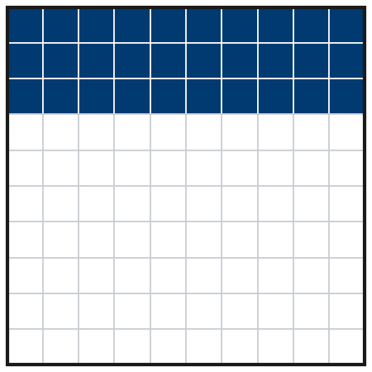

2. Write each ratio as a percent.
a. 9 out of 10 = % | b. 7 out of 20 = %

SUM IT UP in your own words
To write a ratio as a percent, I so that the whole is 100.
Name Date Period
Lesson 4-1 · Session 2 · Guided Notes
Percents Greater Than 100%
Learning target — I can use percents greater than 100% to describe an amount larger than the whole. · 6.RP.A.3c
WORDS TO KNOW fill in the missing words
WORD | WHAT IT MEANS | EXAMPLE
the whole  el todo | The amount that counts as . | last year’s total = 100%
times as much  veces más | Tells how many an amount makes. | 3 times as much = 300%
greater than 100%  mayor que 100% | than the whole. | 150% = 1.5 wholes
KEY IDEA complete each sentence
• 100% is one . More than 100% means more than one whole.
• Always name the first. Then compare the other amount to it.
WORKED EXAMPLE fill in the blanks as we solve
A puppy weighed 5 pounds last month. Now it weighs 8 pounds. What percent of last month’s weight is that?
Step 1 The whole: 5 pounds = .
Step 2 1 pound = 100% ÷ 5 = .
Step 3 8 pounds = 8 × 20% = 160%.
Answer 8 pounds is of last month’s weight.
YOU TRY use the example as a model

1. Write each amount as a percent of the whole.
a. 2 times as much = % | b. 1.6 times as much = %

2. A class read 30 books in May and 45 books in June. May is the whole. June is what percent of May?

Show your work.
Answer %

SUM IT UP in your own words
A percent greater than 100% means because .

