Name Date Period
Lesson 4-2 · Session 1 · Practice · Form B
Fractions, Decimals, Percents
Learning target — I can write the same value as a fraction, a decimal, and a percent. · 6.RP.A.3c

REMEMBER  • A percent means out of 100: 45% = 45/100 = 0.45.  • Fraction to percent: make the denominator 100. If it does not go into 100, simplify first: 15/60 = 1/4 = 25%.  • Decimal to percent: read hundredths. 0.5 = 0.50 = 50%, not 5%. | WORKED EXAMPLE  20 students voted. 7 chose green. Write the green votes as a fraction, a decimal, and a percent.  Step 1 Fraction: 7/20.  Step 2 20 × 5 = 100, so 7/20 = 35/100.  Step 3 35/100 = 0.35 = 35%.  Answer 7/20 = 0.35 = 35%
WORDS percent (por ciento) · equivalent (equivalente) · hundredths (centésimas)
PRACTICE show your work · label units

1. Write each value as a percent.
a. 0.9 = % | b. 11/20 = % | c. 0.04 = %
d. 6/25 = % | e. 0.38 = % | f. 3/4 = %

2. Field Trip Vote. A class of 40 students voted for a field trip. 14 chose a museum, 18 chose a zoo, and the rest chose a nature center. Complete the table.
Hint Find the nature center votes first: 40 − 14 − 18.
Trip | Votes | Fraction (simplest) | Decimal | Percent
Museum | 14
Zoo | 18
Nature center

3. Free Throws. Tasha made 14 of her 20 free throws.  Hint Divide 14 and 20 by 2 first.  a. Fraction in simplest form  b. Percent % | 4. Phone Battery. Luis’s phone shows 0.35 of a full charge.  a. Charge as a percent %  b. Percent used up %

5. Homework Check. Rosa finished 22 of the 40 problems in a review packet. Write the part she finished as a fraction in simplest form, a decimal, and a percent.
Hint Simplify to 11/20, then multiply top and bottom by 5.

Show your work.
Fraction, decimal, %

6. Bracelet Beads. A bracelet has 6 green beads and 14 white beads. What percent of the beads are green? Write that percent as a decimal too.
Hint Find the total number of beads first.

Show your work.
Percent, decimal

7. Step Counter. The grid shows how much of her daily step goal Imani has reached.  a. Percent %  b. Decimal  c. Fraction in simplest form | 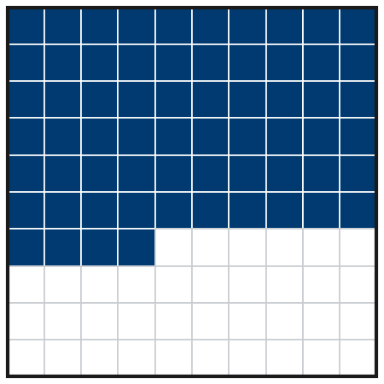

8. Three Surveys. Survey A: 0.62 of students bring lunch. Survey B: 3/5 bring lunch. Survey C: 61% bring lunch.
Hint 3/5 = 60/100.
a. Write all three as percents.
b. Order the surveys from least to greatest.

Show your work.

FIND THE ERROR explain the mistake, then fix it

9. Maya’s Work. Maya wrote the decimal 0.7 as 7%. She said the digit looks the same. Explain her mistake. Then write 0.7 correctly as a percent.

TEST PRACTICE choose the best answer

10. 0.3 written as a percent is —
A 3% | B 0.3% | C 30% | D 300%

11. 3/4 written as a decimal is —
A 0.34 | B 0.75 | C 0.43 | D 3.4

SELF-CHECK CODE find your answer · copy its letter into that problem’s box · spell a math word
0.3  M | 16/25  A | 65%  C | B, C, A  L | 3%  Z | 4%  D | 55%  I | 35%  Q | 5.5%  X | 70%  E

#1c | #3b | #4b | #5 | #6 | #7c | #8b

CHECK YOURSELF | □ I can do this on my own | □ I need a little help | □ I have a question about #

