Name Date Period
Lesson 4-2 · Homework Packet · Level 1 · Sheet 1 of 2
Fractions, Decimals, Percents
Maryland Standard 6.RP.A.3c · Learning target — I can write the same value as a fraction, a decimal, and a percent.

REMEMBER  • A percent is a fraction out of 100: 45% = 45/100 = 0.45.  • Fraction to percent: make the denominator 100.  • Decimal to percent: read hundredths. 0.07 = 7%, 0.4 = 40%. | WORKED EXAMPLE  Write 3/20 as a decimal and as a percent.  Step 1 20 × 5 = 100, so 3/20 = 15/100.  Step 2 15 hundredths = 0.15.  Step 3 15/100 = 15%.  Answer 3/20 = 0.15 = 15%

WORD BANK  percent — out of 100  decimal — a number with a decimal point, like 0.35 | simplest form — top and bottom cannot be divided by the same number  hundredths — parts out of 100
PRACTICE show your work · label units

1. Write the shaded part of the grid three ways.  Step 1 Count the shaded squares out of 100.  Step 2 Write that count over 100, then simplify.  Step 3 Read the same hundredths as a decimal and a percent.  a. Fraction (simplest form)  b. Decimal  c. Percent % | 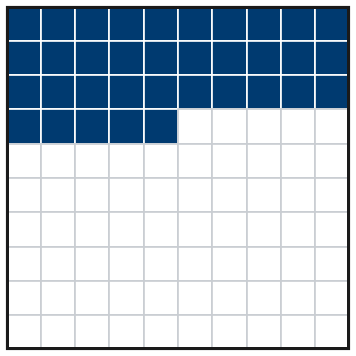

2. Complete the table. Write fractions in simplest form.
Step 1 Fraction to percent: make the bottom 100.
Step 2 Percent to fraction: write it over 100, then simplify.
Fraction | Decimal | Percent
1/4
 | 0.7
 |  | 8%
 |  | 65%
3/5

3. Soccer Practice. Amara scored on 11 of her 25 shots. Write 11 out of 25 as a fraction, a decimal, and a percent.
Step 1 First write the fraction 11/25.
Step 2 Then multiply the top and bottom by 4 to get a bottom of 100.

Show your work.
Fraction, decimal, percent

4. Find the Error. Destiny wrote 3/4 = 0.34 = 34%. Explain her mistake. Write 3/4 correctly.
Frame Destiny’s mistake is . 3/4 = /100, so 3/4 = = %.

CHECK YOURSELF | □ I can do this on my own | □ I need a little help | □ I have a question about #
AT HOME Find a fraction, a decimal, or a percent at home (a recipe, a price tag, a battery icon). Write it the other two ways.
Name Date Period
Lesson 4-2 · Homework Packet · Level 1 · Sheet 2 of 2
Compare and Order
Maryland Standard 6.RP.A.3c · Learning target — I can compare and order values written as fractions, decimals, and percents.

REMEMBER  • Write every value in the same form (all percents).  • Hundredths are the bridge: 0.4 = 0.40 = 40%.  • Benchmarks: 1/4 = 25%, 1/2 = 50%, 3/4 = 75%. | WORKED EXAMPLE  Order from least to greatest: 0.3, 7/20, 32%.  Step 1 0.3 = 0.30 = 30%  Step 2 7/20 = 35/100 = 35%  Step 3 Compare: 30% < 32% < 35%  Answer 0.3, 32%, 7/20

WORD BANK  compare — decide which is greater or less  order — put in a line from least to greatest | same form — all percents, or all decimals  greater than (>) — bigger
PRACTICE show your work · label units

1. Write <, >, or = in each blank.
Step 1 Write both values as percents.
Step 2 Then compare the two percents.
a. 0.6 58% | b. 3/4 0.8 | c. 0.09 1/10

2. Order each set from least to greatest.
Step 1 Change every value to a percent.
Step 2 Order the percents.
Step 3 Write the original numbers in that order.
a. 0.72, 7/10, 75% | b. 1/4, 0.2, 22% | c. 1.3, 125%, 6/5

3. Field Trip Vote. Room A: 0.55 of the students chose the aquarium. Room B: 3/5 chose it. Room C: 52% chose it. Order the rooms from least to greatest share.

Show your work.
Order

4. Stretch. Write one value that is between 3/5 and 0.7. Write it as a fraction, a decimal, and a percent.
Fraction, decimal, percent

5. Find the Error. Nico says 3/8 is greater than 0.4 because 8 is greater than 4. Explain his mistake and compare the values correctly.
Frame Nico is wrong because . 3/8 = % and 0.4 = %, so is greater.

TEST PRACTICE choose the best answer

6. Which list is ordered from least to greatest?
Step 1 Write each value as a percent.
Step 2 Find the list that goes from small to big.
A 2/5, 0.35, 38% | B 0.35, 2/5, 38% | C 0.35, 38%, 2/5 | D 38%, 0.35, 2/5

7. Which value is the greatest?
A 0.62 | B 3/5 | C 64% | D 0.6

CHECK YOURSELF | □ I can do this on my own | □ I need a little help | □ I have a question about #
AT HOME Ask someone at home which is more: 3/4 of a pizza or 70% of the same pizza. Show them how you know.

