Name Date Period
Lesson 4-3 · Session 1 · Practice · Form A
Estimate with Benchmarks
Learning target — I can estimate a percent by comparing an amount to benchmark percents. · 6.RP.A.3c

REMEMBER  • A benchmark is an easy percent: 10%, 25%, 50%, 75%, 100%.  • First name the whole (100%). Then find benchmark amounts: half for 50%, ÷ 4 for 25%, ÷ 10 for 10%.  • Choose the benchmark amount closest to the part. For the percent left, subtract from 100%. | WORKED EXAMPLE  A game download is 80 MB. 41 MB are done. About what percent is done?  Step 1 Whole: 80 MB is 100%.  Step 2 50% of 80 is 40 MB.  Step 3 41 MB is just over 40 MB.  Answer about 50%
WORDS estimate (estimar) · benchmark percent (porcentaje de referencia) · the whole (el todo)
PRACTICE show your work · label units

1. About what percent? Name the closest benchmark: 10%, 25%, 50%, 75%, or 100%.
a. 41 out of 80 ≈ % | b. 31 out of 120 ≈ % | c. 19 out of 40 ≈ %
d. 47 out of 64 ≈ % | e. 13 out of 120 ≈ % | f. 58 out of 60 ≈ %

2. Reading Goal. Ana’s goal is 240 pages this month. She has read 118 pages. Fill in the double number line.
Hint Each jump on the top line is 240 ÷ 4 pages.
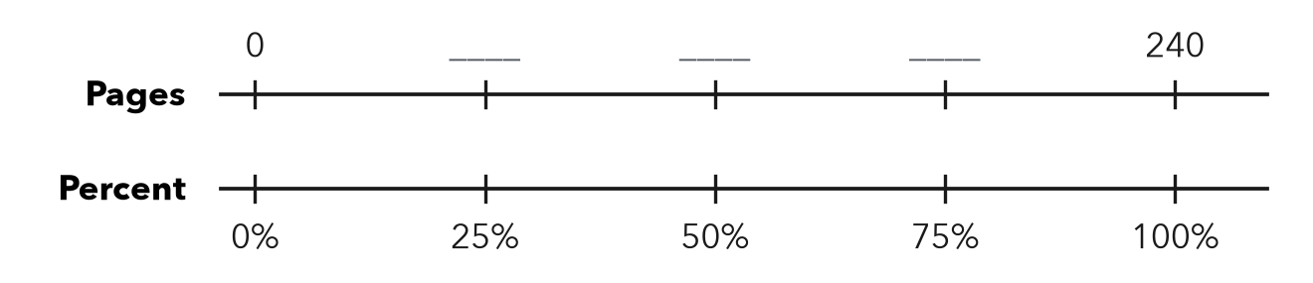
a. Fill in the missing page numbers.
b. About what percent of her goal has she read? %

3. Class Fundraiser. A class wants to raise $400. So far it has raised $310.  Hint Find 75% of $400 and compare.  a. 10% of the goal  b. About what percent? % | 4. Gym Water Jug. A water jug holds 32 cups. It has 17 cups left.  a. Half of the jug, in cups  b. About what percent is left? %

5. Trail Progress. A hiking trail is 36 km long. A hiker has walked 27 km.
Hint Find one fourth of 36 km first.
a. About what percent is walked? %
b. What percent is left? %

Show your work.

6. Estimate Check. Kwame says 19 out of 60 is about 50%. Is he right? Use 10% of 60 to find a better estimate.
Hint Find 50% of 60 and 10% of 60.

Show your work.
Better estimate

7. Parking Lot. A parking lot has 80 spaces. 61 are taken. Estimate the percent taken and name the benchmark amount you used.

Show your work.
About

8. Chorus Tickets. A chorus printed 480 tickets for its concert. It has sold 47 of them.
Hint Divide 480 by 10 to find 10%.
a. About what percent are sold? %
b. About what percent are not sold? %

Show your work.

FIND THE ERROR explain the mistake, then fix it

9. Elena’s Work. A drive holds 200 GB. Elena has used 150 GB, and 30 GB of that is music. She says music is about 75% of the drive. Explain her mistake. Then estimate the percent of the drive that is music.

TEST PRACTICE choose the best answer

10. 10% of an amount is the same as —
A one half | B one tenth | C one fourth | D ten times it

11. 31 out of 120 is about —
A 10% | B 25% | C 50% | D 75%

SELF-CHECK CODE find your answer · copy its letter into that problem’s box · spell a math word
$40  E | 10%  S | 75%  A | $4  Z | 16  R | 90%  T | 25%  E | 80%  X | 50%  N | 47%  Q

#2b | #3a | #3b | #4a | #5b | #8a | #8b

CHECK YOURSELF | □ I can do this on my own | □ I need a little help | □ I have a question about #

