Name Date Period
Lesson 4-3 · Homework Packet · Level 1 · Sheet 1 of 2
Estimate with Benchmarks
Maryland Standard 6.RP.A.3c · Learning target — I can estimate a percent by comparing an amount to benchmark percents.

REMEMBER  • Benchmarks: 10%, 25%, 50%, 75%, 100%.  • Find benchmark amounts of the whole. Which one is the part about equal to?  • A double number line lines up amounts with percents. | WORKED EXAMPLE  A water jug holds 40 cups. There are 29 cups left. About what percent of the jug is left?  Step 1 Benchmarks of 40: 50% = 20 and 75% = 30.  Step 2 29 is very close to 30.  Step 3 So 29 out of 40 is about 75%.  Answer about 75%

WORD BANK  benchmark — an easy percent: 10%, 25%, 50%, 75%  the whole — the full amount; it is 100% | about — close to, not exact  estimate — a close answer
PRACTICE show your work · label units

1. Reading Goal. Jada’s goal is to read 160 pages. She has read 42 pages. Fill in the double number line. Then estimate the percent of her goal she has read.
Step 1 Find 160 ÷ 4. That is one jump on the top line.
Step 2 Fill in each jump on the top line.
Step 3 Find the mark closest to 42.
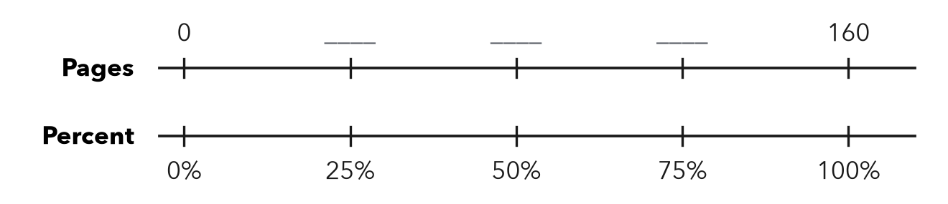
About %

2. About what percent? Name the closest benchmark: 10%, 25%, 50%, 75%, or 100%.
a. 7 out of 60 ≈ % | b. 38 out of 50 ≈ % | c. 23 out of 90 ≈ %
d. 19 out of 40 ≈ % | e. 49 out of 50 ≈ % | f. 11 out of 45 ≈ %
g. 16 out of 150 ≈ % | h. 61 out of 80 ≈ %

3. Class Fundraiser. A class wants $500. They have raised $96 so far. Use 10% of $500 to estimate the percent they have raised.
Step 1 Find 10%: $500 ÷ 10.
Step 2 Double it to get 20%. Is $96 close?
a. 10% of $500 =
b. About what percent have they raised? %

4. Bus Seats. A bus has 48 seats. 35 seats are filled. About what percent of the seats are filled? Name the benchmark you used.
Step 1 Find 50% and 75% of 48.
Step 2 Which amount is 35 closest to?
About %

5. Compare. Which is closer to 50%: 26 out of 50, or 26 out of 60? Explain how you know.
Frame out of is closer to 50% because half of 50 is and half of 60 is .

CHECK YOURSELF | □ I can do this on my own | □ I need a little help | □ I have a question about #
AT HOME Look at a battery icon or a gas gauge. Estimate the percent it shows and explain your benchmark to someone at home.
Name Date Period
Lesson 4-3 · Homework Packet · Level 1 · Sheet 2 of 2
Estimate a Percent of a Number
Maryland Standard 6.RP.A.3c · Learning target — I can estimate a percent of a number using friendly percents and rounded amounts.

REMEMBER  • Round to friendly numbers first.  • 10%: divide by 10. 5% = half of 10%.  • 25% = 1/4, 50% = 1/2, 75% = 3/4. | WORKED EXAMPLE  Estimate 24% of 83.  Step 1 Round: 25% of 80.  Step 2 25% = 1/4, and 80 ÷ 4 = 20.  Answer about 20

WORD BANK  estimate — a close answer, not exact  round — change to a friendly number | 10% — the whole ÷ 10  friendly number — easy to use, like 40 or 200
PRACTICE show your work · label units

1. Estimate. Round to friendly numbers first.
Step 1 Round the percent and the number.
Step 2 Find 10%, then build the percent you need.
a. 11% of 59 ≈ | b. 74% of 41 ≈ | c. 26% of 203 ≈

2. Sneaker Sale. Sneakers cost $198 and are 30% off. Round to $200. Each part of the tape is 10% of $200.
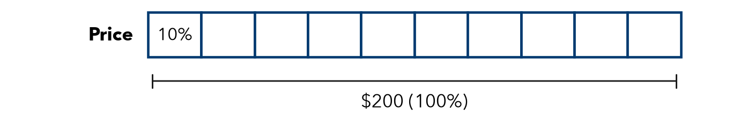
a. About how many dollars is one part (10%)?
b. About how much is the discount (30%)?

3. School Lunch. 412 students. About 48% buy lunch. About how many students buy lunch?
Step 1 Round: 48% is about 50%. 412 is about 400.
Step 2 50% is half. Find half of 400.
About students

4. Apple Orchard. A farm picked 798 apples. About 24% of them were too small to sell. About how many apples were too small?
Step 1 Round: 24% is about 25%. 798 is about 800.
Step 2 25% is one fourth. Divide by 4.
About apples

5. Find the Error. Mia estimated 19% of 512 by writing 20 × 500 = 10,000. Explain her mistake. Give a good estimate.
Frame Mia’s mistake is . 20% means , so a good estimate is .

TEST PRACTICE choose the best answer

6. Which is the best estimate of 26% of 79?
A 2 | B 20 | C 26 | D 40

7. A coat costs $119. It is 40% off. Which is the best estimate of the discount?
Step 1 Round $119 to $120.
Step 2 Find 10% of $120, then multiply by 4.
A $4.80 | B $40 | C $48 | D $72

CHECK YOURSELF | □ I can do this on my own | □ I need a little help | □ I have a question about #
AT HOME Find a sale sign. Estimate the discount out loud with someone at home.

