Name Date Period
Lesson 4-3 · Session 1 · Prerequisite Practice B · Skill 1 of 2
Name the Part and the Whole
Builds on Lesson 4-1 Session 1 · 6.RP.A.3c
TODAY’S LESSON | You will estimate what percent 61 taken spaces are out of 80.
YOU NEED TO | Tell which number is the part and which is the whole. You will use it in Practice Form A, problems 6 and 7.
STEPS TO FOLLOW use these same steps on every problem
1 | Find the whole: the total, the goal, or the full amount.
2 | Find the part: the amount done, used, or chosen.
3 | Write part/whole. The whole always goes on the bottom.
WATCH ME the steps in action
A jar holds 50 marbles. 20 of them are red.
Step 1 The whole is 50 marbles, the full jar.
Step 2 The part is 20 red marbles.
Step 3 Part/whole = 20/50.
Answer 20/50
TRY IT WITH HELP fill in each step
1. Mia’s goal is 30 laps. She has swum 12 laps.
Step 1 Whole: laps
Step 2 Part: laps
Step 3 Part/whole =

2. 18 of the 24 students brought lunch.
Step 1 Whole: students
Step 2 Part: students
Step 3 Part/whole =

YOUR TURN use the steps on your own

3. Write part/whole for each.
a. 7 of 10 cups are full. | b. Ty read 15 of 40 pages.
c. We have 63 of 100 cans. | d. 9 of 12 eggs are brown.

Lesson 4-3 · Session 1 · Prerequisite Practice B · Skill 2 of 2
Read a Double Number Line
Builds on Lesson 3-3 Session 1 · 6.RP.A.3a
TODAY’S LESSON | You will fill in a double number line from 0 to 240 pages.
YOU NEED TO | Find the matching number straight across a double number line. You will use it in Practice Form A, problem 2.
STEPS TO FOLLOW use these same steps on every problem
1 | Find the jump on each line: the space between ticks.
2 | Count by the jump from 0 to fill each blank.
3 | Read straight across to find the matching number.
WATCH ME the steps in action
Fill in the pages.  Step 1 Top jumps by 25%. Bottom jumps by 160 ÷ 4 = 40.  Step 2 Count: 40, 80, 120.  Step 3 75% is straight across from 120 pages.  Answer 40, 80, 120 pages | 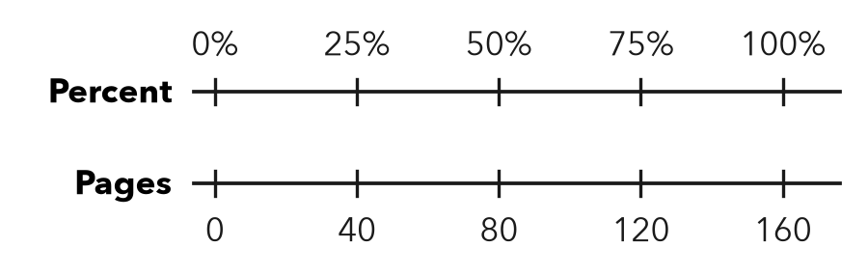

TRY IT WITH HELP fill in each step
4. A line goes from 0% to 100% and from 0 to 80 miles, in 4 equal jumps.
Step 1 Bottom jump: 80 ÷ 4 =
Step 2 Count: , ,
Step 3 50% matches miles.

5. A double number line goes from 0% to 100% and from 0 to 200 miles, in 4 equal jumps.
Step 1 Bottom jump: 200 ÷ 4 =
Step 2 Count: , ,
Step 3 75% matches miles.

YOUR TURN use the steps on your own

6. A double number line goes from 0% to 100% and from 0 to 120 points, in 4 equal jumps. What matches each percent?
a. 25% = | b. 50% = | c. 75% = | d. 100% =

READY CHECK a problem like the one in today’s lesson

7. A double number line goes from 0 to 360 pages. Which pages match 25%, 50%, and 75%?
A 90, 180, 270 | B 25, 50, 75 | C 60, 120, 180 | D 100, 200, 300

CHECK YOURSELF | □ I can do this on my own | □ I need a little help | □ I have a question about #

