Name Date Period
Lesson 5-1 · Session 1 · Practice · Form A
Area of Parallelograms
Learning target — I can find the area of a parallelogram by multiplying the base by the perpendicular height. · 6.G.A.1

REMEMBER  • Area of a parallelogram: A = b × h.  • The height makes a square corner with the base. The slanted side is not the height.  • Missing measure: divide the area by the one you know (90 ÷ 18 = 5). Label square units. | WORKED EXAMPLE  Base 9 in., height 4 in., slanted side 5 in. Find the area.  Step 1 Base = 9 in., height = 4 in.  Step 2 Skip the 5 in. slanted side.  Step 3 A = 9 × 4 = 36  Answer 36 in²
WORDS parallelogram (paralelogramo) · base (base) · height (altura) · perpendicular (perpendicular)
PRACTICE show your work · label units

1. Find the area of each parallelogram with base b and height h.
a. b = 18 cm, h = 7 cm | b. b = 12 in, h = 6 in
c. b = 11 ft, h = 7 ft | d. b = 25 m, h = 4 m

2. School Banner. A banner is a parallelogram.  a. Find the area. ft²  b. Why is the 8 ft side not used? | 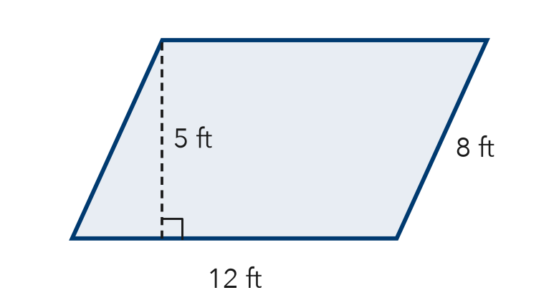

3. Floor Tile. A tile has a base of 15 cm and a height of 10 cm.  a. Area of one tile cm²  b. Area of 3 tiles cm² | 4. Missing Height. A sign has an area of 90 in² and a base of 18 in. Find its height.  Hint What times 18 makes 90?  Answer in.

5. Paper Strip. Find the area of the paper strip.  Hint Use the height with the square corner, not 9 cm.  Answer cm² | 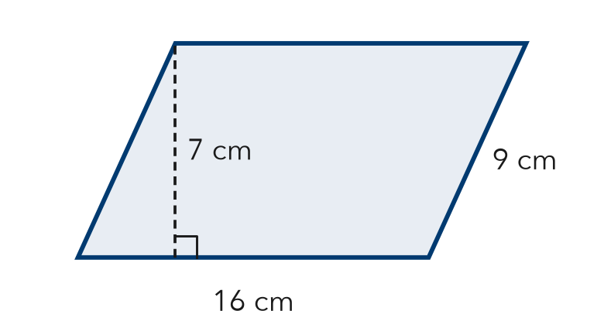
  Show your work.

6. Window Pane. A window pane is a parallelogram. Its area is 96 in² and its base is 8 in. Find the height.
Hint Divide the area by the base.
Answer in.

7. Two Panels. Panel X has base 10 cm and height 13 cm. Panel Y has base 26 cm and height 5 cm. Find each area. Which covers more space?
Hint Find both areas, then compare.

Show your work.
Areas

8. Hallway Mural. A mural is a parallelogram with a base of 15 ft and a height of 8 ft. One can of paint covers 50 ft².
a. Find the area. ft²
b. How many cans are needed? Explain.
c. A second mural has the same height and double the base. Find its area. ft²

Show your work.

FIND THE ERROR explain the mistake, then fix it

9. Marisol’s Work. A parallelogram has base 20 cm, slanted side 17 cm, and height 15 cm. Marisol wrote: “A = 20 × 17 = 340 cm².” Explain her mistake. Then find the area.

TEST PRACTICE choose the best answer

10. A parallelogram has a base of 15 m and a height of 6 m. What is its area?
A 21 m² | B 42 m² | C 90 m² | D 180 m²

11. A parallelogram has an area of 72 cm² and a height of 8 cm. What is its base?
A 9 cm | B 64 cm | C 80 cm | D 576 cm

SELF-CHECK CODE find your answer · copy its letter into that problem’s box · spell a math word
12  R | 144  X | 112  A | 96  Z | 120  S | 150  Q | 60  S | 5  U | 130  E | 768  J

#2a | #3a | #4 | #5 | #6 | #7 | #8a

CHECK YOURSELF | □ I can do this on my own | □ I need a little help | □ I have a question about #

