Name Date Period
Lesson 5-1 · Session 1 · Practice · Form B
Area of Parallelograms
Learning target — I can find the area of a parallelogram by multiplying the base by the perpendicular height. · 6.G.A.1

REMEMBER  • Area of a parallelogram: A = b × h.  • The height makes a square corner with the base. The slanted side is not the height.  • Missing measure: divide the area by the one you know (90 ÷ 18 = 5). Label square units. | WORKED EXAMPLE  Base 9 in., height 4 in., slanted side 5 in. Find the area.  Step 1 Base = 9 in., height = 4 in.  Step 2 Skip the 5 in. slanted side.  Step 3 A = 9 × 4 = 36  Answer 36 in²
WORDS parallelogram (paralelogramo) · base (base) · height (altura) · perpendicular (perpendicular)
PRACTICE show your work · label units

1. Find the area of each parallelogram with base b and height h.
a. b = 16 cm, h = 5 cm | b. b = 13 in, h = 4 in
c. b = 9 ft, h = 8 ft | d. b = 30 m, h = 3 m

2. School Banner. A banner is a parallelogram.  a. Find the area. ft²  b. Why is the 10 ft side not used? | 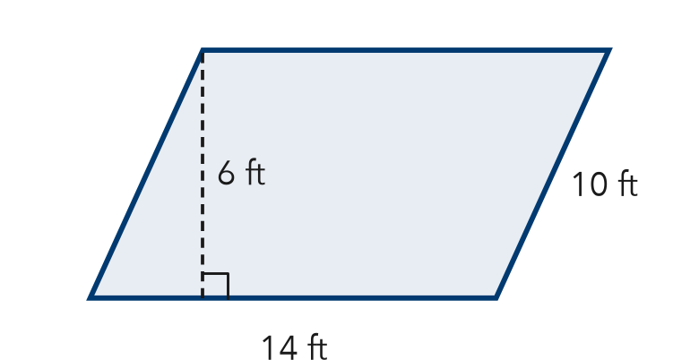

3. Floor Tile. A tile has a base of 12 cm and a height of 9 cm.  a. Area of one tile cm²  b. Area of 3 tiles cm² | 4. Missing Height. A sign has an area of 84 in² and a base of 12 in. Find its height.  Hint What times 12 makes 84?  Answer in.

5. Paper Strip. Find the area of the paper strip.  Hint Use the height with the square corner, not 11 cm.  Answer cm² | 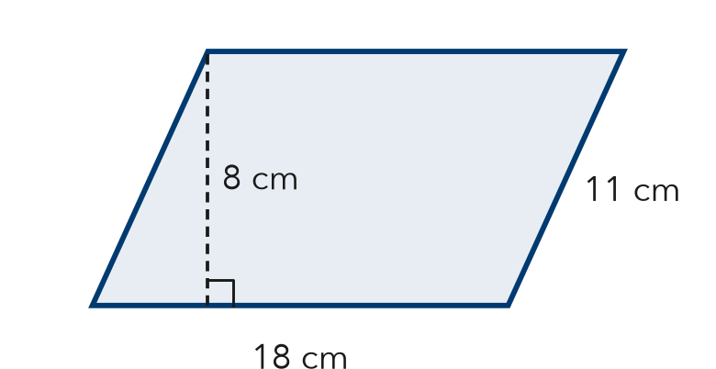
  Show your work.

6. Window Pane. A window pane is a parallelogram. Its area is 117 in² and its base is 9 in. Find the height.
Hint Divide the area by the base.
Answer in.

7. Two Panels. Panel X has base 9 cm and height 14 cm. Panel Y has base 18 cm and height 7 cm. Find each area. Which covers more space?
Hint Find both areas, then compare.

Show your work.
Areas

8. Hallway Mural. A mural is a parallelogram with a base of 20 ft and a height of 6 ft. One can of paint covers 50 ft².
a. Find the area. ft²
b. How many cans are needed? Explain.
c. A second mural has the same height and double the base. Find its area. ft²

Show your work.

FIND THE ERROR explain the mistake, then fix it

9. Deshawn’s Work. A parallelogram has base 14 m, slanted side 10 m, and height 8 m. Deshawn wrote: “A = 14 × 10 = 140 m².” Explain his mistake. Then find the area.

TEST PRACTICE choose the best answer

10. A parallelogram has a base of 25 ft and a height of 4 ft. What is its area?
A 29 ft² | B 50 ft² | C 100 ft² | D 200 ft²

11. A parallelogram has an area of 63 m² and a base of 7 m. What is its height?
A 9 m | B 56 m | C 70 m | D 441 m

SELF-CHECK CODE find your answer · copy its letter into that problem’s box · spell a math word
84  H | 1,053  X | 7  I | 108  E | 13  H | 120  S | 198  Z | 144  G | 140  Q | 126  T

#2a | #3a | #4 | #5 | #6 | #7 | #8a

CHECK YOURSELF | □ I can do this on my own | □ I need a little help | □ I have a question about #

