EXIT TICKET · LESSON 5-1 · SESSION 1 Name
Area of Parallelograms

1. Find each measure of a parallelogram.
a. b = 13 in, h = 4 in; A = in² | b. A = 63 m², b = 7 m; h = m

2. Find the area.  Answer m² | 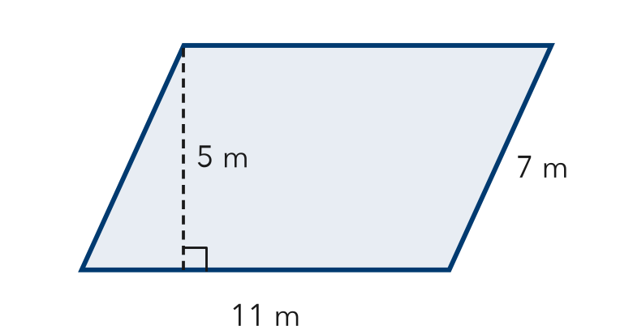

3. Which unit is correct for the area of a shape measured in centimeters?
A cm | B cm² | C cm³ | D square

HOW DID IT GO? □ I got it □ Almost □ I need help
cut here
EXIT TICKET · LESSON 5-1 · SESSION 1 Name
Area of Parallelograms

1. Find each measure of a parallelogram.
a. b = 13 in, h = 4 in; A = in² | b. A = 63 m², b = 7 m; h = m

2. Find the area.
Answer m²

3. Which unit is correct for the area of a shape measured in centimeters?
A cm | B cm² | C cm³ | D square

HOW DID IT GO? □ I got it □ Almost □ I need help
EXIT TICKET · LESSON 5-1 · SESSION 2 Name
Area of Rhombuses

1. Find the area of each rhombus.
a. diagonals 14 ft and 5 ft ft² | b. base 9 m, height 7 m m²

2. Find the area of the rhombus.  Answer cm² | 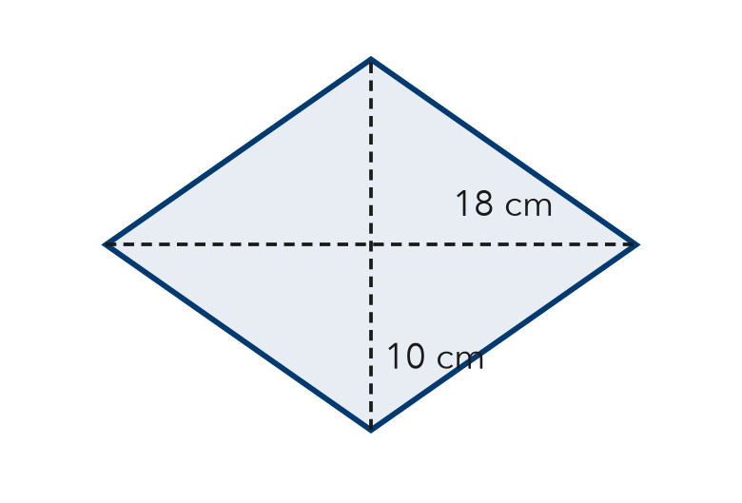

3. A rhombus has an area of 84 cm². One diagonal is 14 cm. The other diagonal is —
A 6 cm | B 12 cm | C 70 cm | D 168 cm

HOW DID IT GO? □ I got it □ Almost □ I need help
cut here
EXIT TICKET · LESSON 5-1 · SESSION 2 Name
Area of Rhombuses

1. Find the area of each rhombus.
a. diagonals 14 ft and 5 ft ft² | b. base 9 m, height 7 m m²

2. Find the area of the rhombus.
Answer cm²

3. A rhombus has an area of 84 cm². One diagonal is 14 cm. The other diagonal is —
A 6 cm | B 12 cm | C 70 cm | D 168 cm

HOW DID IT GO? □ I got it □ Almost □ I need help

