Name Date Period
Lesson 5-1 · Session 1 · Guided Notes
Area of Parallelograms
Learning target — I can find the area of a parallelogram by multiplying the base by the perpendicular height. · 6.G.A.1
WORDS TO KNOW fill in the missing words
WORD | WHAT IT MEANS | EXAMPLE
parallelogram  paralelogramo | A four-sided shape whose opposite sides are . | opposite sides never meet
base  base | The side you the height from. | b in A = b × h
height  altura | The distance from the base to the opposite side, at a corner. | h in A = b × h
KEY IDEA complete each sentence
• Area of a parallelogram: A = × height.
• The height makes a corner with the base. The slanted side is the height.
• Missing height or base: the area by the measure you know.
WORKED EXAMPLE fill in the blanks as we solve
A parallelogram has a base of 9 in., a height of 4 in., and a slanted side of 5 in. Find its area.
Step 1 base = in., height = in.
Step 2 Skip the 5 in. slanted side.
Step 3 A = 9 × 4 =
Answer The area is in².
YOU TRY use the example as a model

1. Find the area.  Answer cm² | 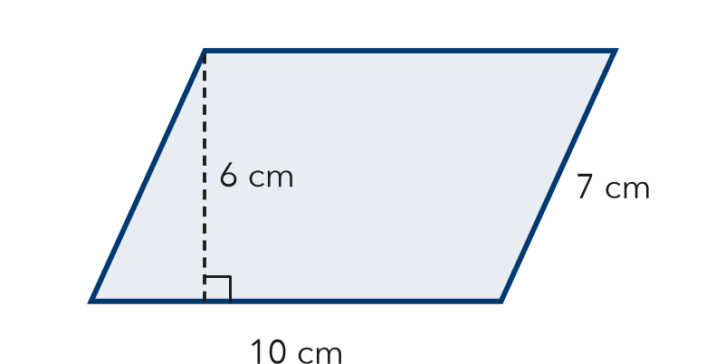
  Show your work.

2. Find the missing measure.
a. A = 42 in², b = 7 in, h = in | b. A = 54 m², h = 6 m, b = m

SUM IT UP in your own words
I do not use the slanted side to find area because .
Name Date Period
Lesson 5-1 · Session 2 · Guided Notes
Area of Rhombuses
Learning target — I can find the area of a rhombus using the base and height or the two diagonals. · 6.G.A.1
WORDS TO KNOW fill in the missing words
WORD | WHAT IT MEANS | EXAMPLE
rhombus  rombo | A parallelogram with four sides of the length. | all 4 sides equal
diagonal  diagonal | A segment from one corner to the corner. | a rhombus has 2 diagonals
congruent  congruente | Exactly the same and shape. | 4 congruent sides
KEY IDEA complete each sentence
• A rhombus is a , so A = base × height works.
• With the two diagonals, A = d1 × d2 ÷ .
• Missing diagonal: the area, then divide by the diagonal you know.
WORKED EXAMPLE fill in the blanks as we solve
A rhombus has diagonals of 10 cm and 8 cm. Find its area.
Step 1 Two diagonals are given, so use A = d1 × d2 ÷ 2.
Step 2 10 × 8 =
Step 3 80 ÷ 2 =
Answer The area is cm².
YOU TRY use the example as a model

1. Find the area of each rhombus.
a. diagonals 6 m and 12 m m² | b. base 7 cm, height 5 cm cm²

2. The rhombus has an area of 72 in². Find the missing diagonal d.  Answer in. | 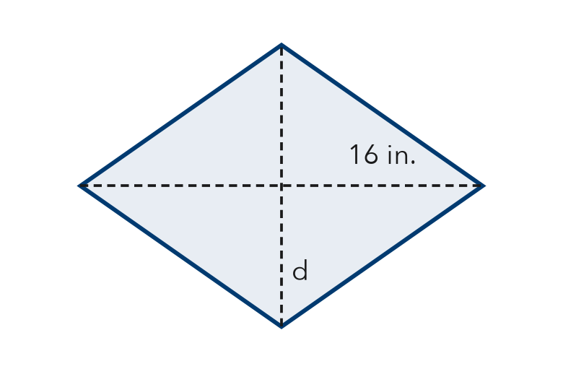
  Show your work.

SUM IT UP in your own words
When I use the diagonals, I divide by 2 because .

