Name Date Period
Lesson 5-1 · Session 1 · Prerequisite Practice B · Skill 1 of 2
Identify Base and Height
Builds on Grade 4 · 4.G.A.1
TODAY’S LESSON | You will pick the 5 ft height, not the 8 ft slanted side, to find a banner’s area.
YOU NEED TO | Tell the base and the height of a parallelogram. You will use it in Practice Form A, problems 2 and 5.
STEPS TO FOLLOW use these same steps on every problem
1 | Find the base: the side the shape sits on.
2 | Find the height: the dashed line with a square corner.
3 | A slanted side is never the height.
WATCH ME the steps in action
Name the base and the height.  Step 1 The base is 10 cm. The shape sits on it.  Step 2 The height is 6 cm. The dashed line has a square corner.  Step 3 The 7 cm slanted side is not used.  Answer Base 10 cm, height 6 cm | 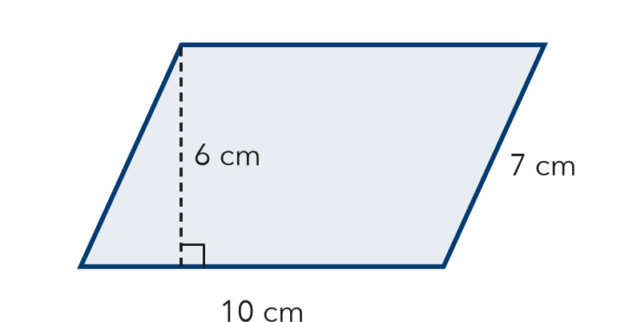

TRY IT WITH HELP fill in each step
1. A parallelogram has base 12 cm, height 5 cm, and slanted side 8 cm.
Step 1 The base is cm.
Step 2 The height is cm.
Step 3 The slanted side, cm, is not used.

2. A parallelogram has base 9 in., height 4 in., and slanted side 5 in.
Step 1 The base is in.
Step 2 The height is in.
Step 3 The slanted side, in., is not used.

YOUR TURN use the steps on your own

3. Which side is the height? Write the number.
a. base 8, height 3, slant 4 | b. base 14, height 6, slant 7
c. base 5, height 9, slant 10 | d. base 20, height 7, slant 8

Lesson 5-1 · Session 1 · Prerequisite Practice B · Skill 2 of 2
Find a Missing Side Length
Builds on Grade 4 · 4.MD.A.3
TODAY’S LESSON | You will find the height of a sign with area 90 in² and base 18 in.
YOU NEED TO | Find a missing side from the area and one side, like 90 = 18 × h. You will use it in Practice Form A, problems 4 and 6.
STEPS TO FOLLOW use these same steps on every problem
1 | Write the area as a product: area = side × ?
2 | Divide the area by the side you know.
3 | Check by multiplying.
WATCH ME the steps in action
A rectangle has area 72 cm² and one side 9 cm. Find the other side.
Step 1 72 = 9 × ?
Step 2 72 ÷ 9 = 8.
Step 3 Check: 9 × 8 = 72.
Answer 8 cm
TRY IT WITH HELP fill in each step
4. A rectangle has area 48 in² and one side 6 in. Find the other side.
Step 1 Write: 48 = 6 × ? The known side is in.
Step 2 Divide: 48 ÷ 6 =
Step 3 Check: 6 × = 48

5. A rectangle has area 84 ft² and one side 7 ft. Find the other side.
Step 1 Write: 84 = 7 × ? The known side is ft.
Step 2 Divide: 84 ÷ 7 =
Step 3 Check: 7 × = 84

YOUR TURN use the steps on your own

6. Find the missing side.
a. Area 56, side 7: other side = | b. Area 90, side 15: other side = | c. Area 108, side 9: other side =
d. Area 120, side 8: other side = | e. Area 72, side 12: other side = | f. Area 65, side 5: other side =

READY CHECK a problem like the one in today’s lesson

7. A window pane has area 96 in² and base 8 in. Which equation finds the height h?
A 96 ÷ 8 = h | B 96 × 8 = h | C 96 + 8 = h | D 8 ÷ 96 = h

CHECK YOURSELF | □ I can do this on my own | □ I need a little help | □ I have a question about #

