Name Date Period
Lesson 5-1 · Session 2 · Prerequisite Practice B · Skill 1 of 2
Area of Parallelograms
Builds on Lesson 5-1 Session 1 · 6.G.A.1
TODAY’S LESSON | You will find the area of a rhombus tile with sides 10 cm and height 9 cm.
YOU NEED TO | Find the area of a parallelogram: base × height. You will use it in Practice Form A, problems 2 and 4.
STEPS TO FOLLOW use these same steps on every problem
1 | Find the base and the height.
2 | Multiply: A = b × h.
3 | Write square units.
WATCH ME the steps in action
Find the area of a parallelogram with base 14 cm and height 6 cm.  Step 1 Base 14 cm. Height 6 cm.  Step 2 14 × 6 = 84.  Step 3 The area is 84 cm².  Answer 84 cm² | 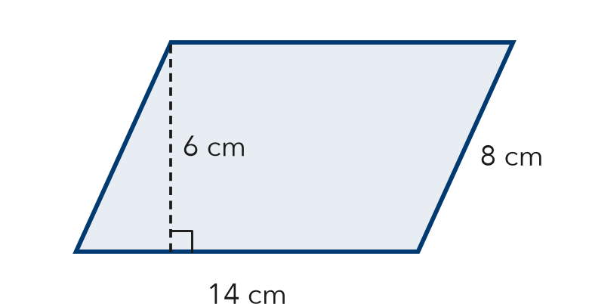

TRY IT WITH HELP fill in each step
1. Base 12 ft, height 5 ft. Find the area.
Step 1 Base ft. Height ft.
Step 2 12 × 5 =
Step 3 The area is ft².

2. Base 18 in., height 7 in. Find the area.
Step 1 Base in. Height in.
Step 2 18 × 7 =
Step 3 The area is in².

YOUR TURN use the steps on your own

3. Find each area.
a. b = 10, h = 9: | b. b = 11, h = 7:
c. b = 15, h = 6: | d. b = 20, h = 4:

Lesson 5-1 · Session 2 · Prerequisite Practice B · Skill 2 of 2
Area of Rectangles
Builds on Grade 4 · 4.MD.A.3
TODAY’S LESSON | You will see that a rhombus fills half of the rectangle drawn around it.
YOU NEED TO | Find the area of a rectangle, like 20 × 14. You will use it in Practice Form A, problems 3 and 6.
STEPS TO FOLLOW use these same steps on every problem
1 | Find the length and the width.
2 | Multiply length × width.
3 | Write square units.
WATCH ME the steps in action
A rectangle is 20 ft by 13 ft. Find its area.
Step 1 Length 20 ft. Width 13 ft.
Step 2 20 × 13 = 260.
Step 3 The area is 260 ft².
Answer 260 ft²
TRY IT WITH HELP fill in each step
4. A rectangle is 18 ft by 24 ft. Find its area.
Step 1 Length ft. Width ft.
Step 2 18 × 24 =
Step 3 The area is ft².

5. A rectangle is 20 in. by 14 in. Find its area.
Step 1 Length in. Width in.
Step 2 20 × 14 =
Step 3 The area is in².

YOUR TURN use the steps on your own

6. Find each area.
a. 10 by 14: | b. 16 by 30:
c. 12 by 25: | d. 15 by 18:

READY CHECK a problem like the one in today’s lesson

7. The diagonals of a kite are 20 in. and 14 in. Which rectangle is drawn around it?
A 20 in. by 14 in. | B 20 in. by 20 in. | C 34 in. by 14 in. | D 10 in. by 7 in.

CHECK YOURSELF | □ I can do this on my own | □ I need a little help | □ I have a question about #

