Name Date Period
Lesson 5-2 · Session 2 · Practice · Form B
Missing Measures in Triangles
Learning target — I can find a missing base or height of a triangle when I know its area. · 6.G.A.1

REMEMBER  • Work backward from A = ½ × b × h.  • Double the area to undo the half, then divide by the measure you know.  • Check: ½ × b × h gives the area. A base or height is in cm, not cm². | WORKED EXAMPLE  Area 40 cm², base 10 cm. Find the height.  Step 1 40 = ½ × 10 × h  Step 2 2 × 40 = 80  Step 3 80 ÷ 10 = 8  Answer 8 cm
WORDS area (área) · formula (fórmula) · inverse operation (operación inversa)
PRACTICE show your work · label units

1. Find the missing measure of each triangle.
a. A = 24 cm², h = 6 cm; b = | b. A = 40 in², b = 10 in; h =
c. A = 35 m², h = 7 m; b = | d. A = 27 ft², b = 9 ft; h =

2. Park Lot. A triangular lot covers 132 yd². Its height is 12 yd.  Hint Double the area first.  a. Fill in the formula: 132 = ½ × ×  b. Find the base b. yd | 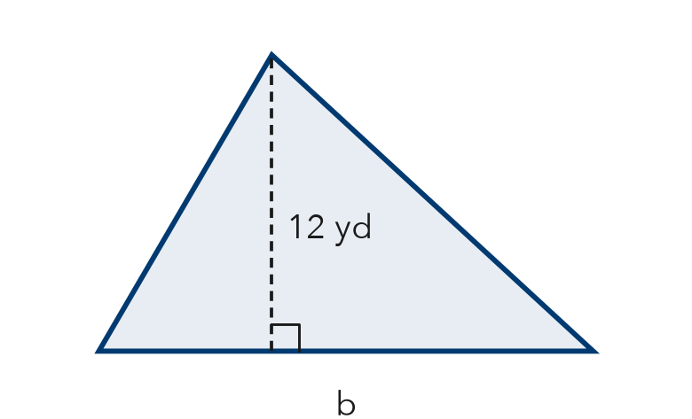

3. Quilt Piece. A triangular quilt piece has an area of 42 in² and a base of 7 in. Find the height.  Answer in. | 4. Roof Gable. A triangular gable covers 135 ft². Its height is 15 ft. Find the base.  Answer ft

5. Awning Panel. The awning panel covers 70 ft². Find the height h.  Hint Undo the ½ by doubling 70.  Answer ft | 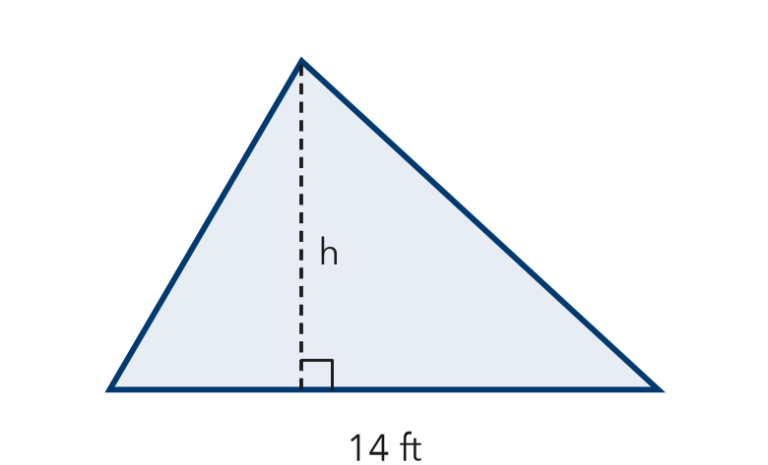

6. Banner Claim. A triangular banner has an area of 90 ft² and a height of 9 ft. Deshawn says the base must be 10 ft. Is he right? Use the formula.  Hint Put Deshawn’s base into ½ × b × h and check.  Base | 7. Sandbox Wedge. A triangular wedge of a sandbox covers 52 m². Its height is 8 m. Find the base.  Answer m
  Show your work.
  Show your work.

8. Two Signs. Sign A is a triangle with area 150 ft² and base 20 ft. Sign B is a triangle with area 150 ft² and height 10 ft.
a. Find the height of Sign A. ft
b. Find the base of Sign B. ft
c. Both signs have the same area. How can their shapes be different?

Show your work.

FIND THE ERROR explain the mistake, then fix it

9. Ravi’s Work. A triangle has an area of 90 cm² and a base of 15 cm. Ravi wrote: “90 ÷ 15 = 6, so the height is 6 cm.” Explain his mistake. Then find the height.

TEST PRACTICE choose the best answer

10. A triangle has area 48 m² and base 12 m. Its height is —
A 4 m | B 8 m | C 36 m | D 576 m

11. A triangle has area 100 in² and height 20 in. Its base is —
A 5 in. | B 80 in. | C 10 in. | D 2,000 in.

SELF-CHECK CODE find your answer · copy its letter into that problem’s box · spell a math word
30  E | 18  V | 10  E | 9  Z | 20  R | 5  X | 22  I | 13  S | 11  Q | 12  N

#2b | #3 | #4 | #5 | #6 | #7 | #8b

CHECK YOURSELF | □ I can do this on my own | □ I need a little help | □ I have a question about #

