Name Date Period
Lesson 5-3 · Session 2 · Practice · Form A
The Trapezoid Area Formula
Learning target — I can find the area of a trapezoid using the trapezoid area formula. · 6.G.A.1

REMEMBER  • A = ½ × (b1 + b2) × h. The bases b1 and b2 are the two parallel sides.  • Add the bases first, multiply by the height, then take half. Slanted sides are not used.  • Missing base: double the area, divide by the height, then subtract the base you know. | WORKED EXAMPLE  Bases 6 m and 12 m, height 4 m.  Step 1 Add the bases: 6 + 12 = 18.  Step 2 Multiply by the height: 18 × 4 = 72.  Step 3 Take half: 72 ÷ 2 = 36.  Answer A = 36 m²
WORDS base (base) · formula (fórmula) · right trapezoid (trapecio rectángulo)
PRACTICE show your work · label units

1. Find the area of each trapezoid with bases b1 and b2 and height h.
a. 9 cm, 15 cm; h = 8 cm cm² | b. 20 in, 28 in; h = 15 in in²
c. 12 ft, 18 ft; h = 4 ft ft² | d. 6 m, 10 m; h = 5 m m²

2. County Land. A county is shaped like this right trapezoid.  a. Sum of the bases mi  b. Area of the county mi²  c. Two copies make a rectangle. How long is it? mi | 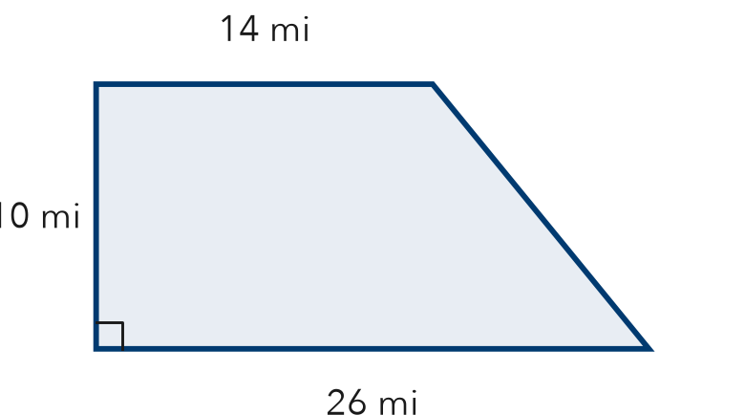

3. Table Runner. A table runner has the trapezoid shape shown. Find its area.  Answer in² | 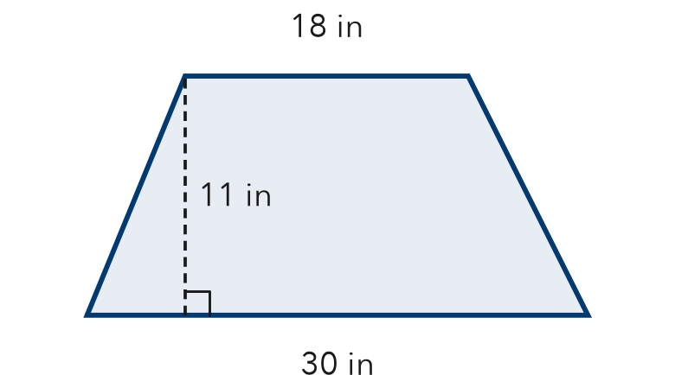
  Show your work.

4. Sidewalk Panel. A sidewalk panel is a trapezoid with parallel sides 8 m and 20 m and a height of 7 m. Find its area.  Answer m² | 5. Talia’s Answer. A trapezoid has bases 11 cm and 17 cm and a height of 20 cm. Talia says its area is 560 cm². Is Talia right?  Hint Check each step of the formula. Was a step skipped?  Answer cm²
  Show your work.
  Show your work.

6. Pool Cover. Bases 16 ft and 22 ft, height 10 ft. Fabric costs $2 per ft². Find the area and cost.
Hint Find the area first. Then multiply by the price.

Show your work.
Area, cost

7. Two Signs. Sign M has bases 10 cm and 26 cm. Sign N has bases 14 cm and 22 cm. Both are 8 cm tall. Find each area. What do you notice?
Hint Compare the sums of the bases.

Show your work.
Notice

8. Missing Base. A trapezoid has an area of 84 m² and a height of 7 m. One base is 10 m.
Hint Double the area, then divide by the height.
a. What is the sum of the two bases? m
b. Find the other base. m

Show your work.

FIND THE ERROR explain the mistake, then fix it

9. Sofia’s Work. A trapezoid has bases 7 m and 21 m and a height of 5 m. Sofia wrote: “A = ½ × 7 × 5 = 17.5 m².” Explain the mistake and find the correct area.

TEST PRACTICE choose the best answer

10. A trapezoid has bases 5 cm and 11 cm and a height of 6 cm. Its area is —
A 22 cm² | B 48 cm² | C 96 cm² | D 165 cm²

11. In A = ½ × (b1 + b2) × h, the first step is to —
A multiply b1 by h | B divide by 2
C add the bases | D multiply the bases

SELF-CHECK CODE find your answer · copy its letter into that problem’s box · spell a math word
14  A | 144  L | 98  R | 200  F | 196  X | 280  M | 560  Q | 380  U | 528  Z | 264  O

#2b | #3 | #4 | #5 | #6 | #7 | #8b

CHECK YOURSELF | □ I can do this on my own | □ I need a little help | □ I have a question about #

