Name Date Period
Lesson 5-3 · Session 2 · Practice · Form B
The Trapezoid Area Formula
Learning target — I can find the area of a trapezoid using the trapezoid area formula. · 6.G.A.1

REMEMBER  • A = ½ × (b1 + b2) × h. The bases b1 and b2 are the two parallel sides.  • Add the bases first, multiply by the height, then take half. Slanted sides are not used.  • Missing base: double the area, divide by the height, then subtract the base you know. | WORKED EXAMPLE  Bases 6 m and 12 m, height 4 m.  Step 1 Add the bases: 6 + 12 = 18.  Step 2 Multiply by the height: 18 × 4 = 72.  Step 3 Take half: 72 ÷ 2 = 36.  Answer A = 36 m²
WORDS base (base) · formula (fórmula) · right trapezoid (trapecio rectángulo)
PRACTICE show your work · label units

1. Find the area of each trapezoid with bases b1 and b2 and height h.
a. 7 cm, 13 cm; h = 6 cm cm² | b. 14 in, 22 in; h = 10 in in²
c. 18 ft, 26 ft; h = 5 ft ft² | d. 4 m, 12 m; h = 9 m m²

2. County Land. A county is shaped like this right trapezoid.  a. Sum of the bases mi  b. Area of the county mi²  c. Two copies make a rectangle. How long is it? mi | 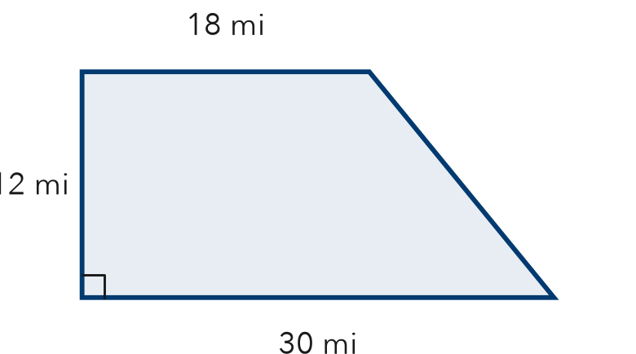

3. Table Runner. A table runner has the trapezoid shape shown. Find its area.  Answer in² | 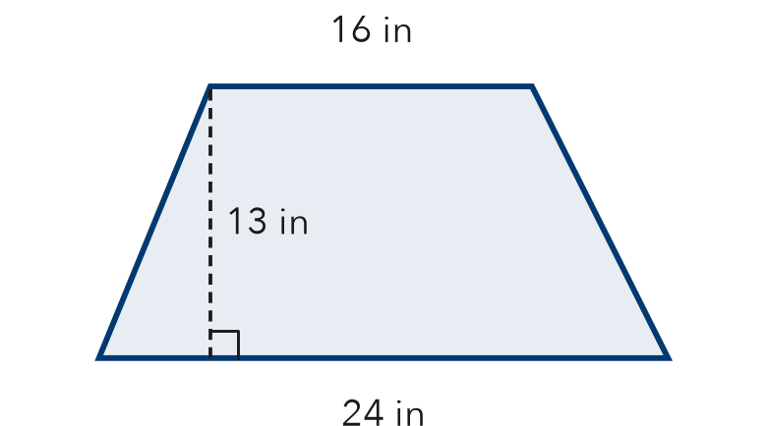
  Show your work.

4. Sidewalk Panel. A sidewalk panel is a trapezoid with parallel sides 6 m and 18 m and a height of 9 m. Find its area.  Answer m² | 5. Marcus’s Answer. A trapezoid has bases 13 cm and 19 cm and a height of 15 cm. Marcus says its area is 480 cm². Is Marcus right?  Hint Check each step of the formula. Was a step skipped?  Answer cm²
  Show your work.
  Show your work.

6. Pool Cover. Bases 18 ft and 26 ft, height 10 ft. Fabric costs $3 per ft². Find the area and cost.
Hint Find the area first. Then multiply by the price.

Show your work.
Area, cost

7. Two Signs. Sign M has bases 8 cm and 28 cm. Sign N has bases 12 cm and 24 cm. Both are 7 cm tall. Find each area. What do you notice?
Hint Compare the sums of the bases.

Show your work.
Notice

8. Missing Base. A trapezoid has an area of 90 m² and a height of 6 m. One base is 11 m.
Hint Double the area, then divide by the height.
a. What is the sum of the two bases? m
b. Find the other base. m

Show your work.

FIND THE ERROR explain the mistake, then fix it

9. Andre’s Work. A trapezoid has bases 9 m and 15 m and a height of 6 m. Andre wrote: “A = ½ × 9 × 6 = 27 m².” Explain the mistake and find the correct area.

TEST PRACTICE choose the best answer

10. A trapezoid has bases 4 in and 12 in and a height of 7 in. Its area is —
A 112 in² | B 168 in² | C 23 in² | D 56 in²

11. The trapezoid formula uses the average of the —
A two bases | B two slanted sides
C height and one base | D four sides

SELF-CHECK CODE find your answer · copy its letter into that problem’s box · spell a math word
288  A | 126  G | 260  V | 240  R | 660  A | 520  Z | 480  Q | 108  E | 19  E | 216  X

#2b | #3 | #4 | #5 | #6 | #7 | #8b

CHECK YOURSELF | □ I can do this on my own | □ I need a little help | □ I have a question about #

