Name Date Period
Lesson 5-3 · Homework Packet · Sheet 1 of 2
Trapezoids by Decomposing
Maryland Standard 6.G.A.1 · Learning target — I can find the area of a trapezoid by decomposing it into a rectangle and triangles.

REMEMBER  • Decompose a trapezoid into a rectangle and one or two triangles.  • Find the area of each piece, then add the areas.  • When you cut off a rectangle, the triangle bases together equal the difference of the two parallel sides. | WORKED EXAMPLE  Parallel sides 6 m and 12 m, height 5 m. Find the area.  Step 1 Rectangle: 6 × 5 = 30  Step 2 Triangle bases: (12 − 6) ÷ 2 = 3 m each  Step 3 Triangles: 2 × (½ × 3 × 5) = 15  Step 4 Add: 30 + 15 = 45  Answer 45 m²
PRACTICE show your work · label units

1. The trapezoid is cut into a rectangle and two matching triangles.  a. Area of the rectangle cm²  b. Area of one triangle cm²  Area of trapezoid cm² | 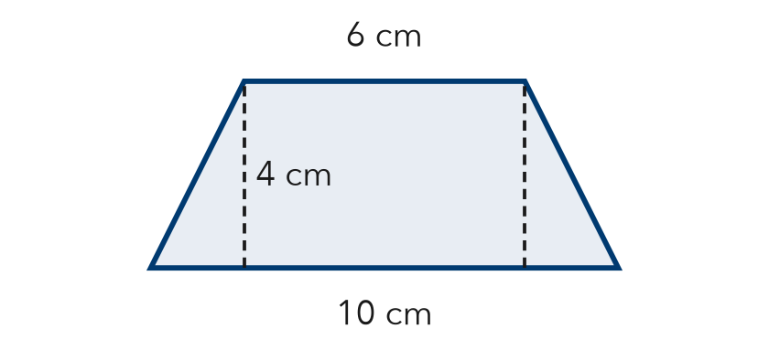

2. Decompose the trapezoid into a rectangle and one triangle. Find its area.  Answer in² | 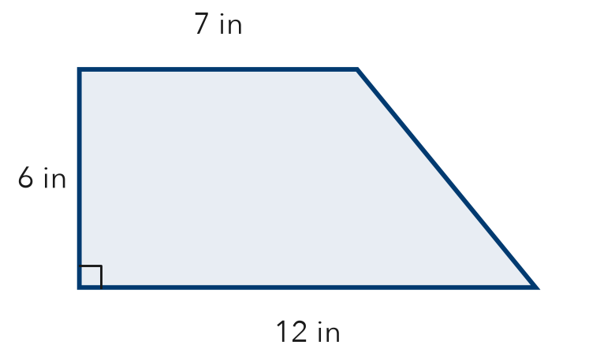
  Show your work.

3. Skate Ramp. The side of a skate ramp is a trapezoid with one square corner. Its parallel sides are 3 ft and 8 ft, and its height is 4 ft. Find the area by decomposing.

Show your work.
Answer ft²

4. Table Top. A table top is a trapezoid with parallel sides of 5 ft and 11 ft and a height of 3 ft. It is cut into a rectangle and two matching triangles. Find its area.
Answer ft²

5. Find the Error. A trapezoid has parallel sides 9 cm and 15 cm and height 4 cm. Tomás says each of its 2 matching triangles has a base of 6 cm. Explain his mistake and find the area.

CHECK YOURSELF | □ I can do this on my own | □ I need a little help | □ I have a question about #
AT HOME Find a trapezoid shape at home or outside (a lampshade side, a bag, a roof). Show someone how to cut it into a rectangle and triangles.
Name Date Period
Lesson 5-3 · Homework Packet · Sheet 2 of 2
The Trapezoid Area Formula
Maryland Standard 6.G.A.1 · Learning target — I can find the area of a trapezoid using the trapezoid area formula.

REMEMBER  • A = ½ × (b1 + b2) × h. The bases b1 and b2 are the parallel sides.  • Add the bases first, then multiply by the height h, then take half. | WORKED EXAMPLE  Parallel sides 7 cm and 11 cm, height 6 cm. Find the area.  Step 1 Add the bases: 7 + 11 = 18  Step 2 Multiply by the height: 18 × 6 = 108  Step 3 Take half: 108 ÷ 2 = 54  Answer 54 cm²
PRACTICE show your work · label units

1. Find the area of the trapezoid.  Answer m² | 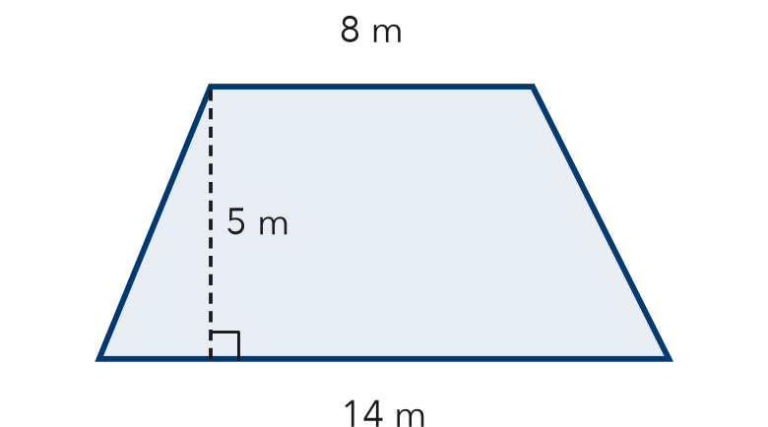
  Show your work.

2. Find the area of each trapezoid with bases b1 and b2 and height h.
a. 4 ft, 10 ft; h = 6 ft ft² | b. 5 in, 9 in; h = 8 in in²
c. 6 m, 12 m; h = 3 m m² | d. 3 cm, 7 cm; h = 9 cm cm²

3. Garden Plot. A garden plot is a trapezoid with parallel sides of 16 ft and 24 ft and a height of 10 ft. One bag of mulch covers 25 ft². How many bags are needed?
Answer bags

4. Missing Base. The area of the trapezoid is 60 in². Find the missing base b.  Answer in | 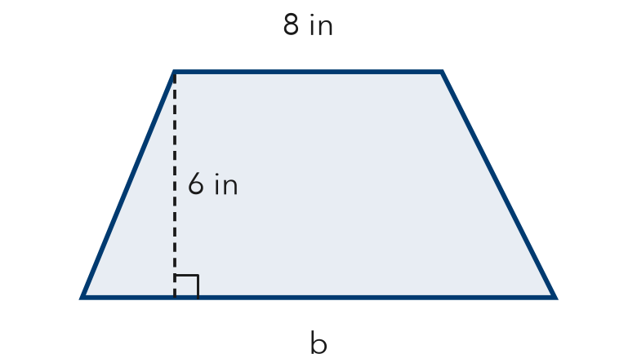
  Show your work.

TEST PRACTICE choose the best answer
5. A trapezoid has parallel sides of 6 cm and 10 cm and a height of 5 cm. What is its area?
A 21 cm² | B 40 cm² | C 80 cm² | D 300 cm²

6. Which expression finds the area of a trapezoid with bases 3 m and 9 m and height 4 m?
A ½ × 3 × 9 × 4 | B (3 + 9) × 4 | C ½ × (3 + 9) × 4 | D ½ × 3 + 9 × 4

CHECK YOURSELF | □ I can do this on my own | □ I need a little help | □ I have a question about #
AT HOME Measure a trapezoid shape at home, like the side of a bag. Estimate its area with the formula.

