Name Date Period
Lesson 5-4 · Session 2 · Practice · Form A
Composite Figures
Learning target — I can find the area of a composite figure by adding or subtracting the areas of simpler shapes. · 6.G.A.1

REMEMBER  • A composite figure is made of simpler shapes: rectangles, triangles, squares.  • Add the areas of pieces that are joined. Subtract the area of a piece that is cut out.  • Use each piece’s own formula: rectangle l × w, triangle ½ × b × h. | WORKED EXAMPLE  A 14 cm by 9 cm rectangle has a triangle (base 6 cm, height 4 cm) cut out.  Step 1 Whole rectangle: 14 × 9 = 126 cm².  Step 2 Cut-out triangle: ½ × 6 × 4 = 12 cm².  Step 3 Removed, so subtract: 126 − 12.  Answer 114 cm² left
WORDS composite figure (figura compuesta) · add (sumar) · subtract (restar)
PRACTICE show your work · label units

1. Decide whether to add or subtract. Then find each area.
a. 40 cm² rectangle + 12 cm² triangle cm² | b. 100 in² square, 16 in² cut out in²
c. 9 ft square, 3 ft square cut out ft² | d. 10 m × 4 m, 2 m square cut out m²

2. Swallowtail Flag. A flag starts as a rectangle 20 in by 14 in. A triangle notch 5 in deep is cut out of the right edge.  a. Area of the whole rectangle in²  b. Area of the notch in²  c. Area of the flag in² | 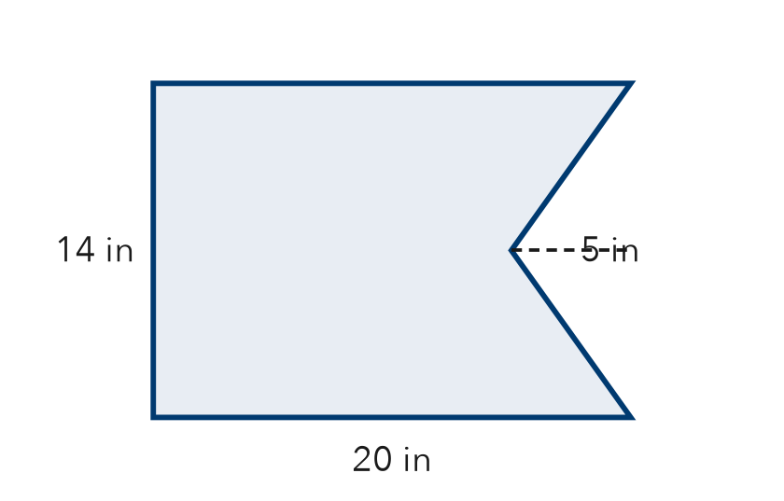

3. L-Shaped Room. An L-shaped floor splits into a 13 ft by 10 ft rectangle and a 5 ft by 11 ft rectangle. Find the floor area.  Answer ft² | 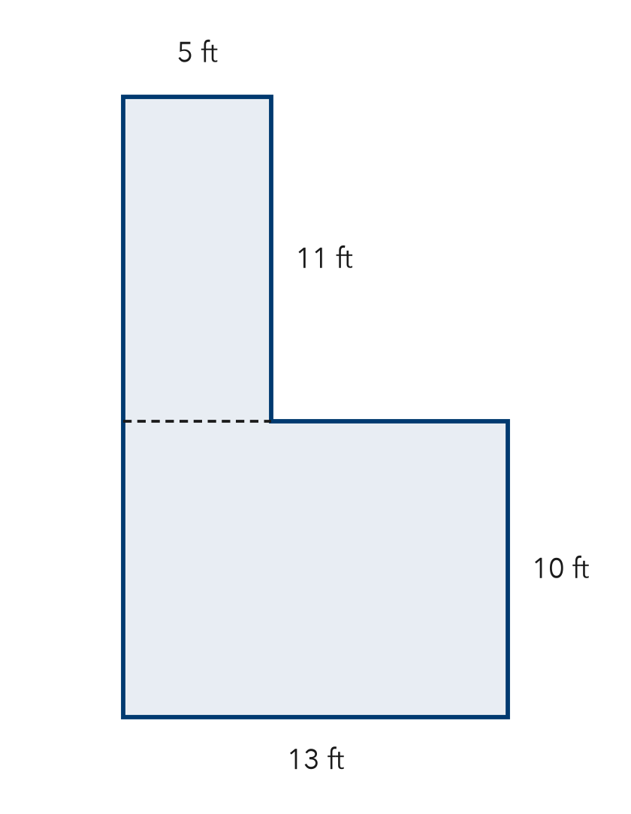
  Show your work.

4. Wall and Window. A wall is 22 ft long and 10 ft tall. A square window 5 ft on each side is not painted. Find the painted area.  Hint The window is taken away.  Answer ft² | 5. Plywood Sheet. A plywood sheet is 24 ft by 9 ft. A 6 ft by 3 ft opening is cut out. How much plywood is left?  Answer ft²
  Show your work.
  Show your work.

6. House Front. A house front is a rectangle with a triangle roof. Find the total area.  Hint Use each shape’s own formula, then add.  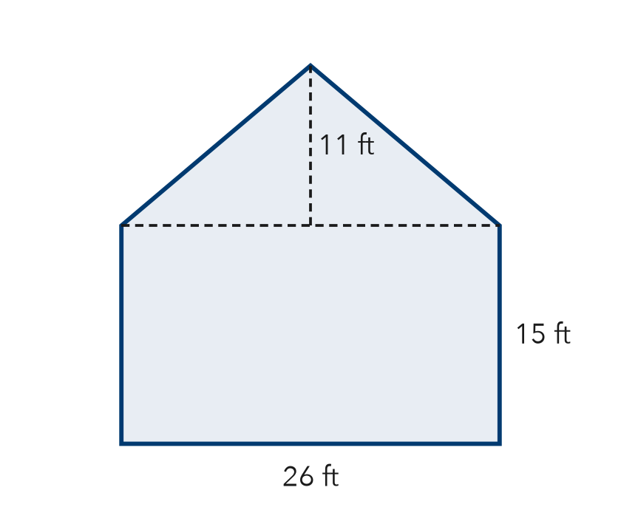  Answer ft² | 7. Deja’s Poster. A poster is 32 in by 25 in. A 10 in square is cut from one corner. Deja says 800 in² is left. Is Deja right?  Hint Did the corner square get taken away?  Area left
  Show your work.
  Show your work.

8. Playground Plan. A playground is 30 m by 20 m. Rubber covers all of it except a triangle sandbox (base 12 m, height 10 m). Rubber costs $14 per m².
a. Area of the whole rectangle m²
b. Area covered with rubber m²
c. Cost of the rubber

Show your work.

FIND THE ERROR explain the mistake, then fix it

9. Omar’s Work. A wall is 19 ft by 11 ft with a 5 ft by 5 ft vent that is not painted. Omar wrote: “Painted area = 209 + 25 = 234 ft².” Explain the mistake and fix it.

TEST PRACTICE choose the best answer

10. When a piece is cut out of a figure, you —
A add its area | B subtract its area
C multiply by its area | D ignore it

11. A composite figure is made of —
A only triangles | B one rectangle
C two or more simpler shapes | D curved lines only

SELF-CHECK CODE find your answer · copy its letter into that problem’s box · spell a math word
700  A | 7,560  T | 540  C | 315  Q | 185  U | 198  T | 245  S | 900  Z | 533  R | 195  B

#2c | #3 | #4 | #5 | #6 | #7 | #8b | #8c

CHECK YOURSELF | □ I can do this on my own | □ I need a little help | □ I have a question about #

