EXIT TICKET · LESSON 5-4 · SESSION 1 Name
Area of Regular Polygons

1. Answer each question.
a. center triangles in a regular pentagon: | b. one triangle with side 8 ft, apothem 5 ft: ft²

2. Find the area of the regular hexagon.  Answer cm² | 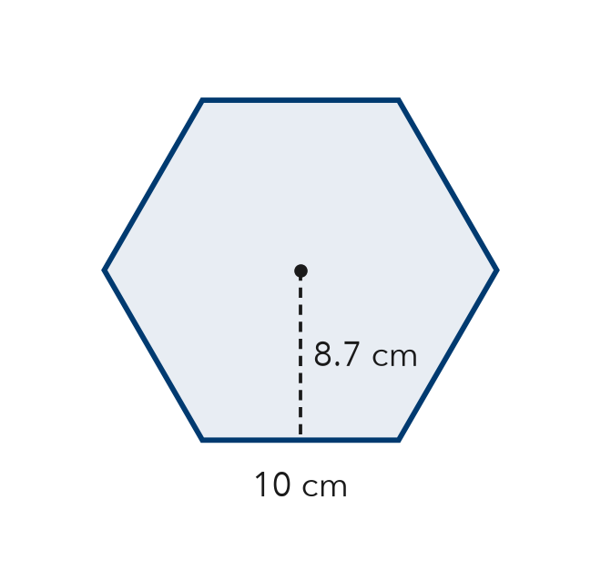
  Show your work.

3. One center triangle of a regular octagon has an area of 15 in². What is the octagon’s area?
A 23 in² | B 60 in² | C 120 in² | D 150 in²

HOW DID IT GO? □ I got it □ Almost □ I need help
cut here
EXIT TICKET · LESSON 5-4 · SESSION 1 Name
Area of Regular Polygons

1. Answer each question.
a. center triangles in a regular pentagon: | b. one triangle with side 8 ft, apothem 5 ft: ft²

2. Find the area of the regular hexagon.

Show your work.
Answer cm²

3. One center triangle of a regular octagon has an area of 15 in². What is the octagon’s area?
A 23 in² | B 60 in² | C 120 in² | D 150 in²

HOW DID IT GO? □ I got it □ Almost □ I need help
EXIT TICKET · LESSON 5-4 · SESSION 2 Name
Composite Figures

1. Add or subtract to find each area.
a. 50 ft² wall, 6 ft² window removed: ft² | b. 24 m² rectangle joined to an 8 m² triangle: m²

2. Find the area of the figure.  Answer ft² | 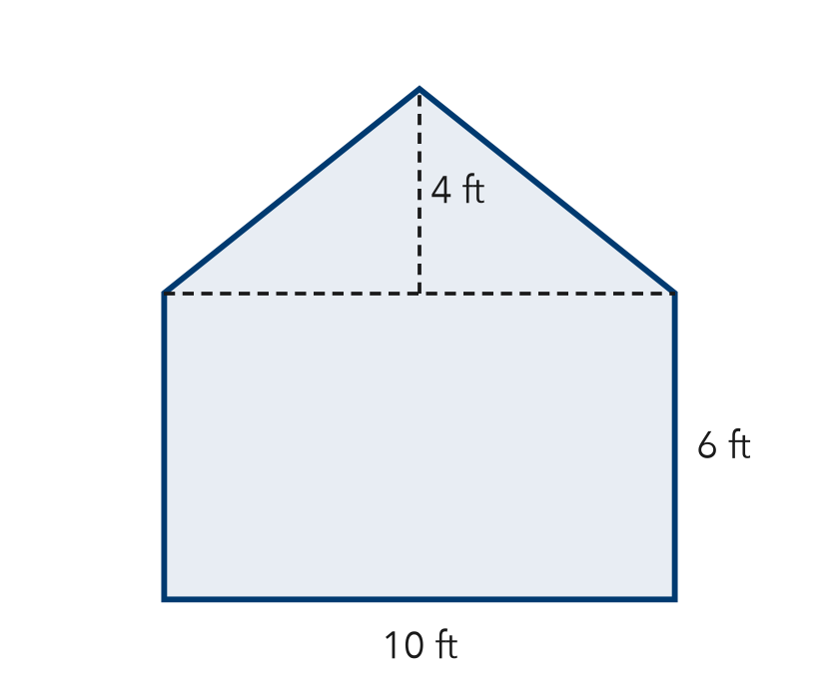
  Show your work.

3. A room is 12 ft by 10 ft. A closet 3 ft by 4 ft is joined to it. What is the total floor area?
A 108 ft² | B 120 ft² | C 132 ft² | D 240 ft²

HOW DID IT GO? □ I got it □ Almost □ I need help
cut here
EXIT TICKET · LESSON 5-4 · SESSION 2 Name
Composite Figures

1. Add or subtract to find each area.
a. 50 ft² wall, 6 ft² window removed: ft² | b. 24 m² rectangle joined to an 8 m² triangle: m²

2. Find the area of the figure.

Show your work.
Answer ft²

3. A room is 12 ft by 10 ft. A closet 3 ft by 4 ft is joined to it. What is the total floor area?
A 108 ft² | B 120 ft² | C 132 ft² | D 240 ft²

HOW DID IT GO? □ I got it □ Almost □ I need help

