Name Date Period
Lesson 5-4 · Session 1 · Guided Notes
Area of Regular Polygons
Learning target — I can find the area of a regular polygon by finding the area of one triangle and multiplying. · 6.G.A.1
WORDS TO KNOW fill in the missing words
WORD | WHAT IT MEANS | EXAMPLE
regular polygon  polígono regular | All sides and all angles equal. | stop sign, hexagon tile
congruent  congruente | Exactly the same and shape. | all center triangles match
apothem  apotema | Distance from the to the middle of a side. | height of a center triangle
KEY IDEA complete each sentence
• Lines from the center to each vertex make triangles.
• A regular polygon with n sides makes center triangles.
• Area = n × (½ × side × ).
WORKED EXAMPLE fill in the blanks as we solve
A regular pentagon has sides of 10 cm and an apothem of about 7 cm. Find its area.
Step 1 5 sides make center triangles.
Step 2 One triangle: ½ × 10 × 7 = cm².
Step 3 All triangles: 5 × 35 = cm².
Answer Area ≈ cm²
YOU TRY use the example as a model

1. Find the area of the regular hexagon.  Answer in² | 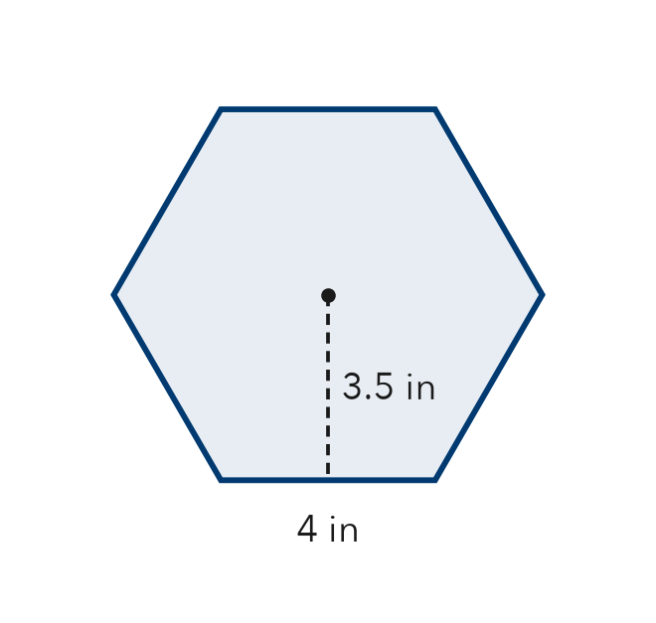
  Show your work.

2. How many center triangles does each regular polygon make?
a. octagon | b. decagon

SUM IT UP in your own words
To find the area of a regular polygon, I and then .
Name Date Period
Lesson 5-4 · Session 2 · Guided Notes
Composite Figures
Learning target — I can find the area of a composite figure by adding or subtracting the areas of simpler shapes. · 6.G.A.1
WORDS TO KNOW fill in the missing words
WORD | WHAT IT MEANS | EXAMPLE
composite figure  figura compuesta | A shape made of two or more shapes. | rectangle + triangle
decompose  descomponer | To a shape into smaller shapes you know. | L shape: 2 rectangles
subtract  restar | To the area of a piece that is cut out. | wall − window
KEY IDEA complete each sentence
• Split a composite figure into rectangles, triangles, or other shapes you .
• the areas of pieces that are joined together.
• the area of a piece that is cut out.
WORKED EXAMPLE fill in the blanks as we solve
A rectangle is 14 cm by 9 cm. A triangle notch with base 6 cm and height 4 cm is cut out. Find the area left.
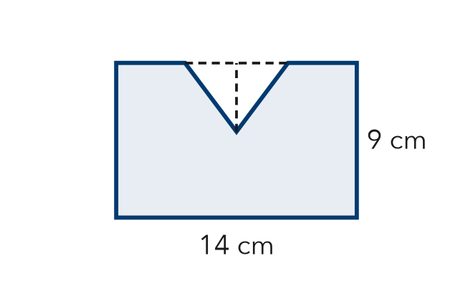
Step 1 Whole rectangle: 14 × 9 = cm².
Step 2 Cut-out triangle: ½ × 6 × 4 = cm².
Step 3 The triangle is removed, so .
Answer 126 − 12 = cm²
YOU TRY use the example as a model

1. Find the area of the L-shaped figure. All corners are right angles.  Answer m² | 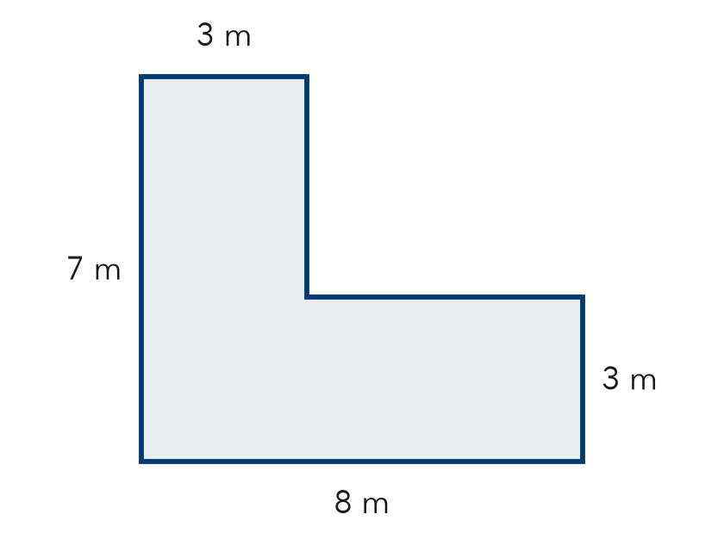
  Show your work.

2. Write add or subtract.
a. a yard, not counting its pool: | b. a wall plus its triangle roof:

SUM IT UP in your own words
I add areas when , and I subtract areas when .

