Name Date Period
Lesson 5-4 · Session 2 · Prerequisite Practice A · Skill 1 of 2
Area of Rectangles
Builds on Grade 4 · 4.MD.A.3
TODAY’S LESSON | You will split an L-shaped floor into rectangles, like 13 ft × 10 ft.
YOU NEED TO | Find a rectangle’s area: length × width, like 26 ft × 14 ft. You will use it in Practice Form A, problems 3, 4, and 5.
STEPS TO FOLLOW use these same steps on every problem
1 | Break the longer side into tens and ones.
2 | Multiply each part by the other side.
3 | Add the parts. Write square units.
WATCH ME the steps in action
Find the area of a rectangle 26 ft by 14 ft.
Step 1 26 = 20 + 6.
Step 2 20 × 14 = 280 and 6 × 14 = 84.
Step 3 280 + 84 = 364, so 364 ft².
Answer 364 ft²
TRY IT WITH HELP fill in each step
1. Find the area of a rectangle 23 m by 8 m.
Step 1 23 = 20 +
Step 2 20 × 8 = and 3 × 8 =
Step 3 160 + 24 = m²

2. Find the area of a rectangle 13 ft by 11 ft.
Step 1 13 = 10 +
Step 2 10 × 11 = and 3 × 11 =
Step 3 110 + 33 = ft²

YOUR TURN use the steps on your own

3. Find the area of each rectangle.
a. 22 ft × 10 ft | b. 16 in × 7 in | c. 18 m × 5 m
d. 32 cm × 6 cm | e. 15 ft × 12 ft | f. 27 m × 4 m

Lesson 5-4 · Session 2 · Prerequisite Practice A · Skill 2 of 2
Find Missing Side Lengths
Builds on Grade 4 · 4.MD.A.3
TODAY’S LESSON | You will split an L-shaped floor into rectangles. Some sides have no label.
YOU NEED TO | Find a missing side: whole side − known part, like 12 − 5. You will use it in Practice Form A, problem 3.
STEPS TO FOLLOW use these same steps on every problem
1 | Find the whole side across from the missing part.
2 | Write the part you know.
3 | Subtract: whole side − known part.
WATCH ME the steps in action
Find the missing side ?.  Step 1 The whole bottom side is 12 m.  Step 2 The top part across from it is 5 m.  Step 3 12 − 5 = 7.  Answer 7 m | 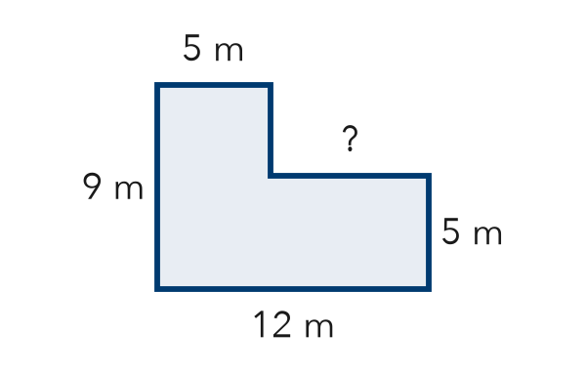

TRY IT WITH HELP fill in each step
4. An L-shape is 20 ft wide at the bottom. The top part is 13 ft wide. Find the step.
Step 1 Whole side: ft
Step 2 Known part: ft
Step 3 20 − 13 = ft

5. An L-shape is 15 m tall on the left. The right part is 9 m tall. Find the step.
Step 1 Whole side: m
Step 2 Known part: m
Step 3 15 − 9 = m

YOUR TURN use the steps on your own

6. Find each missing part.
a. whole 18, part 7 | b. whole 24, part 16
c. whole 30, part 12 | d. whole 9.5, part 4

READY CHECK a problem like the one in today’s lesson

7. An L-shape is 14 ft wide. Its top part is 6 ft wide. How long is the step?
A 20 ft | B 8 ft | C 6 ft | D 84 ft

CHECK YOURSELF | □ I can do this on my own | □ I need a little help | □ I have a question about #

