Name Date Period
Lesson 5-5 · Session 2 · Practice · Form B
Missing Fractional Edges
Learning target — I can find a missing edge of a prism and find volumes with fractional edge lengths. · 6.G.A.2

REMEMBER  • V = l × w × h works with fractions: 12 × 10 × 3/4 = 120 × 3/4 = 90.  • 1 1/2 of a number is the number plus half of it.  • Missing edge: multiply the two known edges, then divide the volume by that product. | WORKED EXAMPLE  A box holds 72 cm³. It is 6 cm long and 4 cm wide.  Step 1 Known edges: 6 × 4 = 24 cm².  Step 2 Divide: 72 ÷ 24 = 3.  Step 3 Check: 6 × 4 × 3 = 72.  Answer height = 3 cm
WORDS edge (arista) · fraction (fracción) · volume (volumen)
PRACTICE show your work · label units

1. Find each volume or missing edge.
a. 1/2 m × 1/2 m × 6 m m³ | b. 12 in × 9 in × 1/2 in in³
c. V = 240 in³, w = 6 in, h = 5 in; l = in | d. V = 105 in³, B = 15 in²; h = in

2. Shipping Box Limit. A shipping box holds 1,080 in³. It is 8 in wide and 9 in tall. Boxes may be at most 13 in long.
Hint Multiply the two known edges, then divide.
a. Multiply the two known edges. in²
b. Find the length. in
c. Does the box meet the rule?

Show your work.

3. Planter Depth. A planter holds 1,008 cm³ of soil. Its base is 12 cm by 7 cm. How tall is it?  Answer cm | 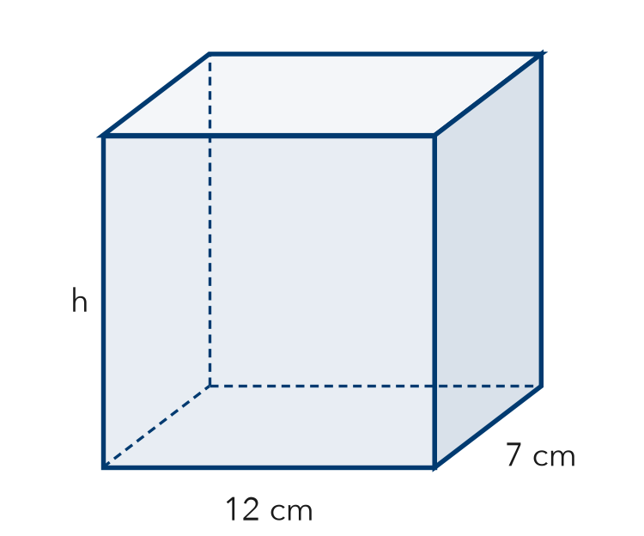
  Show your work.

4. Thin Box. A flat box is 24 in long, 12 in wide, and 3/4 in tall. Find its volume.  Hint Find the base, then take 3/4 of it.  Answer in³ | 5. Seed Flat. A seed flat is 18 in long, 10 in wide, and 1 1/2 in deep. Find its volume.  Hint 1 1/2 means the base plus half the base.  Answer in³
  Show your work.
  Show your work.

6. Concrete Slab. A concrete slab is 20 ft long, 8 ft wide, and 1/2 ft thick. Concrete costs $6 per ft³. Find the volume and the cost.
Hint The thickness is the height.

Show your work.
Volume, cost

7. Aquarium Width. An aquarium holds 4,500 in³ of water. It is 25 in long and 20 in tall. The width label wore off. Find the width.

Show your work.
Answer in

8. Planter Box. A planter is 3/4 m long, 1/2 m wide, and 4 m tall. Soil costs $20 per m³.
a. Find the volume. m³
b. Find the cost to fill it.
c. A second planter is twice as tall. Find its volume. m³

Show your work.

FIND THE ERROR explain the mistake, then fix it

9. Jonah’s Work. A box holds 2,520 cm³. It is 12 cm wide and 10 cm tall. Jonah wrote: “2,520 ÷ 12 = 210, so the length is 210 cm.” Explain the mistake and find the length.

TEST PRACTICE choose the best answer

10. A prism has a volume of 96 in³ and a base area of 12 in². Its height is —
A 8 in | B 84 in | C 108 in | D 1,152 in

11. A block is 1/2 ft by 1/2 ft by 8 ft. Its volume is —
A 2 ft³ | B 4 ft³ | C 8 ft³ | D 9 ft³

SELF-CHECK CODE find your answer · copy its letter into that problem’s box · spell a math word
15  M | 1 1/2  L | 480  I | 3  Y | 180  Z | 9  P | 216  L | 270  T | 84  Q | 12  U

#2b | #3 | #4 | #5 | #6 | #7 | #8a | #8c

CHECK YOURSELF | □ I can do this on my own | □ I need a little help | □ I have a question about #

