EXIT TICKET · LESSON 5-5 · SESSION 1 Name
Volume of Rectangular Prisms

1. Find each volume.
a. 7 cm × 3 cm × 2 cm cm³ | b. B = 30 in², h = 5 in in³

2. Each cube is 1 ft³. Find the volume of the prism.  Answer ft³ | 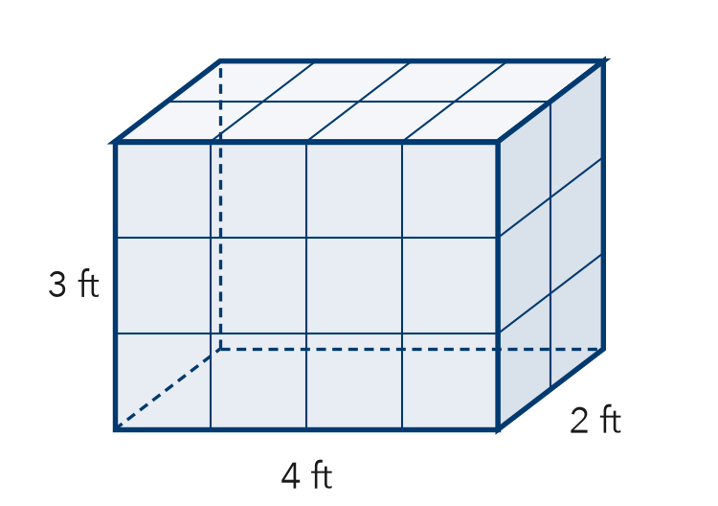
  Show your work.

3. A prism has a base area of 20 m² and a height of 6 m. What is its volume?
A 26 m³ | B 120 m² | C 120 m³ | D 240 m³

HOW DID IT GO? □ I got it □ Almost □ I need help
cut here
EXIT TICKET · LESSON 5-5 · SESSION 1 Name
Volume of Rectangular Prisms

1. Find each volume.
a. 7 cm × 3 cm × 2 cm cm³ | b. B = 30 in², h = 5 in in³

2. Each cube is 1 ft³. Find the volume of the prism.

Show your work.
Answer ft³

3. A prism has a base area of 20 m² and a height of 6 m. What is its volume?
A 26 m³ | B 120 m² | C 120 m³ | D 240 m³

HOW DID IT GO? □ I got it □ Almost □ I need help
EXIT TICKET · LESSON 5-5 · SESSION 2 Name
Missing Fractional Edges

1. Find each value.
a. V of 1/2 cm × 6 cm × 5 cm cm³ | b. V = 84 in³, base 3 in by 4 in; h = in

2. The prism has a volume of 180 cm³. Find its height h.  Answer cm | 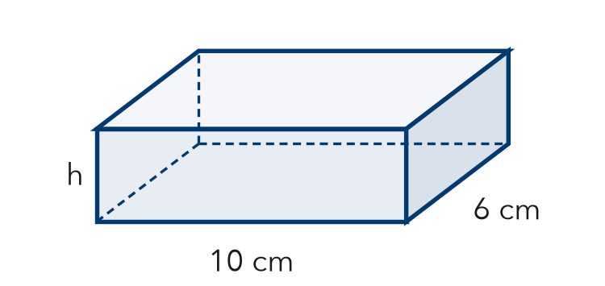
  Show your work.

3. What is the volume of a block 4 ft by 1/2 ft by 3 ft?
A 6 ft³ | B 7 1/2 ft³ | C 12 ft³ | D 24 ft³

HOW DID IT GO? □ I got it □ Almost □ I need help
cut here
EXIT TICKET · LESSON 5-5 · SESSION 2 Name
Missing Fractional Edges

1. Find each value.
a. V of 1/2 cm × 6 cm × 5 cm cm³ | b. V = 84 in³, base 3 in by 4 in; h = in

2. The prism has a volume of 180 cm³. Find its height h.

Show your work.
Answer cm

3. What is the volume of a block 4 ft by 1/2 ft by 3 ft?
A 6 ft³ | B 7 1/2 ft³ | C 12 ft³ | D 24 ft³

HOW DID IT GO? □ I got it □ Almost □ I need help

