Name Date Period
Lesson 5-5 · Session 1 · Guided Notes
Volume of Rectangular Prisms
Learning target — I can find the volume of a rectangular prism by multiplying length, width, and height. · 6.G.A.2
WORDS TO KNOW fill in the missing words
WORD | WHAT IT MEANS | EXAMPLE
volume  volumen | The amount of inside a solid. | V = l × w × h
unit cube  cubo unitario | A cube with every edge unit long. | 1 cm³
base area  área de la base | The area of the face of a prism. | B = l × w
cubic units  unidades cúbicas | Units used to measure . | cm³, in³, ft³
KEY IDEA complete each sentence
• One layer of cubes holds length × cubes.
• The height tells how many stack up.
• V = l × w × h, or V = × h.
WORKED EXAMPLE fill in the blanks as we solve
A box is 6 cm long, 3 cm wide, and 4 cm tall. Find its volume.
Step 1 One layer: 6 × 3 = cubes.
Step 2 The height is 4, so there are layers.
Step 3 Multiply: 18 × 4 = .
Answer V = cm³
YOU TRY use the example as a model

1. Find the volume of the prism.  Answer in³ | 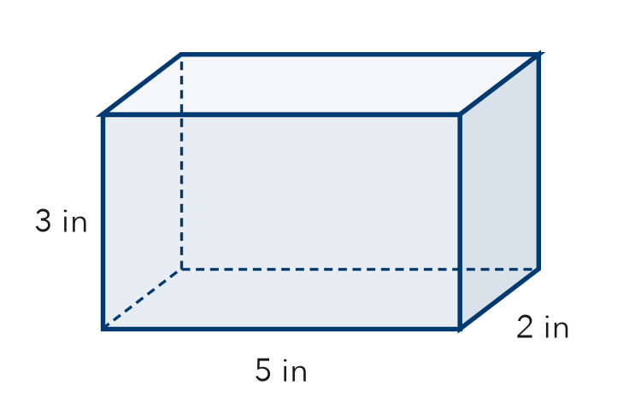
  Show your work.

2. Find each volume.
a. 10 m × 2 m × 3 m m³ | b. B = 25 ft², h = 4 ft ft³

SUM IT UP in your own words
Volume uses cubic units because .
Name Date Period
Lesson 5-5 · Session 2 · Guided Notes
Missing Fractional Edges
Learning target — I can find a missing edge of a prism and find volumes with fractional edge lengths. · 6.G.A.2
WORDS TO KNOW fill in the missing words
WORD | WHAT IT MEANS | EXAMPLE
edge  arista | A where two faces of a solid meet. | length, width, height
base area  área de la base | The of the length and width of the base. | B = l × w
inverse operations  operaciones inversas | Operations that each other. | ÷ undoes ×
KEY IDEA complete each sentence
• V = l × w × h works with too.
• To find a missing edge, the volume by the product of the other two edges.
• Check: the three edges should to the volume.
WORKED EXAMPLE fill in the blanks as we solve
A box holds 72 cm³. It is 6 cm long and 4 cm wide. Find its height.
Step 1 Known edges: 6 × 4 = cm².
Step 2 Divide: 72 ÷ 24 = .
Step 3 Check: 6 × 4 × 3 = .
Answer height = cm
YOU TRY use the example as a model

1. Find the volume of the prism.  Answer in³ | 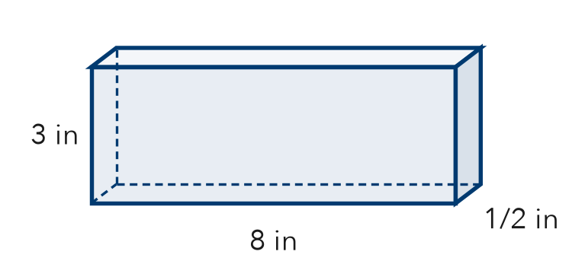
  Show your work.

2. Find each value.
a. V = 60 m³, base 3 m by 4 m; h = m | b. V of 1 1/2 ft × 2 ft × 3 ft ft³

SUM IT UP in your own words
To find a missing edge, I because .

