Name Date Period
Lesson 5-5 · Homework Packet · Level 1 · Sheet 1 of 2
Volume of Rectangular Prisms
Maryland Standard 6.G.A.2 · Learning target — I can find the volume of a rectangular prism by multiplying length, width, and height.

REMEMBER  • Volume counts the unit cubes that fill a solid. Use cubic units (cm³, in³, ft³).  • V = l × w × h, or V = B × h, where B is the area of the base. | WORKED EXAMPLE  A box is 7 cm long, 3 cm wide, and 5 cm tall.  Step 1 One layer of cubes: B = 7 × 3 = 21  Step 2 Stack 5 layers: 21 × 5 = 105  Answer 105 cm³

WORD BANK  volume — the space inside a solid  cubic units — cm³, in³, ft³ | base area — length × width of the bottom  layer — one flat level of cubes
PRACTICE show your work · label units

1. Each small cube is 1 cm³. Find the volume of the prism.  Step 1 Count the cubes in one layer: 4 × 3.  Step 2 Count the layers.  Step 3 Multiply.  Answer cm³ | 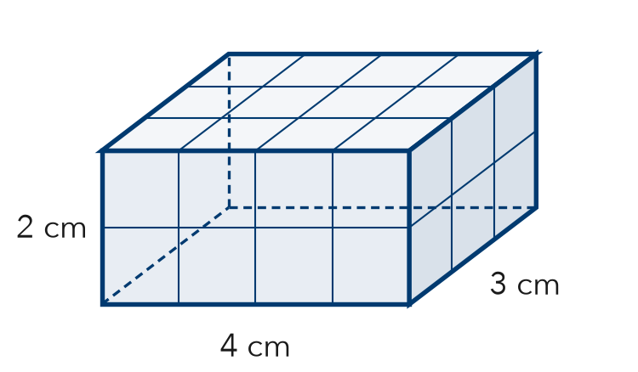
  Show your work.

2. Find the volume of each rectangular prism.
a. 8 in × 5 in × 2 in in³ | b. 10 cm × 10 cm × 4 cm cm³
c. 6 ft × 6 ft × 6 ft ft³ | d. B = 45 m², h = 7 m m³
e. 12 m × 3 m × 5 m m³ | f. B = 32 in², h = 9 in in³

3. Sandbox. A sandbox is 6 ft long, 4 ft wide, and 1 ft deep. One bag of sand fills 2 ft³. How many bags fill the sandbox?  Step 1 Find the volume: 6 × 4 × 1.  Step 2 Divide by 2 ft³ for each bag.  Answer bags | 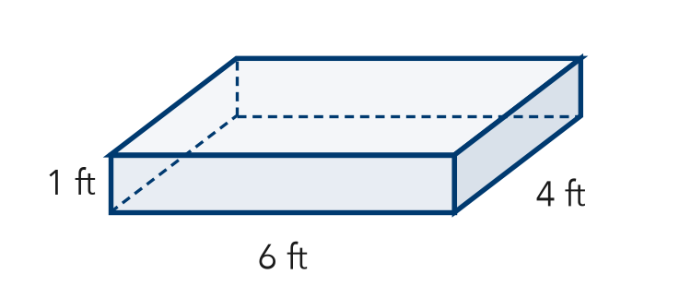
  Show your work.

4. Fish Tank. A fish tank is 20 in long and 10 in wide. It holds 3,000 in³ of water when full. How tall is the tank?
Step 1 Find the base: 20 × 10.
Step 2 Divide 3,000 by the base.
Answer in

5. Compare. Box A is 6 in × 4 in × 2 in. Box B is 3 in × 4 in × 4 in. Mika says Box A holds more because it is longer. Is she right? Explain.
Frame Mika is because Box A holds in³ and Box B holds in³.

CHECK YOURSELF | □ I can do this on my own | □ I need a little help | □ I have a question about #
AT HOME Find a box at home. Measure or estimate its length, width, and height, and find its volume.
Name Date Period
Lesson 5-5 · Homework Packet · Level 1 · Sheet 2 of 2
Missing Fractional Edges
Maryland Standard 6.G.A.2 · Learning target — I can find a missing edge of a prism and find volumes with fractional edge lengths.

REMEMBER  • V = l × w × h works with fractions too. Write mixed numbers as fractions first.  • Missing edge: divide the volume by the product of the other two edges. | WORKED EXAMPLE  A box is 2 ½ ft × 2 ft × 1 ½ ft. Find its volume.  Step 1 Write as fractions: 5/2 × 2/1 × 3/2  Step 2 Multiply: (5 × 2 × 3)/(2 × 1 × 2) = 30/4  Step 3 Simplify: 30/4 = 7 ½  Answer 7 ½ ft³

WORD BANK  fraction edge — an edge like 1/2 ft or 1 1/2 in  missing edge — the edge you do not know | divide — ÷ undoes ×  product — the answer when you multiply
PRACTICE show your work · label units

1. Find the volume of the prism.  Step 1 Write 1 ½ as 3/2 and 2 ½ as 5/2.  Step 2 Multiply 4 × 3/2 × 5/2.  Answer in³ | 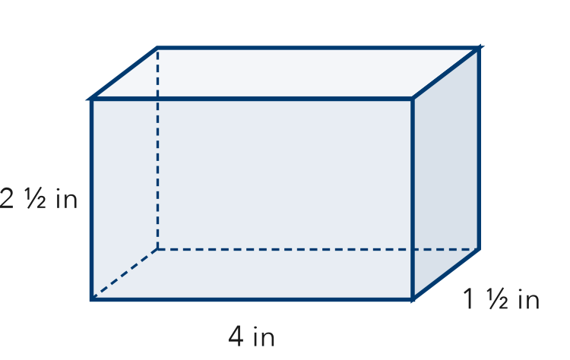
  Show your work.

2. Find each volume.
a. ½ ft × 6 ft × 8 ft ft³ | b. 3 ½ m × 2 m × 4 m m³
c. 2 ½ cm × 4 cm × 3 cm cm³ | d. 1 ½ in × 1 ½ in × 4 in in³
e. 4 ft × ½ ft × 5 ft ft³ | f. 6 cm × 1 ½ cm × 3 cm cm³

3. Planter. A planter box is 3 ft long and 1 ½ ft wide. It holds 9 ft³ of soil. How deep is it?
Step 1 Multiply the two edges: 3 × 1 ½.
Step 2 Divide 9 by that answer.
Answer ft

4. Small Cubes. A box is 2 in long, 1 in wide, and 1 ½ in tall. It is packed with cubes that are ½ in on each edge.
Step 1 Count the cubes along each edge: 2 ÷ ½, 1 ÷ ½, 1 ½ ÷ ½.
Step 2 Multiply to get the number of cubes.
a. How many cubes fill the box?
b. Each cube is 1/8 in³. What is the volume of the box? in³

TEST PRACTICE choose the best answer

5. A box is 5 in long, 2 in wide, and 1 ½ in tall. What is its volume?
A 8 ½ in³ | B 10 in³ | C 15 in² | D 15 in³

6. A prism has a volume of 96 ft³. Its base is 4 ft by 6 ft. What is its height?
Step 1 Find the base: 4 × 6.
Step 2 Divide 96 by the base.
A 4 ft | B 16 ft | C 24 ft | D 576 ft

CHECK YOURSELF | □ I can do this on my own | □ I need a little help | □ I have a question about #
AT HOME Find a box at home with a fraction edge (like 2 ½ in). Estimate its volume.

