Name Date Period
Lesson 5-6 · Session 1 · Practice · Form A
Drawing Nets of Solids
Learning target — I can draw the net of a solid by unfolding its faces onto a flat surface. · 6.G.A.4

REMEMBER  • A net is a flat pattern that folds into a solid. Each face appears once, with no overlaps.  • Rectangular prism: 6 rectangles in 3 matching pairs. Square pyramid: 1 square + 4 triangles. Triangular prism: 2 triangles + 3 rectangles.  • Edges that fold together must be the same length. | WORKED EXAMPLE  Net for a box 5 cm × 3 cm × 2 cm.  Step 1 Bottom and top: 5 cm by 3 cm.  Step 2 Front and back: 5 cm by 2 cm.  Step 3 Two sides: 3 cm by 2 cm.  Answer 6 rectangles, 3 matching pairs
WORDS net (plantilla) · face (cara) · pyramid (pirámide)
PRACTICE show your work · label units

1. How many of each shape are in the net?
a. rectangular prism: rectangles | b. square pyramid: all shapes
c. triangular prism: triangles | d. hexagonal pyramid: triangles

2. Paper Pyramid. Yuri is folding a paper square pyramid. Its net is shown.  a. How many flat pieces are in the net?  b. Area of the square base in²  c. Area of one triangle in² | 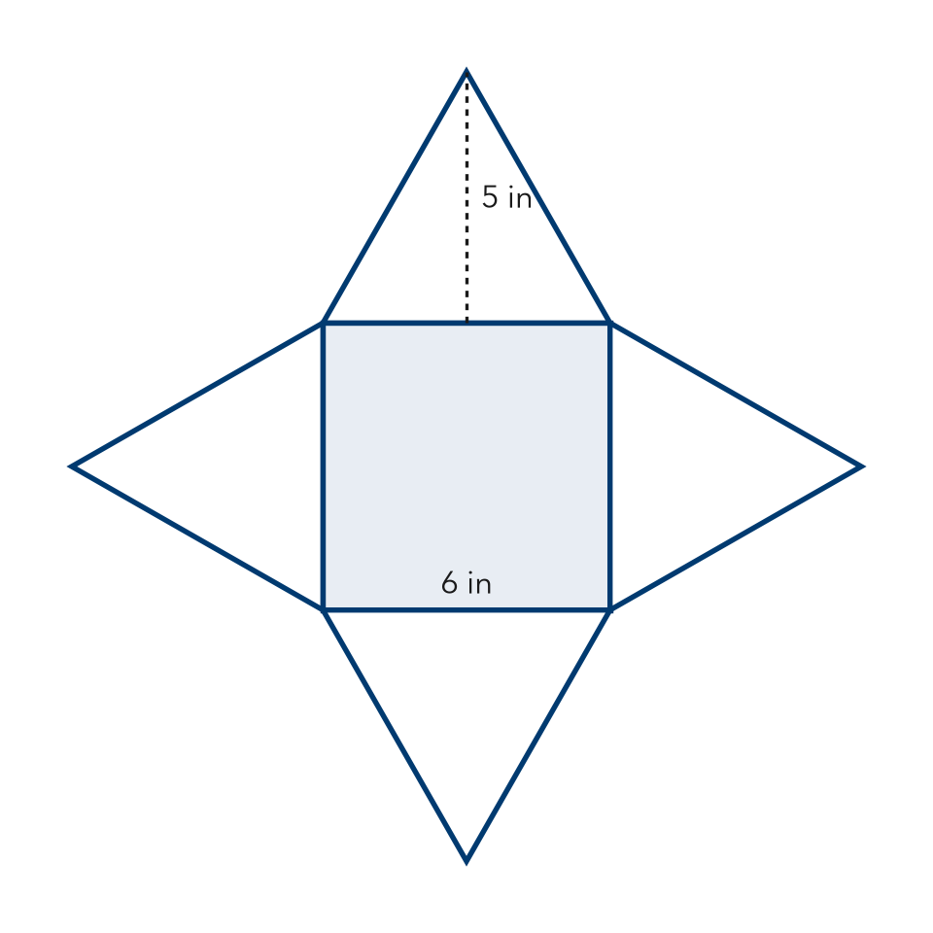

3. Cereal Box. A cereal box is a rectangular prism 8 in by 2 in by 12 in.  Hint The largest face uses the two longest edges.  a. How many rectangles are in the net?  b. Area of the largest face in² | 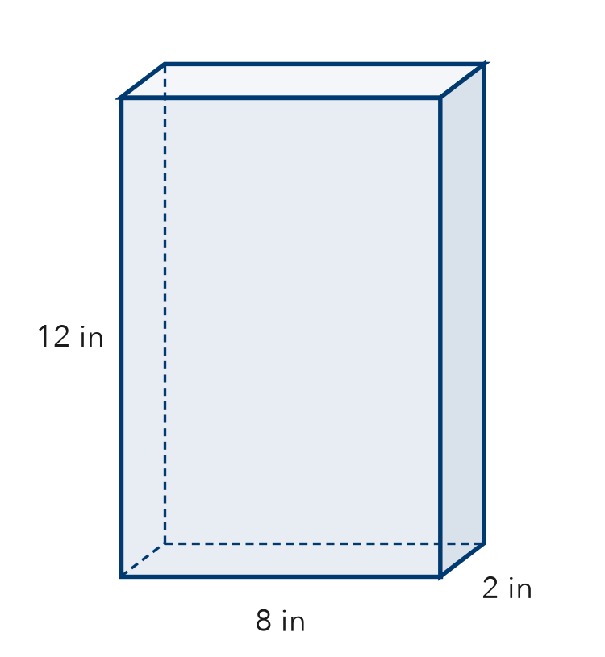
  Show your work.

4. Tent Net. A tent is a triangular prism. Each triangle end has a base of 7 ft and a height of 4 ft. The tent is 10 ft long.  Hint A triangular prism has 2 triangle ends.  a. How many triangles are in the net?  b. Area of one triangle end ft² | 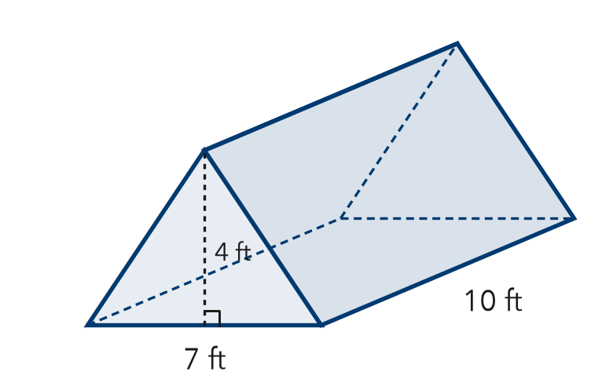
  Show your work.

5. Gift Cube. A gift box is a cube with 9 cm edges. How many faces? Area of one face?  Faces, area | 6. Display Pyramid. A square pyramid has a 14 in base edge. Each triangle is 11 in tall. Find one triangle’s area.  Answer in²
  Show your work.
  Show your work.

7. Maya’s Net. Maya drew a net of 5 squares, all the same size. Maya says it folds into a cube. Is Maya right? Explain.
Hint Count the faces of a cube.

8. Wrapping Plan. A gift box is 10 in long, 5 in wide, and 4 in tall.
a. List the three pairs of matching rectangles in its net.
b. Area of the largest face in²

Show your work.

FIND THE ERROR explain the mistake, then fix it

9. Caleb’s Net. Caleb drew a net for a square pyramid: one square with 3 triangles attached to its sides. Caleb says it will fold up correctly. Explain the mistake.

TEST PRACTICE choose the best answer

10. A net is a flat pattern that folds into a —
A solid | B line | C circle | D number line

11. A square pyramid’s net contains —
A 4 squares and 1 triangle | B 1 square and 4 triangles
C 2 squares and 4 rectangles | D 6 squares

SELF-CHECK CODE find your answer · copy its letter into that problem’s box · spell a math word
77  D | 14  O | 50  S | 96  F | 154  X | 36  U | 28  Z | 81  L | 15  N | 30  Q

#2b | #2c | #3b | #4b | #5 | #6 | #8b

CHECK YOURSELF | □ I can do this on my own | □ I need a little help | □ I have a question about #

