Name Date Period
Lesson 5-6 · Session 2 · Practice · Form B
Reading Nets and Solids
Learning target — I can name the solid a net makes by reading the shapes in the net. · 6.G.A.4

REMEMBER  • Prism: 2 matching bases + rectangles. Pyramid: 1 base + triangles that meet at a point.  • The base shape names the solid: triangular, square, pentagonal, hexagonal.  • A face is flat, an edge is where faces meet, a vertex is a corner. Count them on the folded solid. | WORKED EXAMPLE  A net has 1 square and 4 triangles.  Step 1 1 + 4 = 5 faces.  Step 2 One square base + triangles: square pyramid.  Step 3 Edges 4 + 4 = 8; vertices 4 + 1 = 5.  Answer square pyramid: 5 faces, 8 edges, 5 vertices
WORDS edge (arista) · vertex (vértice) · base (base)
PRACTICE show your work · label units

1. Name the solid each net makes.
a. 2 hexagons + 6 rectangles: | b. 1 pentagon + 5 triangles:
c. 2 triangles + 3 rectangles: | d. 1 rectangle + 4 triangles:

2. Mystery Net. A net shows 6 identical squares, each 5 cm on a side.  a. Name the solid.  b. Faces, edges, vertices  c. Area of one face cm²  d. Area of all the faces cm² | 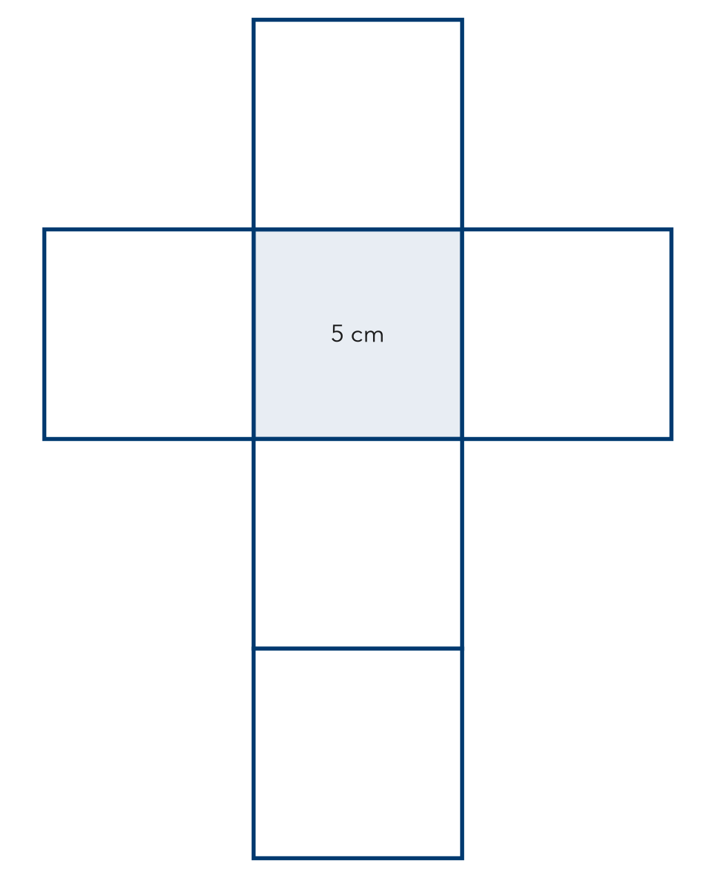

3. Fold the Net. A net has 2 rectangles 10 in by 6 in, 2 rectangles 10 in by 4 in, and 2 rectangles 6 in by 4 in.  Hint Add all six faces.  a. Name the solid.  b. Total area in² | 4. Game Box. A net has 2 squares 10 in by 10 in and 4 rectangles 10 in by 2 in.  a. Name the solid.  b. Total area in²
  Show your work.
  Show your work.

5. Cube Count. A storage cube has 9 cm edges.
Hint Edges are the lines. Vertices are the corners.
a. Faces, edges, vertices
b. Area of one face cm²

Show your work.

6. Ana’s Claim. Ana sees a net of 1 pentagon and 5 triangles. Ana says it folds into a pentagonal prism. Is Ana right?  Hint Count the bases. One base means a pyramid.  Solid | 7. Ornament Net. A net has 1 triangle base with 3 triangles around it. Each outer triangle has a base of 10 cm and a height of 6 cm.  Hint Use the triangle formula on one outer face.  Solid, area
  Show your work.
  Show your work.

8. Three Nets. Net 1: 2 hexagons + 6 rectangles. Net 2: 4 triangles. Net 3: 6 identical squares.
a. Name the solid each net makes.
b. Explain how you tell a prism from a pyramid.

Show your work.

FIND THE ERROR explain the mistake, then fix it

9. Theo’s Work. Theo says a square pyramid has 4 faces, 4 edges, and 4 vertices, because its base has 4 sides. Explain the mistake and give the correct counts.

TEST PRACTICE choose the best answer

10. How many bases does a pyramid have?
A 0 | B 1 | C 2 | D 3

11. A net with 6 identical squares makes a —
A square pyramid | B rectangular prism that is not a cube
C cube | D hexagonal prism

SELF-CHECK CODE find your answer · copy its letter into that problem’s box · spell a math word
150  H | 124  Z | 60  Q | 81  E | 280  P | 30  S | 25  S | 248  A

#2c | #2d | #3b | #4b | #5b | #7

CHECK YOURSELF | □ I can do this on my own | □ I need a little help | □ I have a question about #

