EXIT TICKET · LESSON 5-6 · SESSION 1 Name
Drawing Nets of Solids

1. How many of each shape are in the net?
a. rectangular prism: rectangles | b. square pyramid: triangles

2. A square pyramid has a base 10 cm on each side. Each triangle has a height of 8 cm. Find the area of one triangle in its net.  Answer cm² | 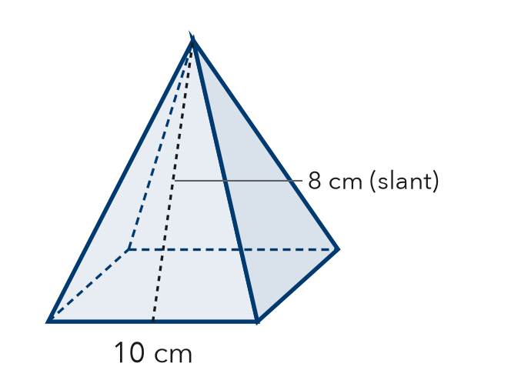
  Show your work.

3. Which set of shapes makes a net of a triangular prism?
A 3 triangles + 2 rectangles | B 2 triangles + 3 rectangles
C 1 triangle + 3 rectangles | D 2 triangles + 2 rectangles

HOW DID IT GO? □ I got it □ Almost □ I need help
cut here
EXIT TICKET · LESSON 5-6 · SESSION 1 Name
Drawing Nets of Solids

1. How many of each shape are in the net?
a. rectangular prism: rectangles | b. square pyramid: triangles

2. A square pyramid has a base 10 cm on each side. Each triangle has a height of 8 cm. Find the area of one triangle in its net.

Show your work.
Answer cm²

3. Which set of shapes makes a net of a triangular prism?
A 3 triangles + 2 rectangles | B 2 triangles + 3 rectangles
C 1 triangle + 3 rectangles | D 2 triangles + 2 rectangles

HOW DID IT GO? □ I got it □ Almost □ I need help
EXIT TICKET · LESSON 5-6 · SESSION 2 Name
Reading Nets and Solids

1. Name the solid each net makes.
a. 1 pentagon + 5 triangles: | b. 2 triangles + 3 rectangles:

2. This net folds into a square pyramid. Find the total area of the net.  Answer in² | 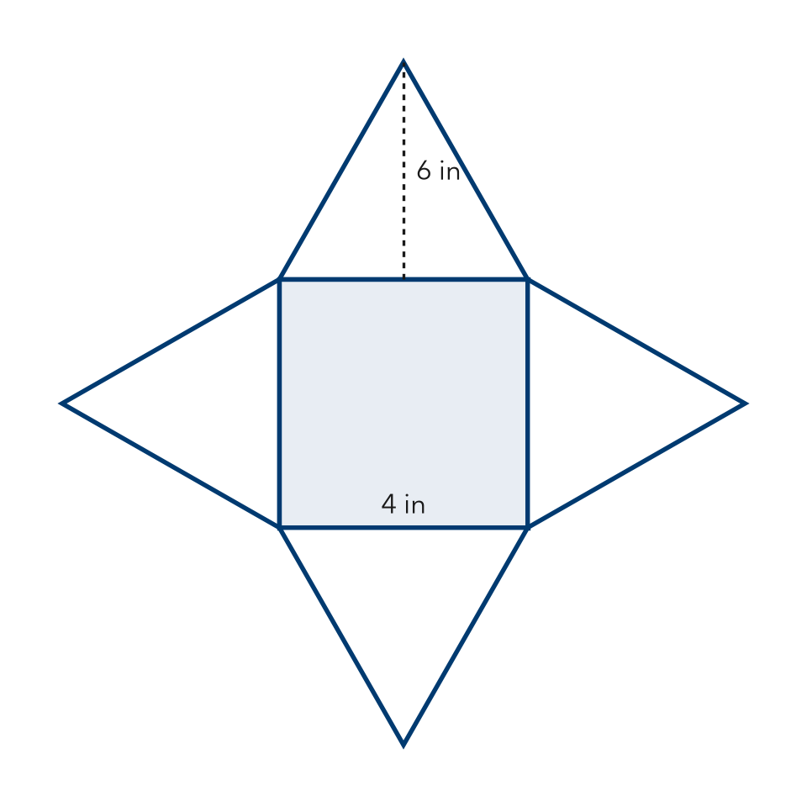
  Show your work.

3. How many vertices does a cube have?
A 6 | B 8 | C 12 | D 4

HOW DID IT GO? □ I got it □ Almost □ I need help
cut here
EXIT TICKET · LESSON 5-6 · SESSION 2 Name
Reading Nets and Solids

1. Name the solid each net makes.
a. 1 pentagon + 5 triangles: | b. 2 triangles + 3 rectangles:

2. This net folds into a square pyramid. Find the total area of the net.

Show your work.
Answer in²

3. How many vertices does a cube have?
A 6 | B 8 | C 12 | D 4

HOW DID IT GO? □ I got it □ Almost □ I need help

