Name Date Period
Lesson 5-6 · Session 1 · Guided Notes
Drawing Nets of Solids
Learning target — I can draw the net of a solid by unfolding its faces onto a flat surface. · 6.G.A.4
WORDS TO KNOW fill in the missing words
WORD | WHAT IT MEANS | EXAMPLE
net  plantilla | A flat that folds into a solid. | an unfolded box
face  cara | One side of a solid. | a cube has 6 faces
prism  prisma | A solid with two matching joined by rectangles. | a box, a tent
pyramid  pirámide | A solid with one base and faces that meet at a point. | square base + 4 triangles
KEY IDEA complete each sentence
• Every face of the solid appears in its net.
• Edges that fold together must have the same .
• A rectangular prism net has rectangles in 3 matching pairs.
WORKED EXAMPLE fill in the blanks as we solve
Draw a net for a box 5 cm long, 3 cm wide, and 2 cm tall.
Step 1 Bottom and top: two cm by 3 cm rectangles.
Step 2 Front and back: two 5 cm by cm rectangles.
Step 3 Left and right: two cm by 2 cm rectangles.
Answer rectangles in all
YOU TRY use the example as a model

1. This net folds into a square pyramid.  a. Area of the base cm²  b. Area of one triangle cm² | 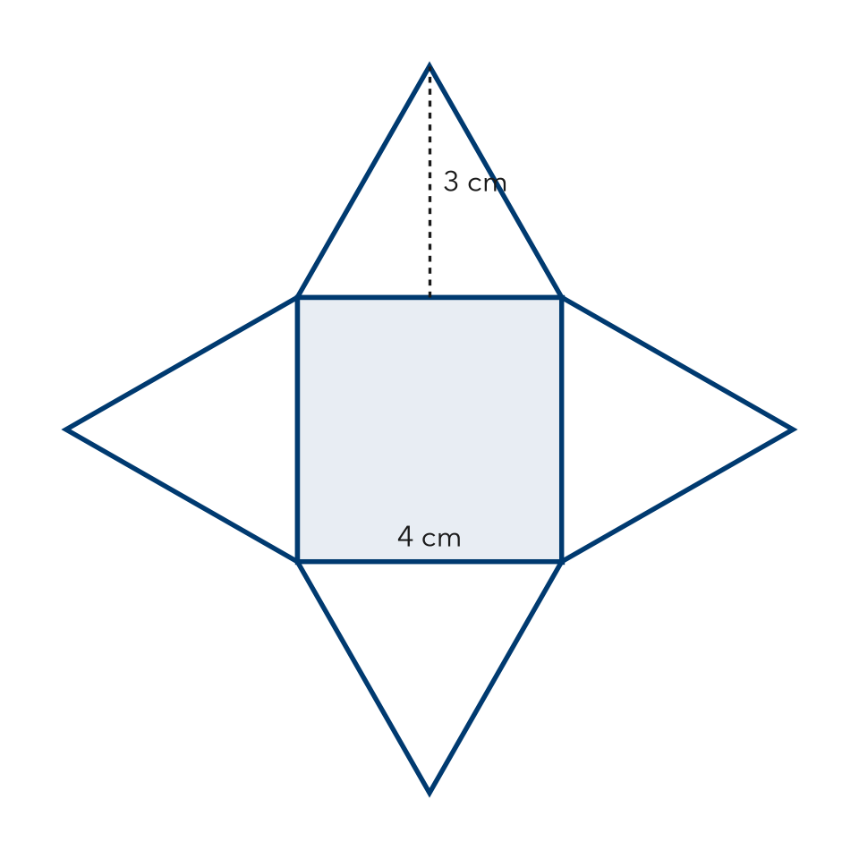

2. How many shapes are in each net?
a. cube: | b. triangular prism:

SUM IT UP in your own words
To check that a net is correct, I and .
Name Date Period
Lesson 5-6 · Session 2 · Guided Notes
Reading Nets and Solids
Learning target — I can name the solid a net makes by reading the shapes in the net. · 6.G.A.4
WORDS TO KNOW fill in the missing words
WORD | WHAT IT MEANS | EXAMPLE
edge  arista | A where two faces meet. | a cube has 12 edges
vertex  vértice | A where edges meet. | a cube has 8 vertices
base  base | The face that a prism or a pyramid. | hexagon base: hexagonal prism
KEY IDEA complete each sentence
• A prism has matching bases joined by rectangles.
• A pyramid has base and triangles that meet at a point.
• Count edges and vertices on the solid, not on the flat net.
WORKED EXAMPLE fill in the blanks as we solve
A net has 1 square and 4 triangles. Name the solid and count its faces, edges, and vertices.
Step 1 Pieces: 1 + 4 = faces.
Step 2 One square base with triangles: a square .
Step 3 Edges: 4 + 4 = . Vertices: 4 + 1 = 5.
Answer square pyramid: 5 faces, 8 edges, vertices
YOU TRY use the example as a model

1. Look at the net.  a. Name the solid.  b. Number of faces | 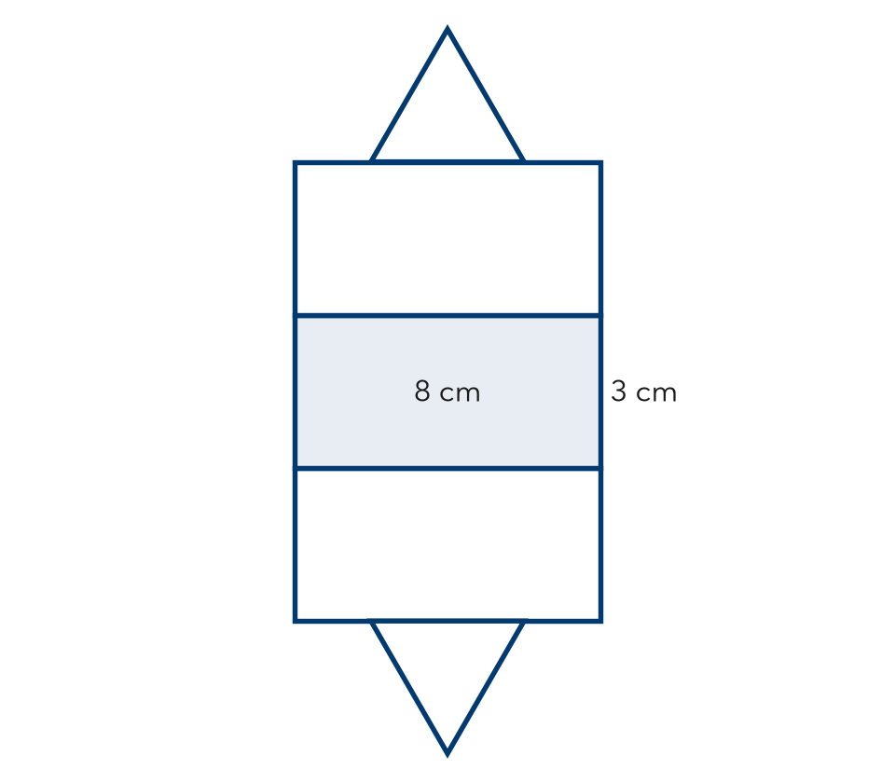

2. Name the solid each net makes.
a. 2 octagons + 8 rectangles: | b. 1 hexagon + 6 triangles:

SUM IT UP in your own words
I can tell a prism from a pyramid by .

