Name Date Period
Lesson 5-6 · Session 2 · Prerequisite Practice A · Skill 1 of 2
Name Polygons by Their Sides
Builds on Grade 2 · 2.G.A.1
TODAY’S LESSON | You will name a solid from its net, like 2 pentagons + 5 rectangles.
YOU NEED TO | Name a polygon from its number of sides. You will use it in Practice Form A, problems 1 and 8.
STEPS TO FOLLOW use these same steps on every problem
1 | Count the sides of the shape.
2 | Match: 3 triangle, 4 quadrilateral, 5 pentagon, 6 hexagon, 8 octagon.
3 | Write the name of the shape.
WATCH ME the steps in action
Name this shape.  Step 1 Count: 5 sides.  Step 2 5 sides match pentagon.  Step 3 It is a pentagon.  Answer pentagon | 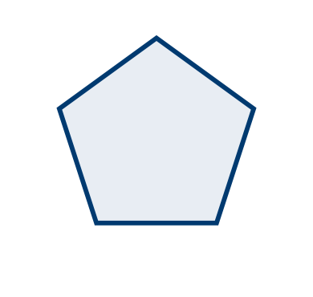

TRY IT WITH HELP fill in each step
1. A shape has 8 sides. Name it.
Step 1 Sides:
Step 2 8 sides match
Step 3 It is an .

2. A shape has 6 sides. Name it.
Step 1 Sides:
Step 2 6 sides match
Step 3 It is a .

YOUR TURN use the steps on your own

3. Name each shape.
a. 3 sides | b. 5 sides | c. 8 sides
d. 4 sides | e. 6 sides | f. 4 equal sides, square corners

Lesson 5-6 · Session 2 · Prerequisite Practice A · Skill 2 of 2
Find the Area of Squares
Builds on Grade 4 · 4.MD.A.3
TODAY’S LESSON | You will find the area of a cube face, like a 7 cm square.
YOU NEED TO | Find a square’s area: side × side, like 13 × 13. You will use it in Practice Form A, problems 2 and 5.
STEPS TO FOLLOW use these same steps on every problem
1 | Find the side length.
2 | Multiply the side by itself: s × s.
3 | Write square units, like cm².
WATCH ME the steps in action
A square face has sides of 13 in. Find its area.
Step 1 Side: 13 in.
Step 2 13 × 13 = 130 + 39 = 169.
Step 3 Unit: in².
Answer 169 in²
TRY IT WITH HELP fill in each step
4. A square face has sides of 9 ft. Find its area.
Step 1 Side: ft
Step 2 9 × 9 =
Step 3 Unit:

5. A square face has sides of 12 cm. Find its area.
Step 1 Side: cm
Step 2 12 × 12 =
Step 3 Unit:

YOUR TURN use the steps on your own

6. Find the area of each square face.
a. side 3 cm | b. side 6 m | c. side 8 in
d. side 11 ft | e. side 15 cm | f. side 20 m

READY CHECK a problem like the one in today’s lesson

7. A cube has 6 cm edges. What is the area of one face?
A 12 cm² | B 24 cm² | C 36 cm² | D 216 cm²

CHECK YOURSELF | □ I can do this on my own | □ I need a little help | □ I have a question about #

