Name Date Period
Lesson 5-7 · Session 1 · Practice · Form A
Surface Area of Rectangular Prisms
Learning target — I can find the surface area of a rectangular prism by adding the areas of its six faces. · 6.G.A.4

REMEMBER  • Surface area is the total area of all the faces, in square units.  • A rectangular prism has 3 pairs of matching faces: SA = 2lw + 2lh + 2wh.  • A cube has 6 matching faces: SA = 6 × (edge × edge). Open top? Leave that face out. | WORKED EXAMPLE  A closed box is 6 cm × 4 cm × 3 cm.  Step 1 Faces: 6 × 4 = 24, 6 × 3 = 18, 4 × 3 = 12.  Step 2 Double each: 48, 36, 24.  Step 3 Add: 48 + 36 + 24 = 108.  Answer SA = 108 cm²
WORDS surface area (área superficial) · face (cara) · congruent (congruente)
PRACTICE show your work · label units

1. Find the surface area of each solid.
a. cube, edges 8 cm cm² | b. prism 9 cm × 6 cm × 4 cm cm²
c. prism 10 in × 5 in × 3 in in² | d. cube, edges 6 m m²

2. Toy Chest. James stains the whole outside of this chest. One can covers 20 ft².  a. Top, front, and end faces  b. Surface area ft²  c. Cans of stain needed | 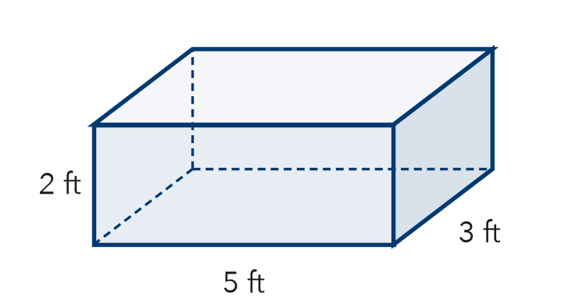
  Show your work.

3. Gift Wrap. Kai wraps a box 12 in by 10 in by 7 in. How much paper covers it?  Hint Find three faces, then double each.  Answer in² | 4. Two Cubes. Cube A has 5 cm edges. Cube B has 7 cm edges. Both are covered in foil.  a. SA of Cube A cm²  b. SA of Cube B cm²
  Show your work.
  Show your work.

5. Moving Crate. A closed crate is 8 ft by 6 ft by 3 ft. Find its surface area.  Answer ft² | 6. Tessa’s Cube. A cube has 12 in edges. Tessa says its surface area is 144 in². Is Tessa right?  Answer in²
  Show your work.
  Show your work.

7. Shipping Carton. A closed shipping carton is 15 in long, 12 in wide, and 10 in tall. Find its surface area.  Hint Every face has a matching face on the opposite side.  Answer in² | 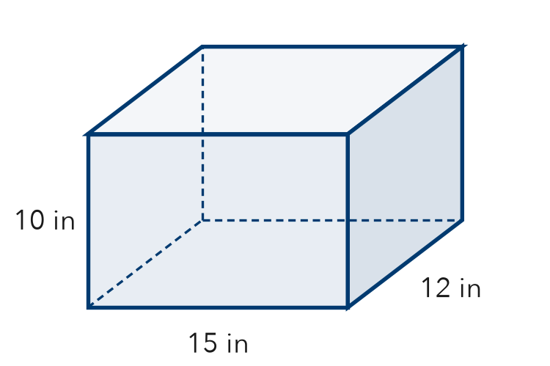
  Show your work.

8. Painting a Crate. A crate is 8 ft long, 5 ft wide, and 4 ft tall. One can of paint covers 40 ft².
Hint Round up: part of a can is still a whole can.
a. Find the surface area. ft²
b. How many cans paint all six faces?
c. No paint on the bottom: new area and cans

Show your work.

FIND THE ERROR explain the mistake, then fix it

9. Jonah’s Work. A box is 10 cm long, 7 cm wide, and 5 cm tall. Jonah wrote: “Surface area = 10 × 7 × 5 = 350 cm².” Explain the mistake and find the surface area.

TEST PRACTICE choose the best answer

10. A cube with 4 cm edges has a surface area of —
A 16 cm² | B 64 cm² | C 96 cm² | D 24 cm²

11. How many pairs of matching faces does a rectangular prism have?
A 2 | B 3 | C 4 | D 6

SELF-CHECK CODE find your answer · copy its letter into that problem’s box · spell a math word
548  U | 274  Q | 1,800  Z | 900  C | 180  F | 144  S | 150  R | 62  S | 184  E | 864  A

#2b | #3 | #4a | #5 | #6 | #7 | #8a | #8c

CHECK YOURSELF | □ I can do this on my own | □ I need a little help | □ I have a question about #

