Name Date Period
Lesson 5-7 · Session 2 · Practice · Form A
Surface Area of Triangular Prisms
Learning target — I can find the surface area of a triangular prism using its net. · 6.G.A.4

REMEMBER  • A triangular prism has 2 triangle ends and 3 rectangles: 5 faces.  • Triangle end: ½ × base × height. In a right triangle, the legs are base and height.  • Each rectangle: a triangle side × the prism’s length. | WORKED EXAMPLE  Prism 6 ft long; ends: base 8 ft, height 3 ft, sides 5 ft.  Step 1 Ends: 2 × (½ × 8 × 3) = 24 ft².  Step 2 Rectangles: (8 + 5 + 5) × 6 = 108 ft².  Step 3 Add: 24 + 108 = 132.  Answer SA = 132 ft²
WORDS triangular prism (prisma triangular) · lateral face (cara lateral) · surface area (área superficial)
PRACTICE show your work · label units

1. Find each area.
a. 2 ends, base 6 ft, height 4 ft: ft² | b. rectangle 5 ft by 10 ft: ft²
c. 2 ends of 9 cm² each: cm² | d. rectangles 3, 4, 5 cm by 11 cm: cm²

2. Candy Box. Both slanted sides of this candy box are 13 cm.  a. Area of both triangle ends cm²  b. Area of the three rectangles cm²  c. Surface area cm² | 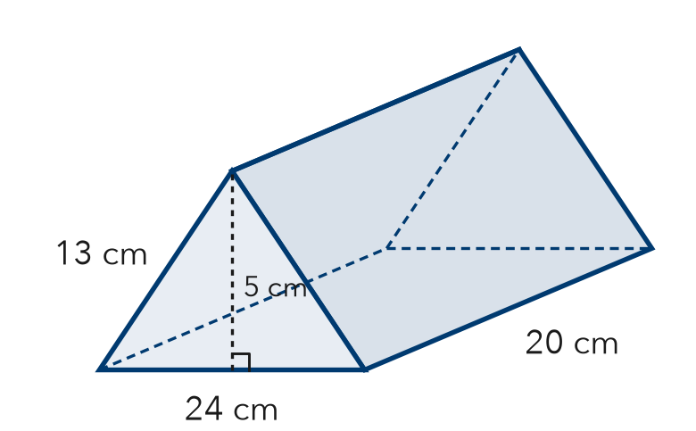
  Show your work.

3. Ramp Wedge. A wedge is a triangular prism 14 cm wide. Its ends are right triangles with sides 20, 21, and 29 cm. Find its surface area.  Answer cm² | 4. Cheese Wedge. A cheese wedge is a prism 6 cm thick. Its ends are right triangles with sides 5, 12, 13 cm. Find its surface area.  Hint The 6 cm is one side of every rectangle.  Answer cm²
  Show your work.
  Show your work.

5. Nolan’s Ends. A prism is 22 in long. Each end has base 14 in and height 24 in. Nolan says both ends cover 168 in². Is he right?  Hint How many triangle ends does a prism have?  Answer in² | 6. Roof Piece. A roof piece is a prism 25 ft long. Each end: base 36 ft, height 24 ft, two 30 ft sides. Find its SA.  Answer ft²
  Show your work.
  Show your work.

7. Planter Wedge. Find the surface area of the planter.  Hint Height for the triangles, sides for the rectangles.  Answer ft² | 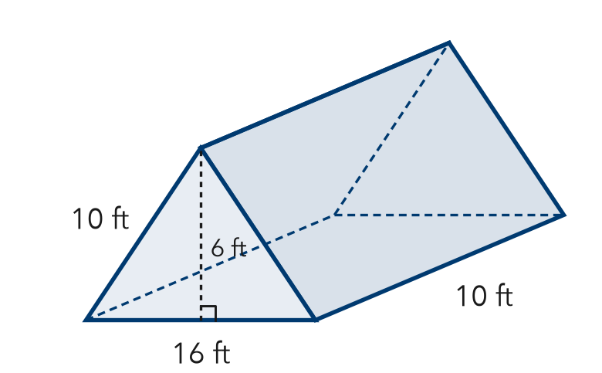
  Show your work.

8. Camping Tent. A tent is a triangular prism 10 ft long. Each end: base 8 ft, height 3 ft, two 5 ft sides. The floor is 8 ft by 10 ft.
a. Area of the two ends ft²
b. Total surface area ft²
c. Fabric needed with no floor ft²

Show your work.

FIND THE ERROR explain the mistake, then fix it

9. Amara’s Work. A prism is 10 cm long. Its ends are right triangles with sides 6, 8, 10 cm. Amara found the rectangles (240 cm²) and one end (24 cm²) and wrote “SA = 264 cm².” Explain and fix it.

TEST PRACTICE choose the best answer

10. How many rectangular faces does a triangular prism have?
A 2 | B 3 | C 5 | D 6

11. Each rectangle in the net uses one triangle side times the —
A triangle’s height | B prism’s length
C triangle’s area | D number of faces

SELF-CHECK CODE find your answer · copy its letter into that problem’s box · spell a math word
3,264  N | 1,400  R | 336  A | 1,120  T | 124  E | 800  Z | 168  Q | 240  I | 204  L | 456  G

#2c | #3 | #4 | #5 | #6 | #7 | #8b | #8c

CHECK YOURSELF | □ I can do this on my own | □ I need a little help | □ I have a question about #

