EXIT TICKET · LESSON 5-7 · SESSION 1 Name
Surface Area of Rectangular Prisms

1. Find each surface area.
a. cube, edges 3 ft ft² | b. prism 4 cm × 3 cm × 2 cm cm²

2. Find the surface area of the prism.  Answer in² | 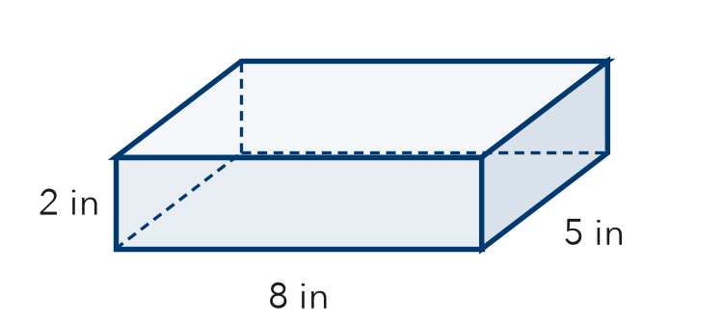
  Show your work.

3. Which expression finds the surface area of a box l by w by h?
A l × w × h | B 2lw + 2lh + 2wh | C l + w + h | D 6 × l

HOW DID IT GO? □ I got it □ Almost □ I need help
cut here
EXIT TICKET · LESSON 5-7 · SESSION 1 Name
Surface Area of Rectangular Prisms

1. Find each surface area.
a. cube, edges 3 ft ft² | b. prism 4 cm × 3 cm × 2 cm cm²

2. Find the surface area of the prism.

Show your work.
Answer in²

3. Which expression finds the surface area of a box l by w by h?
A l × w × h | B 2lw + 2lh + 2wh | C l + w + h | D 6 × l

HOW DID IT GO? □ I got it □ Almost □ I need help
EXIT TICKET · LESSON 5-7 · SESSION 2 Name
Surface Area of Triangular Prisms

1. Find each area.
a. 2 triangle ends, base 4 m, height 3 m m² | b. 3 rectangles: sides 3, 4, 5 m × length 2 m m²

2. Find the surface area of the triangular prism.  Answer in² | 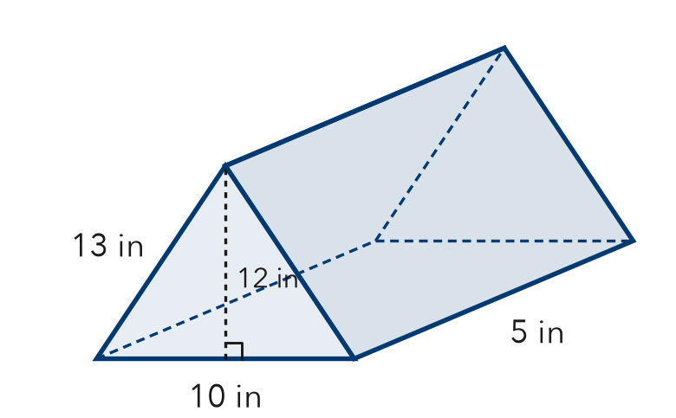
  Show your work.

3. Which measure is NOT a side of any rectangle in a triangular prism’s net?
A the prism’s length | B the triangle’s base
C a slanted side | D the triangle’s height

HOW DID IT GO? □ I got it □ Almost □ I need help
cut here
EXIT TICKET · LESSON 5-7 · SESSION 2 Name
Surface Area of Triangular Prisms

1. Find each area.
a. 2 triangle ends, base 4 m, height 3 m m² | b. 3 rectangles: sides 3, 4, 5 m × length 2 m m²

2. Find the surface area of the triangular prism.

Show your work.
Answer in²

3. Which measure is NOT a side of any rectangle in a triangular prism’s net?
A the prism’s length | B the triangle’s base
C a slanted side | D the triangle’s height

HOW DID IT GO? □ I got it □ Almost □ I need help

