Name Date Period
Lesson 5-7 · Session 1 · Guided Notes
Surface Area of Rectangular Prisms
Learning target — I can find the surface area of a rectangular prism by adding the areas of its six faces. · 6.G.A.4
WORDS TO KNOW fill in the missing words
WORD | WHAT IT MEANS | EXAMPLE
surface area  área superficial | The total of all the faces of a solid. | add every face
congruent  congruente | Exactly the same and shape. | opposite faces match
net  plantilla | A flat that folds into a solid. | shows all 6 faces
KEY IDEA complete each sentence
• A rectangular prism has pairs of matching faces.
• SA = 2lw + 2lh + .
• Surface area is measured in units.
WORKED EXAMPLE fill in the blanks as we solve
A closed box is 6 cm long, 4 cm wide, and 3 cm tall. Find its surface area.
Step 1 Top: 6 × 4 = cm². Front: 6 × 3 = 18 cm². End: 4 × 3 = cm².
Step 2 Double each: 48 + 36 + 24.
Answer SA = cm²
YOU TRY use the example as a model

1. Find the surface area of the prism.  Answer in² | 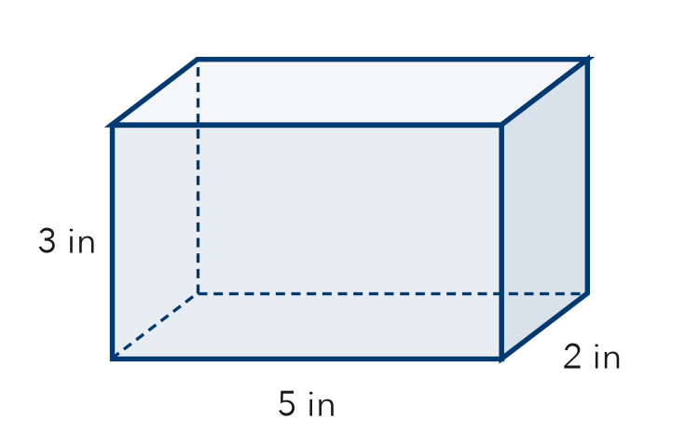
  Show your work.

2. Find the surface area of each cube.
a. edges 2 m m² | b. edges 10 in in²

SUM IT UP in your own words
Surface area is different from volume because .
Name Date Period
Lesson 5-7 · Session 2 · Guided Notes
Surface Area of Triangular Prisms
Learning target — I can find the surface area of a triangular prism using its net. · 6.G.A.4
WORDS TO KNOW fill in the missing words
WORD | WHAT IT MEANS | EXAMPLE
triangular prism  prisma triangular | A solid with 2 triangle and 3 rectangle faces. | a tent shape
lateral face  cara lateral | A side face that is a base. | the 3 rectangles
surface area  área superficial | The total area of all the . | add all 5 faces
KEY IDEA complete each sentence
• Add the areas of all faces: 2 triangles and 3 rectangles.
• Each triangle uses ½ × base × .
• Each rectangle is one triangle × the prism’s length.
WORKED EXAMPLE fill in the blanks as we solve
A prism is 6 ft long. Each triangle end has a base of 8 ft, a height of 3 ft, and two 5 ft sides. Find its surface area.
Step 1 One end: ½ × 8 × 3 = ft². Both ends: 24 ft².
Step 2 Rectangles: 8 × 6 + 5 × 6 + 5 × 6 = ft².
Answer SA = 24 + 108 = ft²
YOU TRY use the example as a model

1. Find the surface area of the triangular prism.  Answer cm² | 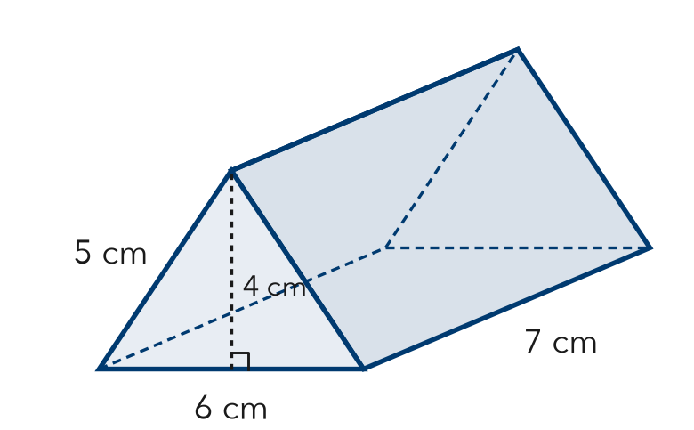
  Show your work.

2. Find each area.
a. 2 triangles, base 10 in, height 2 in in² | b. rectangle 4 in by 9 in in²

SUM IT UP in your own words
For a triangular prism, I use the triangle’s height for and its sides for .

