Name Date Period
Lesson 5-7 · Homework Packet · Level 1 · Sheet 1 of 2
Surface Area of Rectangular Prisms
Maryland Standard 6.G.A.4 · Learning target — I can find the surface area of a rectangular prism by adding the areas of its six faces.

REMEMBER  • Surface area is the total area of all the faces, in square units.  • A rectangular prism has 3 pairs of matching faces: SA = 2lw + 2lh + 2wh. | WORKED EXAMPLE  A box is 8 in × 3 in × 2 in. Find its surface area.  Step 1 One face from each pair: 8 × 3 = 24, 8 × 2 = 16, 3 × 2 = 6  Step 2 Add: 24 + 16 + 6 = 46  Step 3 Each face has a twin, so double: 2 × 46 = 92  Answer 92 in²

WORD BANK  surface area — the total area of all the faces  face — a flat side of a solid | pair — two matching faces  square units — cm², in², ft²
PRACTICE show your work · label units

1. Find the surface area of the prism.  Step 1 Top and bottom: 2 × (10 × 4).  Step 2 Front and back: 2 × (10 × 5).  Step 3 Two ends: 2 × (4 × 5). Then add.  Answer cm² | 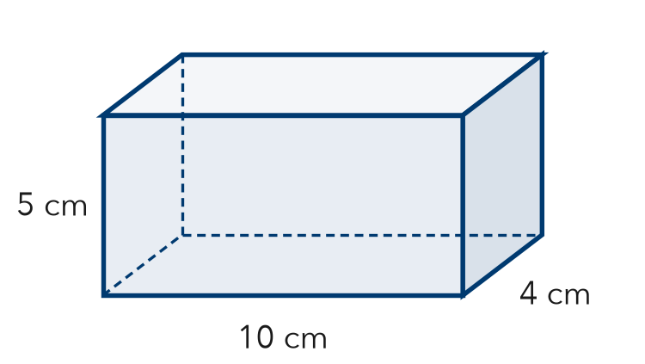
  Show your work.

2. Find the surface area of each solid.
Step 1 Cube: 6 × (edge × edge).
Step 2 Prism: 2lw + 2lh + 2wh.
a. cube, edges 3 cm cm² | b. cube, edges 10 ft ft²
c. prism 4 m × 2 m × 1 m m² | d. prism 5 in × 5 in × 2 in in²
e. cube, edges 5 in in² | f. prism 6 cm × 3 cm × 2 cm cm²

3. Gift Box. Nadia wraps a box. It is 12 in long, 8 in wide, and 4 in tall. Her paper covers 400 in². Is that enough paper? Explain.
Step 1 Find the surface area of the box.
Step 2 Compare it to 400 in².

Show your work.
Answer

4. Toy Chest. A toy chest is 4 ft long, 2 ft wide, and 3 ft tall. Leo paints all faces but the bottom. How many ft² does he paint?
Step 1 Find the top only (no bottom).
Step 2 Find the front and back, then the two sides.
Step 3 Add the 5 faces.
Answer ft²

5. Find the Error. Diego says the surface area of a cube with 2 cm edges is 8 cm² because 2 × 2 × 2 = 8. Explain his mistake and find the surface area.
Frame Diego found the , not the surface area. A cube has faces, so .

CHECK YOURSELF | □ I can do this on my own | □ I need a little help | □ I have a question about #
AT HOME Pick a box at home. Point to each pair of matching faces and tell someone how you would find its surface area.
Name Date Period
Lesson 5-7 · Homework Packet · Level 1 · Sheet 2 of 2
Surface Area of Triangular Prisms
Maryland Standard 6.G.A.4 · Learning target — I can find the surface area of a triangular prism using its net.

REMEMBER  • A triangular prism has 2 triangle bases and 3 rectangles.  • Each rectangle is one side of the triangle × the prism’s length. Add all 5 faces. | WORKED EXAMPLE  Prism 10 cm long. Ends are right triangles with sides 3, 4, 5 cm.  Step 1 Triangles: 2 × (½ × 3 × 4) = 12  Step 2 Rectangles: 30 + 40 + 50 = 120  Step 3 Add: 12 + 120 = 132  Answer 132 cm²

WORD BANK  triangular prism — 2 triangle ends + 3 rectangles  rectangle face — triangle side × prism length | height — straight up from the base, at a square corner  surface area — add all 5 faces
PRACTICE show your work · label units

1. Find the surface area. The triangle ends have sides 5 m, 5 m, and 6 m.  Step 1 Two triangles: 2 × (½ × 6 × 4).  Step 2 Rectangles: each side × 10.  Step 3 Add all 5 faces.  Answer m² | 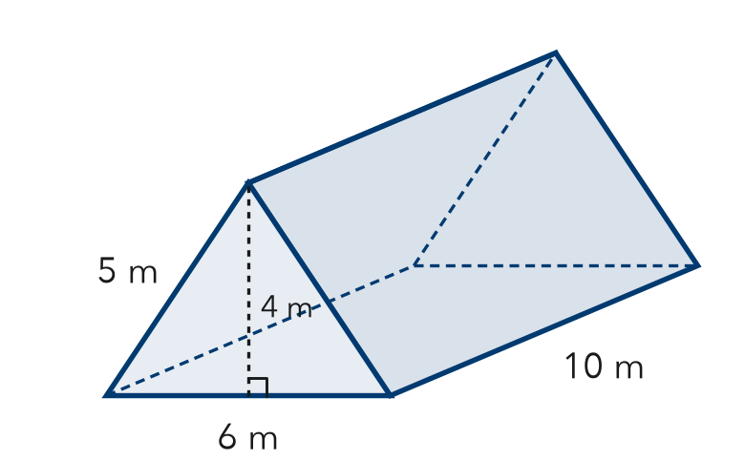
  Show your work.

2. Find each area.
a. 2 triangles, base 8 ft, height 3 ft: ft² | b. 1 rectangle, 5 ft by 9 ft: ft²

3. Tent. A tent is a triangular prism, 9 ft long. Each end is a triangle: base 8 ft, height 3 ft, and two 5 ft sides. Find the fabric for all 5 faces, with the floor.
Step 1 Find the two ends.
Step 2 Find the floor and the two sides.
Step 3 Add.
Answer ft²

4. Doorstop. A wooden doorstop is a triangular prism 4 in long. Its ends are right triangles with sides 5 in, 12 in, and 13 in. Find its surface area.
Step 1 Ends: the legs 5 in and 12 in are the base and height.
Step 2 Rectangles: 5 × 4, 12 × 4, 13 × 4.
Step 3 Add all 5 faces.
Answer in²

5. Find the Error. For the prism in Exercise 1, Lucas found the rectangles as 6 × 10, 4 × 10, and 4 × 10. Explain his mistake.
Frame Lucas used the triangle’s instead of its for two rectangles.

TEST PRACTICE choose the best answer

6. Triangle ends: 9 cm² each. Rectangles: 20, 20, and 24 cm². What is the surface area?
A 64 cm² | B 73 cm² | C 82 cm² | D 146 cm²

7. A prism is 8 cm long. Its triangle ends have sides 6, 8, and 10 cm. What is the total area of the 3 rectangles?
A 24 cm² | B 192 cm² | C 240 cm² | D 480 cm²

CHECK YOURSELF | □ I can do this on my own | □ I need a little help | □ I have a question about #

