Name Date Period
Lesson 5-7 · Session 1 · Prerequisite Practice B · Skill 1 of 2
Pair Faces on a Net
Builds on Lesson 5-6 Session 2 · 6.G.A.4
TODAY’S LESSON | You will find a box’s 3 different faces, like 15 × 12, 15 × 10, and 12 × 10.
YOU NEED TO | Match each box face with the face across from it. You will use it in Practice Form A, problems 2 and 7.
STEPS TO FOLLOW use these same steps on every problem
1 | Top and bottom match: length × width.
2 | Front and back match: length × height.
3 | Two sides match: width × height.
WATCH ME the steps in action
A box is 7 cm by 5 cm by 3 cm. Find one face from each pair.  Step 1 Top and bottom: 7 × 5 = 35 cm².  Step 2 Front and back: 7 × 3 = 21 cm².  Step 3 Two sides: 5 × 3 = 15 cm².  Answer 35, 21, and 15 cm², each twice | 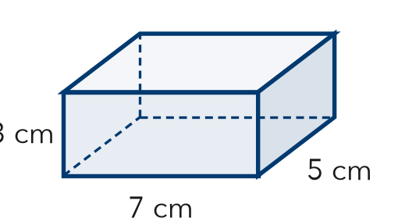

TRY IT WITH HELP fill in each step
1. A box is 6 in by 4 in by 2 in. Find one face from each pair.
Step 1 Top: 6 × 4 = in²
Step 2 Front: 6 × 2 = in²
Step 3 Side: 4 × 2 = in²

2. A box is 10 ft by 5 ft by 3 ft. Find one face from each pair.
Step 1 Top: 10 × 5 = ft²
Step 2 Front: 10 × 3 = ft²
Step 3 Side: 5 × 3 = ft²

YOUR TURN use the steps on your own

3. Find the top, front, and side areas of each box (l × w × h).
a. 8 × 5 × 3 | b. 6 × 6 × 2
c. 9 × 4 × 2 | d. 10 × 7 × 2

Lesson 5-7 · Session 1 · Prerequisite Practice B · Skill 2 of 2
Area of Rectangles
Builds on Grade 4 · 4.MD.A.3
TODAY’S LESSON | You will find each face of a carton, like 15 in × 12 in.
YOU NEED TO | Find a rectangle’s area: length × width, like 14 in × 6 in. You will use it in Practice Form A, problems 3 and 7.
STEPS TO FOLLOW use these same steps on every problem
1 | Break the longer side into tens and ones.
2 | Multiply each part by the other side.
3 | Add the parts. Write square units.
WATCH ME the steps in action
A face is 14 in by 6 in. Find its area.
Step 1 14 = 10 + 4.
Step 2 10 × 6 = 60 and 4 × 6 = 24.
Step 3 60 + 24 = 84, so 84 in².
Answer 84 in²
TRY IT WITH HELP fill in each step
4. A face is 18 cm by 6 cm. Find its area.
Step 1 18 = 10 +
Step 2 10 × 6 = and 8 × 6 =
Step 3 60 + 48 = cm²

5. A face is 13 ft by 7 ft. Find its area.
Step 1 13 = 10 +
Step 2 10 × 7 = and 3 × 7 =
Step 3 70 + 21 = ft²

YOUR TURN use the steps on your own

6. Find the area of each face.
a. 14 cm × 8 cm | b. 25 ft × 4 ft | c. 13 m × 13 m
d. 17 in × 5 in | e. 15 cm × 9 cm | f. 16 ft × 6 ft

READY CHECK a problem like the one in today’s lesson

7. A cube has 5 in edges. What is its surface area?
A 25 in² | B 100 in² | C 125 in² | D 150 in²

CHECK YOURSELF | □ I can do this on my own | □ I need a little help | □ I have a question about #

