Name Date Period
Lesson 5-8 · Session 2 · Practice · Form A
Lateral Area of Pyramids
Learning target — I can find the lateral area of a pyramid, which covers only its slanted faces. · 6.G.A.4

REMEMBER  • Lateral area = the slanted faces only. Do not include the base.  • Surface area = lateral area + base area.  • A triangle-base pyramid has 3 slanted faces; a square pyramid has 4. | WORKED EXAMPLE  Square base 4 m; slant height 6 m; only the sides are covered.  Step 1 Leave out the base.  Step 2 One triangle: ½ × 4 × 6 = 12 m².  Step 3 Four triangles: 4 × 12 = 48.  Answer lateral area = 48 m²
WORDS lateral area (área lateral) · surface area (área superficial) · slant height (altura inclinada)
PRACTICE show your work · label units

1. Find each lateral area.
a. 4 faces, each 25 cm² cm² | b. SA = 150 in², base = 36 in² in²
c. square base 7 m, slant 9 m m² | d. square base 11 in, slant 10 in in²

2. Canvas Frame. Maria’s frame is a pyramid with a triangle base (24 in sides) and slant height 14 in. Only the slanted faces get canvas.
a. Faces that get canvas
b. One slanted face in²
c. Canvas needed in²

Show your work.

3. Open-Bottom Tent. This tent is a square pyramid. The floor is open ground.  a. One panel ft²  b. Fabric for the tent ft²  c. Total if the floor were covered ft² | 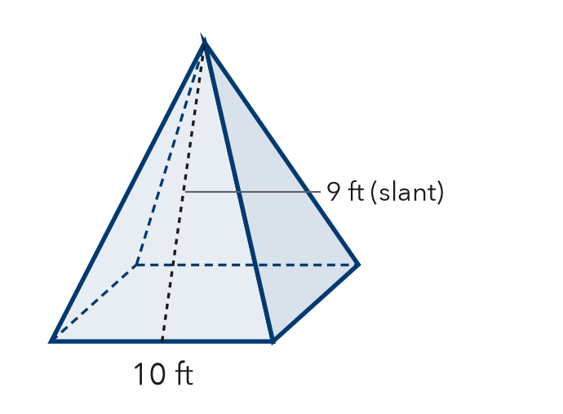
  Show your work.

4. Gazebo Roof. A square pyramid roof has base 14 ft and slant height 8 ft. Only its slanted faces get shingles.  Answer ft² | 5. Tower Cap. A square pyramid cap has base 22 m and slant height 17 m. Only its slanted faces are copper.  Answer m²
  Show your work.
  Show your work.

6. Display Pyramid. A display is a square pyramid: base 26 in, slant height 25 in. Every face is wrapped, base included. How much paper?  Hint Include the base.  Answer in² | 7. Kai’s Canvas. A square pyramid has base 30 cm and slant height 21 cm. Kai says the four slanted faces cover 2,520 cm². Is Kai right?  Hint Find one slanted face first.  Answer cm²
  Show your work.
  Show your work.

8. Tent Cover. A shelter is a square pyramid: base 16 ft, slant height 10 ft, open floor. Canvas costs $3 per ft².
Hint Find the lateral area first, then multiply by the price.
a. Lateral area ft²
b. Cost of the canvas
c. Total SA; why use lateral area here?

Show your work.

FIND THE ERROR explain the mistake, then fix it

9. Rosa’s Work. A square pyramid has base 14 cm and slant height 8 cm. Only the slanted faces are painted. Rosa wrote: “Area = 196 + 224 = 420 cm².” Explain the mistake and fix it.

TEST PRACTICE choose the best answer

10. Lateral area leaves out the —
A base | B triangles | C slant height | D apex

11. How many slanted faces does a pyramid with a triangle base have?
A 3 | B 4 | C 5 | D 6

SELF-CHECK CODE find your answer · copy its letter into that problem’s box · spell a math word
2,520  Q | 1,976  G | 1,260  L | 180  H | 320  E | 1,232  Z | 224  I | 960  S | 504  S | 748  N

#2c | #3b | #4 | #5 | #6 | #7 | #8a | #8b

CHECK YOURSELF | □ I can do this on my own | □ I need a little help | □ I have a question about #

