EXIT TICKET · LESSON 5-8 · SESSION 1 Name
Surface Area of Pyramids

1. Find each area.
a. square base, side 9 cm cm² | b. one triangle, base 9 cm, slant 4 cm cm²

2. Use the net to find the surface area of the square pyramid.  Answer in² | 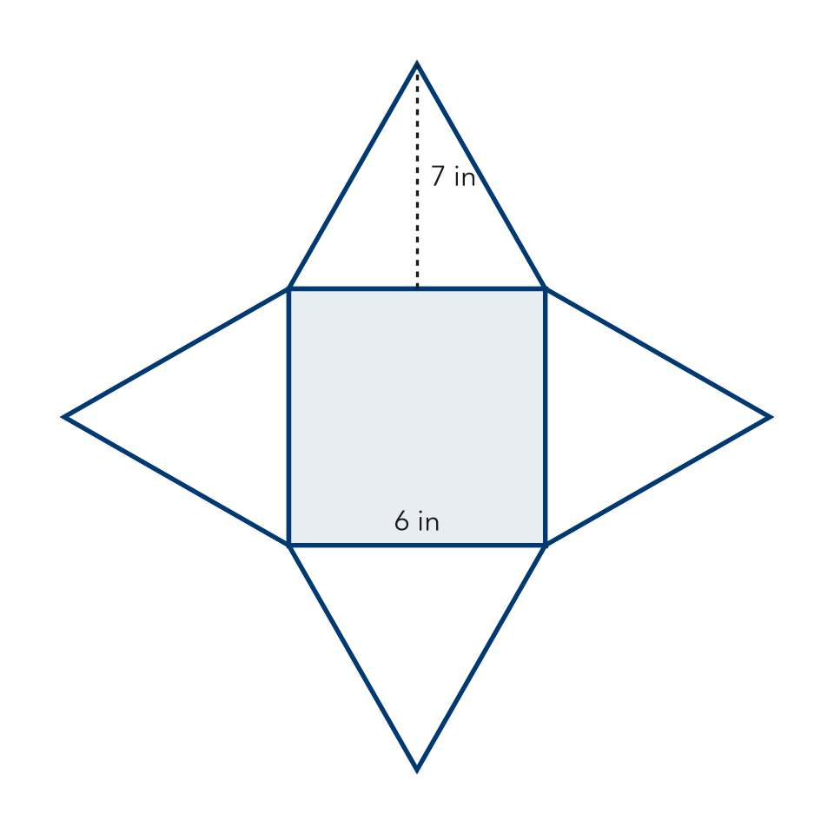
  Show your work.

3. Which measure is the height of each triangular face?
A the slant height | B the pyramid’s straight-up height
C a base edge | D the apex

HOW DID IT GO? □ I got it □ Almost □ I need help
cut here
EXIT TICKET · LESSON 5-8 · SESSION 1 Name
Surface Area of Pyramids

1. Find each area.
a. square base, side 9 cm cm² | b. one triangle, base 9 cm, slant 4 cm cm²

2. Use the net to find the surface area of the square pyramid.

Show your work.
Answer in²

3. Which measure is the height of each triangular face?
A the slant height | B the pyramid’s straight-up height
C a base edge | D the apex

HOW DID IT GO? □ I got it □ Almost □ I need help
EXIT TICKET · LESSON 5-8 · SESSION 2 Name
Lateral Area of Pyramids

1. Find each lateral area.
a. 4 faces, each 15 cm² cm² | b. SA = 100 in², base = 36 in² in²

2. Only the slanted faces are painted. Find the painted area.  Answer m² | 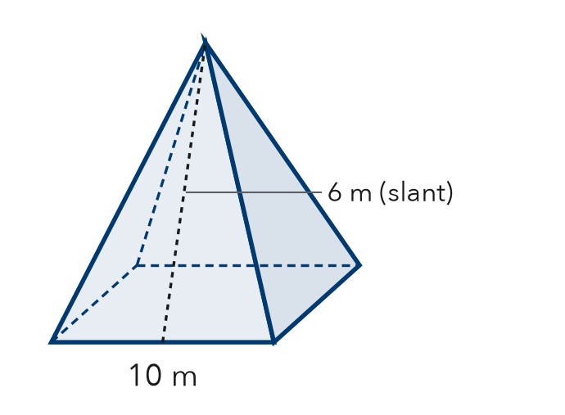
  Show your work.

3. A tent has no floor. What should you find to know how much fabric it needs?
A lateral area | B surface area | C base area | D volume

HOW DID IT GO? □ I got it □ Almost □ I need help
cut here
EXIT TICKET · LESSON 5-8 · SESSION 2 Name
Lateral Area of Pyramids

1. Find each lateral area.
a. 4 faces, each 15 cm² cm² | b. SA = 100 in², base = 36 in² in²

2. Only the slanted faces are painted. Find the painted area.

Show your work.
Answer m²

3. A tent has no floor. What should you find to know how much fabric it needs?
A lateral area | B surface area | C base area | D volume

HOW DID IT GO? □ I got it □ Almost □ I need help

